EUROPEAN UNIVERSITY CYPRUS
MSc THESIS

EXPLORING A SPECIALIZED PROGRAMMED CELL
DEATH PATTERN TO PREDICT
PROGNOSIS AND TREATMENT SENSITIVITY
IN LUNG CANCER

Murtala Ibrahim Kankarofi

Supervisor
Prof. Apostolos Zaravinos

2026

ACKNOWLEDGEMENTS
First of all, I would like to thank my supervisor for his invaluable advice, critical comments and assistance during the preparation of the present research project.
In addition, I want to show my gratitude to the faculty and staff members of the university who have created conditions that have enabled me to complete this research project.
I would also like to thank researchers and organizations who have produced publicly accessible datasets and computational tools utilized in this research project, including The Cancer Genome Atlas, Gene Expression Omnibus, Genomic Data Commons, DepMap, PRISM and Genomics of Drug Sensitivity in Cancer.
I am very grateful to my family, friends and colleagues who have encouraged me during my studies.
Finally, thank everybody whose contribution was essential for completing the present thesis project.

ABSTRACT
Lung cancer is molecularly heterogeneous, and dysregulation of programmed cell death (PCD) pathways may contribute to differences in tumour biology and prognosis. This study investigated PCD-related molecular patterns separately in lung adenocarcinoma (LUAD) and lung squamous cell carcinoma (LUSC). A catalogue of 296 genes representing apoptosis, necroptosis, pyroptosis, ferroptosis and cuproptosis was curated. Tumour-versus-normal analysis identified 47 genes that were concordantly dysregulated in both histologies, which were used to define two expression-derived molecular subtypes in each TCGA cohort. Projection across eight independent GEO cohorts showed partial, mechanism-specific reproducibility, although separation between projected groups was modest. The subtypes also differed in immune and stromal characteristics, pathway activity, mutation, copy-number alteration and DNA methylation. Repeated nested cross-validation demonstrated modest prognostic discrimination in LUAD (mean C-index = 0.604) but near-chance discrimination in LUSC (mean C-index = 0.505). A 47-gene ridge-penalized Cox PCD score (MPCDS) was therefore developed for LUAD. Across four independent LUAD GEO cohorts, higher MPCDS consistently showed an adverse-risk direction, with statistically significant associations in three cohorts. Exploratory drug-sensitivity and immunotherapy-related analyses generated hypotheses but did not directly assess patient treatment response. Overall, the findings support partial external reproducibility of PCD-related molecular patterns and a modest prognostic role for MPCDS in LUAD; prospective validation is required before clinical application.
Keywords: lung cancer; lung adenocarcinoma; lung squamous cell carcinoma; programmed cell death; apoptosis; necroptosis; pyroptosis; ferroptosis; cuproptosis; machine learning; multi-omics; prognosis; MPCDS.
Table of Contents
ACKNOWLEDGEMENTS 2
ABSTRACT 2
TABLE OF FIGURES 8
LIST OF ABBREVIATIONS 10
CHAPTER 1: INTRODUCTION 11
1.1 BACKGROUND AND RATIONALE 11
1.2 LUNG CANCER AND MOLECULAR HETEROGENEITY 12
1.3 PROGRAMMED CELL DEATH IN CANCER 12
1.4 PROGRAMMED CELL-DEATH MECHANISMS INVESTIGATED 13
1.4.1 Apoptosis 13
1.4.2 Necroptosis 14
1.4.3 Pyroptosis 14
1.4.4 Ferroptosis 15
1.4.5 Cuproptosis 16
1.5 MULTI-OMICS AND MACHINE LEARNING IN LUNG CANCER RESEARCH 16
1.6 RESEARCH PROBLEM AND KNOWLEDGE GAP 17
1.7 AIM OF THE STUDY 17
1.8 SPECIFIC OBJECTIVES 18
1.9 SIGNIFICANCE OF THE STUDY 18
CHAPTER 2: LITERATURE REVIEW 19
2.1 INTRODUCTION 19
2.2 MOLECULAR CHARACTERISTICS OF LUAD AND LUSC 19
2.3 PCD AND THE TUMOUR IMMUNE MICROENVIRONMENT 20
2.4 MULTI-OMICS APPROACHES TO LUNG-CANCER SUBTYPING 20
2.5 MOLECULAR SUBTYPING BASED ON PROGRAMMED CELL DEATH 21
2.6 MACHINE LEARNING AND PROGNOSTIC SIGNATURES 21
2.7 PCD AND THERAPEUTIC SENSITIVITY 22
2.8 SUMMARY OF LITERATURE AND RESEARCH GAP 23
CHAPTER 3: MATERIALS AND METHODS 24
3.1 STUDY DESIGN 24
3.2 DATA ACQUISITION AND PREPROCESSING 24
3.2.1 TCGA RNA-Sequencing Data 24
3.2.2 Clinical and Survival Data 25
3.2.3 Somatic Mutation Data 25
3.2.4 Copy-Number Variation Data 26
3.2.5 DNA Methylation Data 26
3.2.6 GEO External Validation Cohorts 26
3.3 CURATION OF PROGRAMMED CELL DEATH-RELATED GENES 27
3.4 DIFFERENTIAL-EXPRESSION ANALYSIS 27
3.5 UNIVARIATE PROGNOSTIC ANALYSIS 28
3.6 IDENTIFICATION OF PCD MOLECULAR SUBTYPES 28
3.7 PCD MECHANISM SCORING 29
3.8 EXTERNAL VALIDATION OF PCD MOLECULAR SUBTYPES 30
3.9 FUNCTIONAL ENRICHMENT ANALYSIS 30
3.10 IMMUNE AND STROMAL CHARACTERIZATION 30
3.11 MULTI-OMICS CHARACTERIZATION 31
3.11.1 Somatic Mutation Analysis 31
3.11.2 Copy-Number Variation Analysis 31
3.11.3 DNA Methylation Analysis 31
3.12 CONSTRUCTION OF THE MPCDS PROGNOSTIC MODEL 32
3.13 LASSO-COX SENSITIVITY ANALYSIS 32
3.14 SURVIVAL AND PROGNOSTIC EVALUATION 32
3.15 EXTERNAL VALIDATION OF MPCDS 33
3.16 TIME-DEPENDENT ROC ANALYSIS 33
3.17 DECISION-CURVE ANALYSIS 33
3.18 DRUG-SENSITIVITY ANALYSIS 34
3.18.1 GDSC/ONCOPREDICT Analysis 34
3.18.2 Prism Pharmacogenomic Analysis 34
3.19 IMMUNOTHERAPY-RELATED INDICATORS 34
3.19.1 PD-L1 Expression 34
3.19.2 Nonsynonymous Mutation Burden 34
3.19.3 MICROSATELLITE INSTABILITY (MSI) 35
3.19.4 TIDE ANALYSIS 35
3.20 STATISTICAL ANALYSIS 35
3.21 DATA VISUALIZATION 35
CHAPTER 4: RESULTS 36
4.1 OVERVIEW OF THE ANALYTICAL COHORTS 36
4.2 IDENTIFICATION OF CONCORDANTLY DYSREGULATED PCD-RELATED GENES 36
4.3 PROGNOSTIC CHARACTERISTICS OF THE 47 CANDIDATE PCD GENES 36
4.4 IDENTIFICATION OF PCD MOLECULAR SUBTYPES 37
4.5 PCD MECHANISM PROFILES OF THE MOLECULAR SUBTYPES 39
4.6 EXTERNAL VALIDATION OF THE PCD SUBTYPES 39
4.6.1 External Validation in Four LUSC Cohorts 39
4.6.2 External Validation in Four LUAD Cohorts 39
4.7 IMMUNE AND STROMAL CHARACTERISTICS OF PCD_C1 AND PCD_C2 41
4.8 FUNCTIONAL PATHWAY DIFFERENCES BETWEEN PCD SUBTYPES 43
4.9 MULTI-OMICS CHARACTERIZATION OF THE PCD SUBTYPES 43
4.9.1 Nonsynonymous Mutation Burden 43
4.9.2 $KEAP1$ Mutation Frequency 43
4.9.3 Copy-Number Alteration Burden 43
4.9.4 DNA Methylation Differences 43
4.10 DEVELOPMENT AND INTERNAL VALIDATION OF THE MPCDS 44
4.11 LASSO-COX SENSITIVITY ANALYSIS 46
4.12 EXTERNAL VALIDATION OF MPCDS IN FOUR GEO COHORTS 47
4.13 TIME-DEPENDENT ROC PERFORMANCE 49
4.14 DECISION-CURVE ANALYSIS 50
4.15 PREDICTED DRUG SENSITIVITY USING GDSC2/ONCOPREDICT 51
4.16 PRISM PHARMACOGENOMIC ANALYSIS 52
4.17 IMMUNOTHERAPY-RELATED BIOMARKERS 53
4.17.1 PD-L1/CD274 Expression 53
4.17.2 Nonsynonymous Mutation Burden 54
4.17.3 Microsatellite Instability 54
4.18 TIDE IMMUNOTHERAPY SURROGATE ANALYSIS 55
4.19 INTEGRATIVE VISUALIZATION OF PCD SUBTYPE, MPCDS AND STAGE 56
4.20 SUMMARY OF MAJOR FINDINGS 58
CHAPTER 5: DISCUSSION 59
5.1 OVERVIEW OF THE PRINCIPAL FINDINGS 59
5.2 CONCORDANT PCD DYSREGULATION IN LUAD AND LUSC 59
5.3 BIOLOGICAL INTERPRETATION OF THE PCD MOLECULAR SUBTYPES 60
5.4 IMMUNE MICROENVIRONMENT DIFFERENCES 61
5.5 MULTI-OMICS SUPPORT FOR THE PCD SUBTYPES 61
5.6 HISTOLOGY-SPECIFIC PROGNOSTIC PERFORMANCE 62
5.7 INTERPRETATION OF THE LUAD MPCDS 62
5.8 EXTERNAL VALIDATION OF THE LUAD MPCDS ACROSS FOUR GEO COHORTS 63
5.9 THERAPEUTIC SENSITIVITY AND PHARMACOGENOMIC FINDINGS 63
5.10 IMMUNOTHERAPY-RELATED FINDINGS 64
5.11 STRENGTHS OF THE STUDY 64
5.12 LIMITATIONS 64
5.13 FUTURE DIRECTIONS 65
5.14 CHAPTER SUMMARY 65
CHAPTER 6: CONCLUSION AND RECOMMENDATIONS 67
6.1 CONCLUSION 67
6.2 RECOMMENDATIONS 68
6.3 FINAL STATEMENT 69
REFERENCES 70
APPENDICES/SUPPLEMENTARY TABLES AND FIGURES 76
APPENDIX A SUPPLEMENTARY FIGURES 76
APPENDIX B SUPPLEMENTARY TABLES 86

TABLE OF FIGURES
Figure 1 Apoptosis PCD pathway 13
Figure 2 Necroptosis PCD pathway 14
Figure 3 Pyroptosis PCD pathway 15
Figure 4 Ferroptosis PCD pathway 15
Figure 5 Cuproptosis PCD pathway 16
Figure 6 Overall study workflow 24
Figure 7 Cluster-number diagnostics for TCGA-LUAD and TCGA-LUSC. 29
Figure 8 Identification of PCD molecular subtypes in TCGA-LUAD and TCGA-LUSC. 38
Figure 9 External projection of PCD molecular subtypes across eight GEO cohorts 41
Figure 10 Immune and functional characterization of PCD molecular subtypes 42
Figure 11 Multi-omics characteristics of PCD subtypes in TCGA-LUAD and TCGA-LUSC 44
Figure 12 Development and internal validation of the LUAD programmed cell death score (MPCDS). 45
Figure 13 Sensitivity analysis using a 70/30 LUAD training and held-out split with LASSO-Cox regression 46
Figure 14 External prognostic evaluation of the LUAD MPCDS in four GEO cohorts. 48
Figure 15 Time-dependent ROC performance of the LUAD MPCDS in TCGA-LUAD and four GEO cohorts. 50
Figure 16 Decision-curve analysis of the LUAD MPCDS in the TCGA-LUAD development cohort. 51
Figure 17 Predicted drug-sensitivity associations in TCGA-LUAD and comparison with PRISM cell-line data. 52
Figure 18 Associations between LUAD MPCDS and PRISM drug-response measurements in DepMap cell lines. 53
Figure 19 Associations of LUAD MPCDS and PCD subtype with immunotherapy-related molecular indicators. 55
Figure 20 TIDE-derived immunotherapy-response surrogates in TCGA-LUAD. 56
Figure 21 Relationship between PCD subtype, MPCDS group and AJCC stage in 496 TCGA-LUAD patients with complete data. 57
Figure 22 Principal-component analysis of the 47-gene PCD expression profile in 517 TCGA-LUAD tumours. 58
Figure 23 Supplementary Figure S1. Cluster-number diagnostics for TCGA-LUAD 76
Figure 24 Supplementary Figure S2. Cluster-number diagnostics for TCGA-LUSC. 76
Figure 25 Supplementary Figure S3. Mean silhouette width across candidate cluster numbers in TCGA-LUAD. 77
Figure 26 Supplementary Figure S4. Mean silhouette width across candidate cluster numbers in TCGA-LUSC. 77
Figure 27 Supplementary Figure S5. Sample-level silhouette plot for the two TCGA-LUAD PCD subtypes. 78
Figure 28 Supplementary Figure S6. Sample-level silhouette plot for the two TCGA-LUSC PCD subtypes. 78
Figure 29 Supplementary Figure S7. Time-dependent ROC curves for the continuous LUAD MPCDS in GSE68465. 78
Figure 30 Supplementary Figure S8. Time-dependent ROC curves for the continuous LUAD MPCDS in GSE72094. 78
Figure 31 Supplementary Figure S9. Time-dependent ROC curves for the continuous LUAD MPCDS in GSE31210. 79
Figure 32 Supplementary Figure S10. Time-dependent ROC curves for the continuous LUAD MPCDS in GSE50081. 79
Figure 33 Supplementary Figure S11. Cross-method sensitivity of immune-cell associations in TCGA-LUAD 79
Figure 34 Supplementary Figure S12. Immune-cell associations across five computational estimation methods in TCGA-LUAD. 80
Figure 35 Supplementary Figure S13. Expression of the 47 concordant PCD genes across TCGA-LUAD molecular subtypes. 81
Figure 36 Supplementary Figure S14. Expression of the 47 concordant PCD genes across TCGA-LUSC molecular subtypes. 82
Figure 37 Supplementary Figure S15. Selected Hallmark pathway differences between PCD molecular subtypes. 83
Figure 38 Supplementary Figure S16. Differences in programmed cell death mechanism scores between molecular subtypes in TCGA-LUAD and TCGA-LUSC. 83
Figure 39 Supplementary Figure S17. Directional concordance of subtype-associated DNA methylation across TCGA-LUAD and TCGA-LUSC. 84
Figure 40 Supplementary Figure S18. Largest coefficients in the final TCGA-LUAD ridge-Cox MPCDS model. 84
Figure 41 Supplementary Figure S19. Global association landscape for MPCDS and PRISM drug-response measurements in LUAD cell lines. Each point represents one of 1,440 tested compounds. 85
Figure 42 Supplementary Figure S20. Multiple-testing summary of MPCDS–PRISM drug-response associations. 85

LIST OF ABBREVIATIONS
AUC | Area Under the Curve
BH | Benjamini-Hochberg
CI | Confidence Interval
C-index | Concordance Index
CNV | Copy-Number Variation
DE | Differential Expression
DESeq2 | Differential Gene Expression Analysis Based on the Negative Binomial Distribution
DMP | Differentially Methylated Probe
DCA | Decision-Curve Analysis
FDR | False Discovery Rate
GEO | Gene Expression Omnibus
GDC | Genomic Data Commons
GDSC | Genomics of Drug Sensitivity in Cancer
GSEA | Gene Set Enrichment Analysis
HR | Hazard Ratio
IC50 | Half-Maximal Inhibitory Concentration
KEAP1 | Kelch-Like ECH-Associated Protein 1
KM | Kaplan-Meier
LASSO | Least Absolute Shrinkage and Selection Operator
LUAD | Lung Adenocarcinoma
LUSC | Lung Squamous Cell Carcinoma
MCP-counter | Microenvironment Cell Populations-counter
ML | Machine Learning
MLKL | Mixed Lineage Kinase Domain-Like Protein
MPCDS | Machine-Learning-Derived Programmed Cell Death Score
MSI | Microsatellite Instability
MSI-H | Microsatellite Instability-High
MSigDB | Molecular Signatures Database
MSS | Microsatellite Stable
NSCLC | Non-Small-Cell Lung Cancer
OS | Overall Survival
PCA | Principal Component Analysis
PCD | Programmed Cell Death
PCD_C1 | Programmed Cell Death Cluster 1
PCD_C2 | Programmed Cell Death Cluster 2
PD-1 | Programmed Cell Death Protein 1
PD-L1 | Programmed Death-Ligand 1
PRISM | Profiling Relative Inhibition Simultaneously in Mixtures
RCD | Regulated Cell Death
RIPK1 | Receptor-Interacting Protein Kinase 1
RIPK3 | Receptor-Interacting Protein Kinase 3
ROC | Receiver Operating Characteristic
RNA-seq | RNA Sequencing
TCGA | The Cancer Genome Atlas
TIDE | Tumour Immune Dysfunction and Exclusion
TMB | Tumour Mutation Burden
TPM | Transcripts Per Million

CHAPTER 1: INTRODUCTION

1.1 BACKGROUND AND RATIONALE
Lung cancer remains one of the most significant global health challenges because of its high incidence and mortality. In 2024, approximately 2.6 million new lung cancer cases and 1.9 million deaths were estimated worldwide, making lung cancer the most frequently diagnosed cancer and the leading cause of cancer-related mortality [1]. Despite major advances in surgery, radiotherapy, chemotherapy, targeted therapy and immunotherapy, clinical outcomes remain highly variable.
Lung cancer is broadly classified into small-cell lung cancer and non-small-cell lung cancer (NSCLC), with NSCLC accounting for most cases [2]. Lung adenocarcinoma (LUAD) and lung squamous cell carcinoma (LUSC) are two major NSCLC histological subtypes. Although they arise within the same organ, they possess distinct genomic, epigenomic and transcriptional characteristics [3,4]. These differences partly explain why patients with apparently similar clinical characteristics may experience different disease courses and treatment responses.
Large-scale molecular studies have demonstrated substantial heterogeneity within both LUAD and LUSC. LUAD commonly contains alterations involving genes such as TP53, KRAS, EGFR, STK11 and KEAP1, whereas LUSC has a different molecular landscape involving recurrent alterations such as TP53, CDKN2A, PIK3CA, NFE2L2 and KEAP1 [3,4]. Molecular heterogeneity has therefore become increasingly important in lung-cancer classification and treatment selection.
One biological process closely associated with cancer development and treatment resistance is programmed or regulated cell death. Normal cells possess controlled mechanisms for eliminating damaged or abnormal cells [5]. Cancer cells can acquire mechanisms that enable them to evade these death signals, allowing them to survive, proliferate and accumulate further abnormalities. Resistance to cell death is therefore recognized as an important feature of cancer [6].
Historically, apoptosis was considered the major form of programmed cell death. However, several additional regulated cell-death mechanisms have now been identified, including necroptosis, pyroptosis, ferroptosis and cuproptosis [7–10]. These mechanisms differ in their molecular regulators, metabolic requirements and consequences for the tumour microenvironment.
Because these pathways can interact, studying only one form of programmed cell death may provide an incomplete picture of tumour biology. An integrated analysis of multiple PCD mechanisms may therefore help identify biologically distinct tumour groups and reveal relationships with prognosis, immune characteristics and therapeutic sensitivity.
The availability of large-scale public cancer datasets makes this type of investigation possible. The Cancer Genome Atlas (TCGA) provides matched transcriptomic, genomic, epigenomic and clinical information, while the Gene Expression Omnibus (GEO) provides independent datasets suitable for external validation. Combining these resources with machine-learning and multi-omics approaches offers an opportunity to identify molecular patterns that may not be evident using conventional clinical classification alone.
Accordingly, this study investigated five major programmed cell-death mechanisms—apoptosis, necroptosis, pyroptosis, ferroptosis and cuproptosis—in LUAD and LUSC. The study aimed to identify PCD-associated molecular subtypes, characterize their biological features, and develop a machine-learning-based programmed cell death score (MPCDS) for prognostic assessment and therapeutic-sensitivity exploration.

1.2 LUNG CANCER AND MOLECULAR HETEROGENEITY
Lung cancer cannot be considered as a homogeneous molecular disease. Heterogeneity can be observed not only between various histological types but also among patients with a specific histological subtype [3,4]. LUAD and LUSC exhibit particular molecular heterogeneity. According to TCGA profiling of LUAD, multiple recurrent abnormalities involving oncogenic and tumour-suppressor pathways were found [3]. However, the TCGA profiling of LUSC detected different mutations, copy-number abnormalities and epigenetic features [4].
Such heterogeneity is also clinically significant. Several molecular alterations in LUAD patients predict patients' response to the treatment based on targeted therapies. Alterations of EGFR, ALK, ROS1, BRAF, MET, RET, KRAS, NTRK and ERBB2 became a reason for increased application of molecular testing in NSCLC treatment [11]. Immunotherapy directed at the blockade of PD-1/PD-L1 pathway is also used for NSCLC patients despite the variability of treatment results.
Molecular differences between LUAD and LUSC play a role in designing research projects. The uncontrolled combination of two tumour types can conceal the histology-related effect. This is why the current research examined LUAD and LUSC separately on key stages of molecular discovery and prognostics before detecting common patterns of both tumour types.
Molecular heterogeneity also exists within each tumour type. Patients with the same clinical stage may harbour different genomic alterations, immune states and gene-expression programmes. Consequently, molecular subtyping can provide additional biological information beyond conventional histological and clinical classifications.
In the present study, programmed cell-death patterns were investigated as one potential source of this heterogeneity. Genes involved in apoptosis, necroptosis, pyroptosis, ferroptosis and cuproptosis were evaluated to determine whether their expression patterns could define distinct molecular states within lung cancer.

1.3 PROGRAMMED CELL DEATH IN CANCER
Programmed or regulated cell death refers to genetically and biochemically controlled mechanisms through which cells are eliminated. These processes are essential for development, tissue homeostasis and protection from damaged or abnormal cells [7,12].
Cancer cells frequently develop mechanisms that suppress or bypass death signaling. This provides a survival advantage and contributes to tumour progression, metastatic potential and treatment resistance [6]. Conversely, many anticancer treatments depend on their ability to trigger cell death.
Multiple regulated cell-death pathways have now been recognized. Although apoptosis remains the most extensively studied, necroptosis, pyroptosis, ferroptosis and cuproptosis have emerged as additional mechanisms with important roles in cancer biology [7,9,13].
These pathways are not completely independent. They can share upstream regulators and may influence one another depending on cellular and metabolic conditions. Their consequences also differ: some forms of cell death occur with relatively limited inflammatory signaling, whereas others can release cellular contents and alter the tumour immune microenvironment [10,14].
This interaction between cell death and immunity is particularly important in cancer. Certain forms of tumour-cell death can promote antigen release and immune activation, whereas others may contribute to chronic inflammation or immune suppression depending on the context [13,14].
For this reason, analyzing multiple PCD mechanisms together may provide a broader representation of the cell-death landscape of a tumour than investigating individual pathways separately.

1.4 PROGRAMMED CELL-DEATH MECHANISMS INVESTIGATED

1.4.1 Apoptosis
Apoptosis is a highly regulated form of cell death characterized by activation of intracellular proteases known as caspases. It can occur through intrinsic mitochondrial pathways or extrinsic death-receptor signaling [7].
In cancer, disruption of apoptotic pathways can allow abnormal cells to survive despite genomic damage or therapeutic stress. Many traditional anticancer therapies ultimately rely on activation of apoptotic mechanisms. Resistance to apoptosis can therefore contribute to treatment failure.
Figure 1 Apoptosis PCD pathway
Caption: Schematic representation of apoptosis through intrinsic and extrinsic routes. Cellular stress activates BAX and BAK in the intrinsic route, leading to cytochrome c release, Apoptosome formation and caspase-9 activation [15] . In the extrinsic route, death-receptor signaling activates caspase-8 [16] . Both routes converge on executioner caspases-3 and -7. This is a literature-based schematic, not a result measured in the study cohorts.

1.4.2 Necroptosis
Necroptosis is a regulated form of necrotic cell death commonly involving receptor-interacting protein kinases RIPK1 and RIPK3 and the execution protein MLKL [7]. Unlike apoptosis, necroptosis results in membrane disruption and release of intracellular material.
This inflammatory nature allows necroptosis to influence immune responses within the tumour microenvironment. Depending on the biological context, necroptosis may contribute to antitumour immunity or tumour-promoting inflammation [13].
Figure 2 Necroptosis PCD pathway
Caption: Representative RIPK3–MLKL necroptosis pathway. When caspase-8-mediated apoptosis is restrained, TNF/TNFR1 signaling can support RIPK1/RIPK3 necrosome formation. RIPK3 activates MLKL [17] , promoting plasma-membrane disruption and release of inflammatory contents. This diagram shows one representative route rather than every trigger of necroptosis.

1.4.3 Pyroptosis
Pyroptosis is an inflammatory form of regulated cell death characterized primarily by gasdermin-mediated membrane pore formation. It is commonly associated with activation of inflammatory caspases and the release of inflammatory mediators [7,18].
In cancer, pyroptosis may directly eliminate malignant cells while simultaneously modifying the surrounding immune environment. Its effects can therefore depend on tumour type, immune context and the molecular pathway through which pyroptosis is activated.
Figure 3 Pyroptosis PCD pathway
Caption: Canonical and human noncanonical routes to pyroptosis. In the canonical route, inflammasomes activate caspase-1. In the human noncanonical route, cytosolic lipopolysaccharide activates caspase-4 or -5. Both routes lead to gasdermin D cleavage; its N-terminal fragment forms membrane pores [19] that permit inflammatory mediator release and can lead to cell lysis. This is a conceptual pathway diagram.

1.4.4 Ferroptosis
Ferroptosis is an iron-dependent form of regulated cell death driven by lipid peroxidation and failure of cellular antioxidant systems [8]. It differs mechanistically from apoptosis, necroptosis and pyroptosis.
Cancer cells may exhibit specific metabolic dependencies that influence their susceptibility to ferroptosis. Consequently, induction of ferroptosis has been investigated as a possible strategy for eliminating tumour cells, particularly those resistant to conventional death mechanisms [20] .
Figure 4 Ferroptosis PCD pathway
Caption: Lipid peroxide accumulation and antioxidant defense in ferroptosis. Iron and oxidisable membrane lipids favour lipid peroxide accumulation. SLC7A11 supports glutathione production, while GPX4 limits lipid peroxides [21] . When this protection is insufficient, ferroptotic cell death can follow. This schematic describes established mechanisms, not measurements from the study cohorts.

1.4.5 Cuproptosis
Cuproptosis is a more recently described form of regulated cell death associated with intracellular copper accumulation. Copper binds directly to lipoylated proteins involved in the tricarboxylic acid cycle, causing protein aggregation, loss of iron-sulfur cluster proteins, proteotoxic stress and ultimately cell death [9].
The discovery of cuproptosis highlighted a direct connection between metal homeostasis, mitochondrial metabolism and regulated cell death. Its role in cancer remains an active area of investigation, particularly because tumour cells frequently undergo substantial metabolic reprogramming.
Figure 5 Cuproptosis PCD pathway
Caption: Simplified mitochondrial mechanism of cuproptosis. Copper accumulation acts through an FDX1-linked pathway involving lipoylated tricarboxylic acid cycle proteins, including DLAT. Protein aggregation and loss of iron–sulfur proteins accompany mitochondrial stress and cell death. This is a literature-based diagram; it does not establish cuproptosis activity in the analysed tumours.
Together, these five mechanisms represent biologically distinct but potentially interacting components of the broader PCD landscape.

1.5 MULTI-OMICS AND MACHINE LEARNING IN LUNG CANCER RESEARCH
Single-layer molecular analysis may not fully capture the complexity of cancer. Gene-expression changes can coexist with somatic mutations, copy-number alterations, DNA methylation abnormalities and differences in immune-cell infiltration. Multi-omics analysis allows these complementary molecular layers to be evaluated together or interpreted in relation to a common phenotype.
TCGA is particularly useful for this purpose because it provides genomic, transcriptomic, epigenomic and clinical data from large cancer cohorts [3,4]. GEO additionally provides independent expression datasets that can be used to assess external reproducibility.
Machine-learning and penalized-regression methods can be used to construct prognostic models from high-dimensional molecular data [22]. However, such models can easily overfit the development dataset. Internal cross-validation and independent external validation are therefore essential for determining whether apparent prognostic performance is reproducible.
In this study, PCD-related expression patterns were first used to identify molecular subtypes. The resulting phenotypes were then characterized using mutation, copy-number, methylation, pathway and immune information. A prognostic PCD score was subsequently developed and evaluated using internal and external validation approaches.

1.6 RESEARCH PROBLEM AND KNOWLEDGE GAP
Although individual programmed cell-death mechanisms have been extensively studied in cancer, many investigations focus on a single pathway, such as apoptosis or ferroptosis. This may overlook interactions among multiple PCD mechanisms.
Furthermore, many prognostic gene-expression signatures rely primarily on transcriptomic information and may not examine whether the identified molecular patterns are supported by additional genomic, epigenomic or immune characteristics.
Another limitation is that LUAD and LUSC are sometimes analysed together despite their different molecular architectures. A signature that performs well in one histological type may not necessarily be prognostic in the other.
There is therefore a need for an integrated analysis that:
- Considers several major PCD mechanisms simultaneously;
- Evaluates their shared and histology-specific patterns in LUAD and LUSC;
- Characterizes PCD-associated subtypes using multiple omics layers;
- Assesses their immune and pathway characteristics; and
- Determines whether PCD-associated expression patterns can provide reproducible prognostic and therapeutic information.
The present study was designed to address these gaps.

1.7 AIM OF THE STUDY
The main aim of this study was to explore specialized programmed cell-death patterns in lung cancer using multi-omics and machine-learning approaches and to develop a PCD-based model for prognostic assessment and therapeutic-sensitivity investigation.

1.8 SPECIFIC OBJECTIVES
The specific objectives were to:
- Obtain and preprocess transcriptomic, genomic and clinical data for LUAD and LUSC from TCGA and relevant independent GEO datasets
- Curate genes associated with apoptosis, necroptosis, pyroptosis, ferroptosis and cuproptosis and identify those that are differentially expressed between tumour and normal lung tissues;
- Identify PCD-related molecular subtypes using unsupervised clustering and assess their reproducibility in independent GEO datasets;
- Characterize the identified PCD subtypes using somatic mutation, copy-number variation, DNA methylation, immune infiltration and pathway-enrichment analyses;
- Construct and validate a machine-learning-based programmed cell death score (MPCDS) for prognostic assessment;
- Evaluate associations between PCD characteristics, survival outcomes, predicted drug sensitivity and immunotherapy-related indicators; and
- Integrate and visualize the molecular, clinical and therapeutic characteristics of the identified PCD phenotypes.

1.9 SIGNIFICANCE OF THE STUDY
This study provides an integrated assessment of multiple programmed cell-death mechanisms in lung cancer rather than focusing on a single pathway. By analyzing LUAD and LUSC separately and subsequently identifying shared patterns, the study accounts for important histological differences while investigating potentially conserved PCD-related features.
The integration of transcriptomic, genomic, epigenomic, immune and clinical information provides a broader biological characterization of PCD-associated molecular subtypes. In addition, external validation and cross-validation were incorporated to reduce the risk of overinterpreting development-cohort findings.
The study may therefore contribute to understanding how programmed cell-death patterns relate to lung-cancer heterogeneity, prognosis and therapeutic sensitivity. The findings are intended to generate biologically and clinically relevant hypotheses for future validation rather than to establish an immediately deployable clinical decision tool.

CHAPTER 2: LITERATURE REVIEW

2.1 INTRODUCTION
Lung cancer is characterized by substantial molecular heterogeneity, which contributes to differences in tumour behaviour, prognosis and treatment response. Although histological classification remains clinically important, modern molecular studies have shown that tumours belonging to the same histological group can differ markedly in genomic alterations, gene-expression programmes, epigenetic states and immune characteristics [3,4].
Programmed cell death (PCD) is increasingly recognized as an important component of this heterogeneity. Cancer cells frequently alter mechanisms of cell death to survive cellular stress and evade treatment [6,10]. Beyond apoptosis, several additional regulated cell-death mechanisms, including necroptosis, pyroptosis, ferroptosis and cuproptosis, have been implicated in tumour progression, immune regulation and treatment response [7,9,18].
This chapter reviews the biological significance of these PCD mechanisms in cancer, their relationship with lung-cancer heterogeneity and immunity, and the use of multi-omics and machine-learning methods for molecular subtyping, prognostic modelling and therapeutic-response assessment.

2.2 MOLECULAR CHARACTERISTICS OF LUAD AND LUSC
Lung adenocarcinoma and lung squamous cell carcinoma are biologically distinct forms of NSCLC. TCGA studies demonstrated that LUAD contains recurrent alterations in genes such as TP53, KRAS, EGFR, STK11 and KEAP1, whereas LUSC is characterized by frequent alterations involving TP53, CDKN2A, PIK3CA, NFE2L2 and related pathways [3,4].
These genomic differences have therapeutic consequences. LUAD has benefited particularly from targeted therapies directed against oncogenic drivers such as EGFR, ALK, ROS1, BRAF, MET, RET, KRAS and NTRK [23]. In contrast, fewer routinely actionable genomic alterations have historically been available for LUSC, although immunotherapy and broader molecular testing have expanded treatment options.
The differences between LUAD and LUSC also extend to DNA methylation, copy-number alterations, transcriptomic states and immune-cell composition. Consequently, molecular studies that combine the two tumour types without considering histological context may obscure biologically meaningful associations. This has encouraged the development of subtype-specific molecular analyses and integrative approaches.

2.3 PCD AND THE TUMOUR IMMUNE MICROENVIRONMENT
The tumour immune microenvironment strongly influences cancer progression and treatment response. PCD can modify this environment through the release of tumour antigens, danger-associated molecular patterns, cytokines and inflammatory mediators [13,14].
Immunogenic cell death describes forms of tumour-cell death capable of stimulating adaptive antitumour immunity. Dying tumour cells may activate dendritic cells, enhance antigen presentation and support T-cell responses [14]. Necroptosis and pyroptosis are particularly relevant because of their inflammatory and membrane-disruptive characteristics, while ferroptosis may also modify immune responses through oxidative and metabolic mechanisms.
In lung cancer, immune composition is clinically relevant because immune-checkpoint inhibitors have become major treatment options. However, response to immunotherapy varies considerably, and PD-L1 expression alone does not fully predict benefit. Additional features including tumour mutation burden, immune-cell infiltration, immune dysfunction and exclusion may contribute to treatment response.
A recent review of programmed cell death in lung cancer emphasized that apoptosis, necroptosis, pyroptosis and ferroptosis can influence both tumour-cell fate and the immune microenvironment and may affect sensitivity to immunotherapy [24]. These findings support the investigation of PCD-associated transcriptional states together with immune-infiltration patterns.

2.4 MULTI-OMICS APPROACHES TO LUNG-CANCER SUBTYPING
Molecular subtyping aims to divide tumours into groups based on shared biological characteristics rather than histology alone. Transcriptomic clustering has been widely used for this purpose, but integration with additional omics layers can provide stronger biological interpretation.
Multi-omics approaches may combine information from gene expression, mutation, copy-number variation, DNA methylation, microRNA or protein expression. This data can reveal different aspects of tumour biology and may improve understanding of molecular subtypes.
Liang et al. performed a multi-omic investigation of LUAD and identified molecular subtypes with distinct biological characteristics using transcriptomic and proteomic information [25]. Similarly, Brativnyk et al. integrated epigenetic and transcriptomic data and showed that DNA-methylation-related processes can contribute to patient classification in LUAD [26].
More recent approaches have combined multi-omics information with machine-learning methods. Wei et al. integrated several molecular data types and demonstrated that multi-omic classification could identify LUAD subgroups associated with survival [27]. Zhang et al. also used molecular clustering and machine-learning approaches to identify LUAD subtypes with differences in prognosis, genomic characteristics, immune features and predicted therapy response [28].
These studies demonstrate that multi-omics analysis can provide additional biological information beyond a single molecular layer. However, increasing analytical complexity can also increase the risk of overfitting, particularly when multiple feature-selection and machine-learning procedures are applied to relatively small cohorts. Independent validation is therefore important.

2.5 MOLECULAR SUBTYPING BASED ON PROGRAMMED CELL DEATH
PCD-associated gene-expression patterns have increasingly been used to classify tumours into molecular subtypes. Such approaches generally begin by assembling genes associated with one or more forms of regulated cell death and then applying unsupervised clustering to identify patient groups with distinct expression patterns.
One relevant LUAD study evaluated genes representing 13 different programmed cell-death mechanisms and used machine-learning methods to investigate molecular subtypes, prognosis and therapeutic response [29]. This work demonstrated the potential value of combining multiple PCD mechanisms rather than studying only one form of cell death. However, broad PCD catalogues may also contain overlapping genes and biologically heterogeneous pathways, emphasizing the need for careful gene curation and external validation.
Consensus clustering is commonly used in molecular-subtyping studies because repeated resampling can provide information on cluster stability. PCA, silhouette analysis and independent cohort projection can provide additional evidence that identified clusters represent stable molecular structures rather than arbitrary divisions.
For the present study, this literature supports the use of a curated multi-mechanism PCD gene set and consensus-based clustering. However, the study differs from some previous reports by evaluating LUAD and LUSC separately and by specifically identifying concordantly dysregulated PCD genes before subtype development.

2.6 MACHINE LEARNING AND PROGNOSTIC SIGNATURES
High-dimensional molecular data provides opportunities for prognostic modelling but also creates substantial statistical challenges. When the number of candidate predictors is high relative to the number of patients or outcome events, conventional regression models may become unstable.
Penalized regression methods such as LASSO and ridge regression can reduce this problem. LASSO performs both shrinkage and variable selection by forcing some coefficients to zero, whereas ridge regression shrinks coefficients without necessarily eliminating variables. The optimal approach depends on the structure of the data and the strength and distribution of prognostic signals. Prognostic models are commonly evaluated using Kaplan–Meier survival analysis, Cox regression, concordance index and time-dependent ROC curves. Decision-curve analysis may additionally be used to assess potential clinical net benefit. A major concern in machine-learning-based prognostic research is overfitting. Strong performance in the training cohort does not necessarily indicate generalizability. Therefore, cross-validation, held-out testing and independent external validation are important.
Recent LUAD studies have increasingly used multiple machine-learning algorithms to construct risk models. Zhang et al. compared many machine-learning combinations and externally evaluated their selected prognostic score across several datasets [28]. Although such studies demonstrate the potential of computational prognostic models, performance must be interpreted cautiously when extensive model search is conducted. For this reason, the present study placed particular emphasis on internal cross-validation and independent GEO validation rather than relying solely on apparent performance in the development dataset.

2.7 PCD AND THERAPEUTIC SENSITIVITY
PCD pathways are directly relevant to cancer therapy because most anticancer treatments ultimately depend on their ability to damage or eliminate malignant cells. Alteration of PCD pathways may therefore influence chemotherapy, targeted therapy and immunotherapy response.
Pharmacogenomic resources such as the Genomics of Drug Sensitivity in Cancer and PRISM provide drug-response information for cancer cell lines. Transcriptomic prediction methods can use these reference datasets to estimate drug sensitivity in tumour-expression profiles. Such analyses can generate hypotheses about potential therapeutic vulnerabilities but should not be interpreted as direct evidence of patient response.
Similarly, immunotherapy-response algorithms such as TIDE estimate features associated with T-cell dysfunction and exclusion. These computational tools can be useful for exploring associations between molecular phenotypes and immunotherapy-related characteristics, although they do not replace clinical response data. Recent LUAD studies have integrated molecular risk scores with predicted chemotherapy sensitivity, immune characteristics and TIDE-based immunotherapy estimates [28]. These studies support the use of therapeutic-sensitivity analyses as exploratory extensions of molecular classification.
Within a PCD framework, such analyses are particularly relevant because the ability of a cancer cell to respond to therapeutic stress is closely linked to its death-regulatory machinery. Nevertheless, predicted drug sensitivity and computational immunotherapy scores should be described as hypothesis-generating rather than clinically validated treatment biomarkers.

2.8 SUMMARY OF LITERATURE AND RESEARCH GAP
Existing literature demonstrates that LUAD and LUSC are molecularly heterogeneous diseases and that programmed cell-death pathways contribute to tumour progression, immune regulation and treatment response. Several studies have developed PCD-related signatures or molecular subtypes, while others have demonstrated the value of multi-omics integration and machine learning in lung cancer.
However, important limitations remain. Many studies focus on a single PCD mechanism, while others combine numerous cell-death pathways without first identifying robust tumour-associated genes. Some analyses focus only on LUAD, and relatively few studies directly compare conserved PCD patterns between LUAD and LUSC. In addition, prognostic signatures are sometimes evaluated mainly within the dataset used for model development, increasing the possibility of overfitting.
The present study therefore addresses these gaps by curating genes representing five major PCD mechanisms, identifying concordantly dysregulated PCD genes independently in LUAD and LUSC, developing expression-derived molecular subtypes, characterizing these subtypes across multiple omics and immune layers, and evaluating prognostic and therapeutic associations using internal and external validation. This approach provides a structured framework for determining whether PCD-related molecular patterns represent reproducible features of lung-cancer biology and whether they may provide additional information relevant to prognosis and therapeutic sensitivity.

CHAPTER 3: MATERIALS AND METHODS

3.1 STUDY DESIGN
This study employed a retrospective computational design to investigate programmed cell death-related molecular patterns in lung adenocarcinoma (LUAD) and lung squamous cell carcinoma (LUSC). Publicly available transcriptomic, clinical, genomic and epigenomic datasets were obtained from The Cancer Genome Atlas (TCGA) and the Gene Expression Omnibus (GEO).
The analytical workflow consisted of data acquisition and preprocessing, programmed cell death gene curation, tumour-versus-normal differential-expression analysis, molecular subtype identification, external subtype validation, immune and pathway characterization, multi-omics analysis, prognostic modelling, external prognostic validation, drug-sensitivity assessment and evaluation of immunotherapy-related indicators. LUAD and LUSC were analysed separately during the principal molecular-discovery and prognostic analyses to preserve histology-specific effects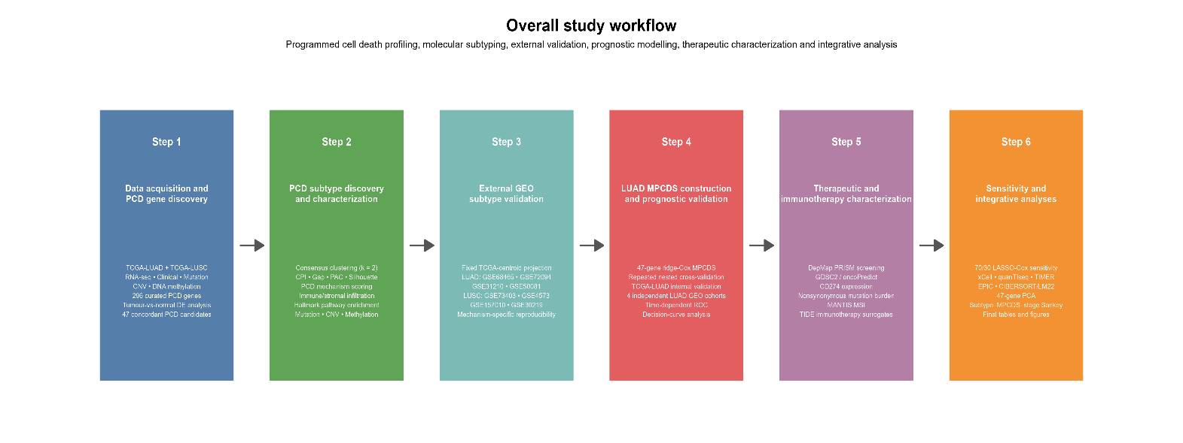
Figure 6 Overall study workflow
Caption: (A) TCGA-LUAD and TCGA-LUSC data were assembled and programmed cell death (PCD) genes were curated. (B) PCD molecular subtypes were identified and characterized in each histology. (C) The subtype patterns were projected into independent GEO cohorts for external validation. (D) A lung adenocarcinoma multigene PCD score (MPCDS) was constructed and evaluated for prognosis. (E) Pharmacogenomic and immunotherapy-related indicators were explored. (F) Sensitivity and integrative analyses assessed the consistency of the findings. Arrows indicate the order of the analytical stages; they do not represent biological causation.

3.2 DATA ACQUISITION AND PREPROCESSING

3.2.1 TCGA RNA-Sequencing Data
RNA-sequencing data for TCGA-LUAD and TCGA-LUSC were obtained from the Genomic Data Commons using the TCGAbiolinks package. Gene Expression Quantification data generated using the STAR-Counts workflow were retrieved for primary tumour and solid-tissue normal samples. Raw-count and transcript-per-million (TPM) expression matrices were generated. Raw counts were used for differential-expression analysis, while TPM values were used for clustering and other expression-based downstream analyses.
For LUAD, the final differential-expression dataset consisted of 576 samples, comprising 517 primary tumour samples and 59 solid-tissue normal samples. The LUSC dataset contained 501 primary tumour samples and 51 solid-tissue normal samples. Where multiple tumour samples were available for the same patient, one tumour profile was retained for analyses requiring independent patient-level observations.

3.2.2 Clinical and Survival Data
Clinical records for TCGA-LUAD and TCGA-LUSC were retrieved from the Genomic Data Commons (GDC) using the TCGAbiolinks R package and linked to molecular profiles through TCGA patient identifiers [30] . The retrieved information included vital status, days to death, days to last follow-up, age at diagnosis, sex and pathological stage where available. Patient identifiers were checked for duplicates before preparing the clinical datasets. Age at diagnosis was converted from days to years, when necessary, while the original clinical variables were retained for subsequent analyses [31] .
Overall survival was the primary survival endpoint. Patients recorded as dead were assigned an event status of 1, with survival time taken from days to death; patients recorded as alive were assigned an event status of 0 and censored at their recorded days to last follow-up. Patients with an unknown vital status, missing survival time or survival time of zero or less were excluded from survival analyses. Clinical records were subsequently matched to the relevant tumour-expression profiles at patient level, so the number of patients available could differ between analyses depending on the required molecular and clinical data.

3.2.3 Somatic Mutation Data
Masked Somatic Mutation files in Mutation Annotation Format (MAF) were obtained from the GDC for TCGA-LUAD and TCGA-LUSC using its aliquot-ensemble somatic-variant merging and masking workflow (NCI Genomic Data Commons, “MAF Format”; NCI Genomic Data Commons, “Aliquot Ensemble Somatic Variant Merging and Masking”) [32] . These files contain annotated somatic variant calls and undergo masking intended to limit the inclusion of potentially identifiable germline variants [33] . Mutation records were combined within each histology, and TCGA sample barcodes were used to link variants to patients and their PCD subtype assignments.
For subtype analyses, variants were restricted to primary tumour samples, records annotated as somatic and patients with a subtype assignment. Nonsynonymous variants included missense and nonsense mutations, frameshift and in-frame insertions or deletions, splice-site variants, translation-start-site variants and nonstop mutations. Identical genomic variants present in multiple primary tumour aliquots were counted once per patient. Patient-level counts and recurrent gene alterations were then compared between PCD_C1 and PCD_C2. Patients without primary-tumour mutation coverage were not classified as having zero mutations.

3.2.4 Copy-Number Variation Data
Masked Copy Number Segment files were obtained from the GDC for primary tumour samples in both TCGA cohorts (NCI Genomic Data Commons, “Copy Number Variation Analysis”). Each record describes a contiguous genomic segment and its segment mean, a log2-scale measure of copy-number change relative to a diploid reference. Segment files were linked to patient and sample identifiers before being matched to PCD subtype assignments [34] . Where more than one copy-number profile was available for a patient, the analysis preferentially retained the profile matching the selected expression sample; otherwise, it favoured the profile with the greater number of contributing probes.
Copy-number burden was calculated from autosomal segments on chromosomes 1–22. For each patient, overall burden was defined as the segment-length-weighted mean of the absolute segment means. Positive segment means were summarized separately as gain burden, and the magnitudes of negative segment means as loss burden. These continuous measures were compared between PCD_C1 and PCD_C2 using Wilcoxon tests. No fixed amplification or deletion threshold was imposed when calculating burden; thus, the measures describe the overall magnitude of segmented copy-number change rather than counts of discrete amplification or deletion events.

3.2.5 DNA Methylation Data
DNA methylation beta-value files generated on the Illumina HumanMethylation450 platform were obtained from the GDC for primary tumour samples in TCGA-LUAD and TCGA-LUSC (Bibikova et al., 2011; NCI Genomic Data Commons, “Methylation Analysis Pipeline”). A beta value represents the estimated methylation level at a CpG site on a scale from 0 to 1 [35] . The preparation scripts identified 473 LUAD and 370 LUSC methylation sample files and checked that CpG probes were consistently ordered across files. Sample-level and probe-level missingness were then assessed separately within each histology [36,37] .
CpG probes with more than 10% missing beta values were excluded, retaining 406,026 probes for LUAD. One LUSC sample was removed as a quality-control outlier because 31.99% of its original beta values were missing. Probe missingness was recalculated after its removal, leaving 369 LUSC samples and 398,357 retained probes. Remaining missing beta values were not imputed at this preparation stage. For subsequent subtype analyses, methylation samples were matched to the selected tumour-expression samples and PCD subtype assignments, so only patients with the required matched data entered those comparisons.

3.2.6 GEO External Validation Cohorts
Eight independent GEO cohorts were prepared for external validation: four LUAD cohorts (GSE68465, GSE72094, GSE31210 and the adenocarcinoma subset of GSE50081) and four LUSC cohorts (GSE73403, GSE4573, GSE157010 and the squamous subset of GSE30219). Each cohort was processed separately. Microarray probes were mapped to gene symbols using the corresponding platform annotations, historical symbols were harmonized, and multiple probes mapping to the same gene were summarized by their median expression. Expression values were transformed to the $\log{2}$ scale where required and standardized gene-wise within each cohort [38] . TCGA and GEO expression matrices were not combined.
For subtype validation, the TCGA-derived PCD_C1 and PCD_C2 expression centroids were applied to each matching histology without reclustering the GEO samples. Between 46 and 47 of the 47 subtype-defining genes were available per cohort. Samples were assigned to the centroid with the higher Pearson correlation. Projected subtype separation was assessed using silhouette widths, while PCD mechanism patterns were examined using genes excluded from the subtype projection to reduce circularity. Separately, the fixed TCGA-LUAD ridge-Cox MPCDS was evaluated in the four LUAD cohorts with available survival data. Its coefficients were retained without outcome-based refitting; cohort median score groups were used only to display Kaplan–Meier curves.

3.3 CURATION OF PROGRAMMED CELL DEATH-RELATED GENES
A programmed cell death (PCD) gene catalogue was assembled to cover apoptosis, necroptosis, pyroptosis, ferroptosis and cuproptosis. Five human gene sets were retrieved from the Molecular Signatures Database (MSigDB): REACTOME_APOPTOSIS, REACTOME_RIPK1_MEDIATED_REGULATED_NECROSIS, REACTOME_PYROPTOSIS, GOBP_FERROPTOSIS and WP_FERROPTOSIS [39] . The first three represent Reactome pathways; the ferroptosis sets come from Gene Ontology Biological Process and WikiPathways. The MSigDB release and software version used for curation were recorded so that the selected gene sets can be traced to the version used in this analysis [40] .
Because cuproptosis was not represented among those five selected sets, 12 cuproptosis-related genes were curated separately: FDX1, LIAS, LIPT1, DLD, DLAT, PDHA1, PDHB, MTF1, GLS, CDKN2A, SLC31A1 and ATP7B. This selection included genes associated with the copper-dependent cell-death mechanism and copper transport [9] . After duplicate gene symbols were removed, the catalogue contained 296 unique genes: 166 associated with apoptosis, 32 with necroptosis, 27 with pyroptosis, 89 with ferroptosis and 12 with cuproptosis. These mechanism counts overlap because a gene could belong to more than one category; the full 296-gene list should therefore accompany the thesis as a supplementary table.

3.4 DIFFERENTIAL-EXPRESSION ANALYSIS
Tumour-versus-normal differential-expression analysis was performed independently for LUAD and LUSC using DESeq2 R/Bioconductor package [41] . Technical RNA-sequencing aliquots were resolved before analysis, and one primary tumour profile per patient was retained. Genes were required to have at least 10 counts in at least 10 samples before inclusion. The DESeq2 model was specified using tumour status as the design variable, with normal tissue as the reference condition. Genes were considered significantly differentially expressed when they satisfied both:
$$FDR<0.05$$
and
$$\left|\log_{2}{FoldChange}\right| ≥1$$
Differential-expression results were extracted for the curated PCD genes. A total of 294 PCD-related genes passed expression filtering in each histological cohort. Significant genes were subsequently compared between LUAD and LUSC. Genes that were significantly altered in both histologies and exhibited the same direction of change were classified as concordant PCD candidates. This procedure identified 47 concordantly dysregulated PCD genes, which were carried forward for molecular subtyping and prognostic analysis. The names and LUAD and LUSC differential-expression results for all 294 PCD genes that passed expression filtering are provided in Supplementary Table S12 (04_results/differential_expression/TCGA_LUAD_vs_LUSC_PCD_DE_comparison.csv).

3.5 UNIVARIATE PROGNOSTIC ANALYSIS
The prognostic relevance of the 47 concordant PCD genes was initially evaluated using univariate Cox proportional-hazards regression. The analysis was conducted separately in TCGA-LUAD and TCGA-LUSC using overall survival as the endpoint. Hazard ratios, 95% confidence intervals and P-values were estimated for each candidate gene. Multiple testing was controlled using the Benjamini-Hochberg false-discovery-rate procedure. This analysis was performed to characterize the prognostic relevance of the candidate genes and was not used to redefine the original 47-gene set.

3.6 IDENTIFICATION OF PCD MOLECULAR SUBTYPES
Unsupervised consensus clustering was performed separately for TCGA-LUAD and TCGA-LUSC using the 47 concordant PCD genes [42] . Tumour-only TPM values were transformed using:
$$\log_{2}{(TPM+1)}$$
and standardized gene-wise using Z-scores. The clustering matrices contained 47 genes across 517 LUAD tumour samples and 47 genes across 501 LUSC tumour samples. Consensus clustering was performed using ConsensusClusterPlus [43] with the following settings:
- Candidate cluster numbers from $k=2 to k=8$
- 1,000 resampling iterations
- 80% sample resampling
- 100% gene retention
- Hierarchical clustering
- Pearson distance
- Average linkage
- Random seed of 12345
Cluster-number selection was assessed separately in LUAD and LUSC across candidate values of k = 2–8. The diagnostics included the consensus matrices and proportion of ambiguous clustering (PAC) from ConsensusClusterPlus, a cluster prediction index (CPI), the gap statistic and mean silhouette width. CPI was evaluated using 30 runs and five folds; the gap statistic used 100 reference datasets. These complementary criteria were examined together because they did not always favour the same cluster number.
A two-cluster solution was retained as a parsimonious choice in both histologies. CPI peaked at k = 2 in LUAD and LUSC, and mean silhouette width was also highest at k = 2 (LUAD: 0.177; LUSC: 0.235). However, PAC favoured k = 8 in both cohorts, while the gap-statistic criteria varied by histology. The modest silhouette widths indicate that the two groups were not sharply separated. The selected groups were labelled PCD_C1 and PCD_C2: LUAD contained 284 PCD_C1 and 233 PCD_C2 samples, and LUSC contained 286 PCD_C1 and 215 PCD_C2 samples (Figure 7; Supplementary Figures S1–S6).
Figure 7 Cluster-number diagnostics for TCGA-LUAD and TCGA-LUSC.
Caption: (A) Cluster numbers favoured by the cluster prediction index (CPI), minimum proportion of ambiguous clustering (PAC), global maximum and one-standard-error gap-statistic criteria, and maximum mean silhouette width. The dashed line marks the selected k = 2 solution. (B) Mean silhouette width for k = 2–8 in each histology. The diagnostic criteria did not all select k = 2; the silhouette widths show modest separation.

3.7 PCD MECHANISM SCORING
The complete 296-gene catalogue was used to characterize the biological properties of PCD_C1 and PCD_C2. For each patient, standardized expression values for genes belonging to each PCD mechanism were summarized to generate mechanism-level scores representing apoptosis, necroptosis, pyroptosis, ferroptosis and cuproptosis. Mechanism scores were compared between PCD_C1 and PCD_C2 within each histological cohort.

3.8 EXTERNAL VALIDATION OF PCD MOLECULAR SUBTYPES
The TCGA-derived PCD subtypes were evaluated in four independent LUAD and four independent LUSC GEO cohorts using fixed-centroid projection. For each histology, PCD_C1 and PCD_C2 centroids were calculated from standardized TCGA expression values for the subtype-defining genes available in the corresponding GEO cohort. Each GEO sample was assigned to the centroid with which its expression profile had the higher Pearson correlation. GEO samples were not reclustered, and survival outcomes were not used to determine subtype assignments.
External projection was assessed using the numbers assigned to each subtype and mean silhouette width. To examine biological reproducibility with reduced circularity, scores for apoptosis, necroptosis, pyroptosis, ferroptosis and cuproptosis were calculated using available PCD genes excluded from the centroid projection. Differences between projected subtypes were compared with the corresponding TCGA subtype differences for direction and statistical evidence. Subtype projection was interpreted as partial, mechanism-specific reproducibility where supported; it was not treated as proof of identical biological or prognostic behaviour across cohorts.

3.9 FUNCTIONAL ENRICHMENT ANALYSIS
Functional differences between PCD_C1 and PCD_C2 were investigated using Hallmark gene-set enrichment analysis [44] . Differential-expression statistics were ranked and analysed using the fgsea framework with Hallmark gene sets. Analyses were performed independently for LUAD and LUSC. Positive normalized enrichment scores indicated enrichment in PCD_C2, while negative values indicated enrichment in PCD_C1.
Gene sets containing between 15 and 500 genes were included. Statistical significance was defined using Benjamini-Hochberg-adjusted P-values below 0.05. The final pathway directions were compared between LUAD and LUSC to identify shared or histology-specific functional patterns.

3.10 IMMUNE AND STROMAL CHARACTERIZATION
Immune and stromal characteristics were estimated from TCGA-LUAD and TCGA-LUSC expression data using MCP-counter [45] and ESTIMATE [46] . Additional analyses assessed the consistency of immune-cell patterns using CIBERSORT with the LM22 reference[47] , xCell [48] , TIMER [49] , EPIC [50] and quanTIseq [51] . Because these methods define cell populations and report estimates differently, their results were compared for broadly corresponding immune-cell populations rather than treated as directly interchangeable measurements.
Immune-cell estimates were compared between PCD_C1 and PCD_C2 and were subsequently assessed in relation to continuous MPCDS. Findings supported by multiple methods were regarded as more robust, whereas conflicting estimates were retained as method-dependent observations.

3.11 MULTI-OMICS CHARACTERIZATION

3.11.1 Somatic Mutation Analysis
Somatic mutation analyses were conducted separately for TCGA-LUAD and TCGA-LUSC using primary tumour samples with PCD subtype assignments. The analysis retained nonsynonymous somatic variants and counted identical variants only once per patient. For each patient, the number of retained variants was compared between PCD_C1 and PCD_C2 using a Wilcoxon rank-sum test. This measure was reported as a nonsynonymous mutation count, rather than tumour mutational burden per megabase, because a callable genomic-region denominator was unavailable. For individual genes, the proportions of patients with a mutation in PCD_C1 and PCD_C2 were compared using Fisher’s exact test; gene-level P-values were adjusted using the Benjamini–Hochberg method.

3.11.2 Copy-Number Variation Analysis
Copy-number variation (CNV) analyses were conducted separately for TCGA-LUAD and TCGA-LUSC patients assigned to a PCD subtype. One primary-tumour CNV profile was selected per patient, preferentially matching the biological sample used for expression analysis. Autosomal CNV segments were used to calculate a genome-wide burden for each patient as the segment-length-weighted mean of the absolute segment values. Separate length-weighted measures captured positive values (gains) and the magnitude of negative values (losses). No fixed amplification or deletion threshold was applied. Each of the three measures was compared between PCD_C1 and PCD_C2 using a Wilcoxon rank-sum test, with Benjamini–Hochberg adjustment across the three tests within each histological cohort.

3.11.3 DNA Methylation Analysis
DNA methylation analyses were performed separately for TCGA-LUAD and TCGA-LUSC using methylation profiles from the same biological samples selected for expression analysis. Probes with more than 10% missing values in the final subtype-matched cohort were excluded; remaining missing values were not imputed. Beta values were transformed to M-values for statistical modelling. For each histology, subtype-associated methylation was assessed with limma [52] using the contrast:
$$PCD_C2-PCD_C1$$
Positive contrast values indicated higher methylation in PCD_C2 than PCD_C1. Moderated statistics were obtained using empirical-Bayes estimation, and probe-level P-values were adjusted using the Benjamini–Hochberg method. The difference between mean beta values in PCD_C2 and PCD_C1 was also calculated for each probe. A probe was classified as differentially methylated when its adjusted P-value was below 0.05 and the absolute mean beta-value difference was at least 0.10.

3.12 CONSTRUCTION OF THE MPCDS PROGNOSTIC MODEL
Prognostic modelling was performed separately in TCGA-LUAD and TCGA-LUSC using the 47 concordant PCD genes. Internal performance was estimated with 20 repetitions of nested cross-validation, each using five outer folds for evaluation and five inner folds for model selection. Within each training set, penalized Cox models spanning ridge through LASSO penalties were compared, and the selected model was evaluated on the held-out outer fold using Harrell’s C-index [53] . This procedure kept model selection within the training data for each evaluation.
Internal validation showed modest prognostic discrimination in LUAD and near-chance discrimination in LUSC; consequently, the final MPCDS was developed for LUAD only. A ridge-penalized Cox model was fitted using all 47 genes, with its penalty selected by ten-fold cross-validation in the full LUAD development cohort. All 47 genes retained non-zero coefficients. For patient j, the MPCDS was calculated as:
$${MPCDS}_{j}=\sum_{i=1}^{47}{β_{i}Z_{ij}}$$
Here $β_{i}$ is the fitted ridge-Cox coefficient for gene $i_{1}$, and $Z_{ij}$ is that gene’s expression value for patient j in the model input matrix; expression was standardized internally during model fitting. The development-cohort median MPCDS was used to define high- and low-score groups for descriptive Kaplan–Meier plots. This median was not treated as a clinically validated cutoff.

3.13 LASSO-COX SENSITIVITY ANALYSIS
A separate 70/30 train-test LASSO-Cox analysis was performed to examine the originally proposed sparse-modelling approach. The TCGA-LUAD survival cohort was randomly divided into 352 training patients and 152 held-out testing patients. LASSO-Cox regression was fitted to the 47 candidate genes using training-set standardization and cross-validation for selection of the penalty parameter. The resulting training model selected four genes: GCLC, EGLN3, DSG2 and CLSPN. The model was then evaluated without refitting in the held-out testing cohort. Because test-set prognostic performance was weak, this model was retained only as a sensitivity analysis, while the repeated nested-CV ridge model remained the primary MPCDS framework.

3.14 SURVIVAL AND PROGNOSTIC EVALUATION
The prognostic association of MPCDS was assessed using Cox proportional-hazards regression, while Kaplan–Meier curves and log-rank tests described survival differences between groups defined by the cohort median score. Harrell’s C-index measured discrimination of the continuous score. To examine whether MPCDS added information beyond clinical variables in TCGA-LUAD, a model containing age, sex and pathological stage was compared with a model containing those variables plus MPCDS. This comparison used 20 repetitions of five-fold cross-validation. Within each training fold, the ridge score and both clinical models were fitted using training data; their C-indices were then calculated in the held-out fold. High- and low-score groups were used for descriptive plots, whereas the continuous score was used for the model comparisons.

3.15 EXTERNAL VALIDATION OF MPCDS
The fixed TCGA-LUAD MPCDS was evaluated in four independent LUAD GEO cohorts: GSE68465, GSE72094, GSE31210 and the adenocarcinoma subset of GSE50081. Depending on the microarray platform, 46 or 47 of the 47 model genes were available. Expression for each available gene was standardized within its external cohort. To apply the TCGA model on this scale, each fitted TCGA coefficient was multiplied by that gene’s standard deviation in the TCGA-LUAD development cohort; the resulting fixed weights were applied to the corresponding standardized GEO expression values. Missing genes were omitted from that cohort’s score calculation. No genes or coefficients were selected or refitted using GEO survival outcomes.
The continuous MPCDS was assessed in each cohort using Harrell’s C-index and Cox proportional-hazards regression. Cohort-median high- and low-score groups were used for descriptive Kaplan–Meier plots and log-rank tests; no survival-optimized cutoff was selected. As a secondary analysis in GSE68465, a clinical model including age, sex, pT and pN was compared with the same model plus MPCDS. The primary external evaluation across all four cohorts used the continuous MPCDS, C-index and Cox regression.

3.16 TIME-DEPENDENT ROC ANALYSIS
Time-dependent receiver-operating-characteristic analysis evaluated discrimination of the continuous LUAD MPCDS at 1, 3 and 5 years in TCGA-LUAD and four independent LUAD GEO cohorts: GSE68465, GSE72094, GSE31210 and GSE50081. Time-specific areas under the curve (AUCs) and 95% confidence intervals were estimated using inverse-probability-of-censoring weighting [54] . The number of observed events and patients known to survive beyond each time point was checked in every cohort. Estimates at follow-up times with limited supporting data were interpreted cautiously.

3.17 DECISION-CURVE ANALYSIS
Decision-curve analysis was performed in TCGA-LUAD to explore the potential clinical value of adding the continuous MPCDS to a model containing conventional clinical variables. Survival-aware net benefit was calculated at 1, 3 and 5 years across threshold probabilities from 0.05 to 0.70, accounting for censoring [55] . At each time point, the clinical model and clinical-plus-MPCDS model were compared with treat-all and treat-none strategies. These were apparent estimates from the development cohort and were interpreted as exploratory; decision-curve analysis was not performed as an external validation in the GEO cohorts.

3.18 DRUG-SENSITIVITY ANALYSIS

3.18.1 GDSC/ONCOPREDICT Analysis
Drug sensitivity in TCGA-LUAD was predicted for 198 compounds using GDSC2 reference data and oncoPredict [56] . Spearman correlations assessed associations between the continuous MPCDS and predicted half-maximal inhibitory concentration (IC50) for each compound [57] . Predicted IC50 values were also compared between PCD_C1 and PCD_C2 using Wilcoxon tests. Lower predicted IC50 was interpreted as greater predicted sensitivity. P-values were adjusted using the Benjamini–Hochberg method. These estimates were computational predictions, not measured patient treatment responses.

3.18.2 Prism Pharmacogenomic Analysis
A complementary pharmacogenomic analysis used DepMap LUAD cell-line expression profiles and PRISM Repurposing Secondary Screen drug-response area-under-the-curve (AUC) values [58] . All 47 MPCDS genes were available in the LUAD cell-line expression data. Expression for each gene was standardized across the LUAD cell lines, and the fixed TCGA-derived weights for standardized expression were used to calculate MPCDS without refitting the model. For each compound with AUC measurements in at least 30 LUAD cell lines and variation in AUC, Spearman correlation tested the association between continuous MPCDS and AUC. P-values were adjusted across the tested compounds using the Benjamini–Hochberg method. Lower AUC was interpreted as greater relative sensitivity in the cell-line screen; these associations did not measure patient treatment response.

3.19 IMMUNOTHERAPY-RELATED INDICATORS

3.19.1 PD-L1 Expression
In TCGA-LUAD, PD-L1 was represented by expression of its encoding gene, CD274, in primary tumour samples. CD274 expression was analysed as $\log_{2}{(TPM + 1)}$. Its association with the continuous MPCDS was assessed using Spearman correlation, and expression was compared between PCD_C1 and PCD_C2 using a Wilcoxon rank-sum test. These expression-based analyses did not directly measure tumour PD-L1 protein levels.

3.19.2 Nonsynonymous Mutation Burden
For TCGA-LUAD patients with available mutation data, the number of nonsynonymous somatic mutations per patient was obtained from the mutation analysis described in 3.11.1. Counts were transformed as $\log_{2}{(count + 1)}$ for comparison. The association with continuous MPCDS was assessed using Spearman correlation, and values were compared between PCD_C1 and PCD_C2 using a Wilcoxon rank-sum test. Because the counts were not divided by a callable genomic-region size, they were not interpreted as clinical tumour mutational burden measured in mutations per megabase.

3.19.3 MICROSATELLITE INSTABILITY (MSI)
Microsatellite instability was assessed using MANTIS scores for 569 TCGA-LUAD cases (MSI-H, n = 3; MSS, n = 566), with a score of 0.4 or higher classified as MSI-H [59] . Of these, 514 cases matched the PCD subtype data and 501 matched the MPCDS data. Continuous MANTIS scores were evaluated in relation to subtype and MPCDS. Because only three cases were MSI-H, categorical MSI-H versus MSS comparisons were descriptive [60].

3.19.4 TIDE ANALYSIS
Tumour Immune Dysfunction and Exclusion (TIDE; https://liulab-dfci.github.io/RIMA/Response.html) scores were used as computational immunotherapy-response surrogates [61] . TIDE scores were compared between PCD_C1 and PCD_C2 using a Wilcoxon rank-sum test, while predicted responder proportions were compared using Fisher’s exact test. Associations between continuous MPCDS and TIDE scores or selected TIDE components were assessed using Spearman correlation. These computational estimates were interpreted as exploratory surrogates and did not establish actual patient response to immunotherapy.

3.20 STATISTICAL ANALYSIS
All analyses were performed in R. Continuous measurements were summarized using means and standard deviations or medians and interquartile ranges, as appropriate to the analysis. Comparisons between the two PCD subtypes generally used Wilcoxon rank-sum tests for continuous measurements and Fisher’s exact tests for categorical mutation or predicted-response frequencies. Spearman correlation was used to assess associations between continuous scores and molecular or computational measurements.
Survival was analysed using Kaplan–Meier estimation, log-rank tests and Cox proportional-hazards regression. Prognostic discrimination was assessed using Harrell’s C-index and, where specified, time-dependent areas under the curve. The relevant results sections report the cohort and sample size for each analysis. When multiple genes, probes, pathways, immune populations or compounds were tested, P-values were adjusted using the Benjamini–Hochberg method as specified for that analysis; unadjusted P-values were retained for analyses without such a correction.

3.21 DATA VISUALIZATION
Results were visualized using heatmaps, consensus-clustering plots, principal-component analysis, Kaplan-Meier curves, Cox coefficient plots, pathway-enrichment plots, immune-infiltration plots, multi-omics summaries, time-dependent ROC curves, decision curves and Sankey/alluvial diagrams. PCA and Sankey visualizations were produced as supplementary integrative analyses.

CHAPTER 4: RESULTS

4.1 OVERVIEW OF THE ANALYTICAL COHORTS
The study evaluated programmed cell death-related molecular patterns independently in lung adenocarcinoma (LUAD) and lung squamous cell carcinoma (LUSC). For tumour-versus-normal differential-expression analysis, the TCGA-LUAD cohort contained 517 primary tumour samples and 59 normal lung samples, while TCGA-LUSC contained 501 primary tumour samples and 51 normal samples.
A catalogue of 296 genes representing apoptosis, necroptosis, pyroptosis, ferroptosis and cuproptosis was curated for downstream analysis. PCD subtypes were projected into eight independent GEO cohorts: four LUAD cohorts (GSE68465, GSE72094, GSE31210 and the adenocarcinoma subset of GSE50081) and four LUSC cohorts (GSE73403, GSE4573, GSE157010 and the squamous-cell subset of GSE30219). The four LUAD cohorts were also used to externally evaluate the LUAD MPCDS. Cohort-specific sample numbers and subtype projection results are presented in 4.6.

4.2 IDENTIFICATION OF CONCORDANTLY DYSREGULATED PCD-RELATED GENES
Differential-expression analysis was performed independently in LUAD and LUSC. Of the 294 PCD-related genes that passed expression filtering, 57 were significantly differentially expressed in LUAD. Of these, 36 were upregulated and 21 were downregulated in tumour tissue relative to normal lung tissue. In LUSC, 95 PCD-related genes were significantly differentially expressed, comprising 61 upregulated and 34 downregulated genes. Comparison of the two histological cohorts identified 47 genes that were significantly dysregulated in both LUAD and LUSC and changed in the same direction. Of these concordant genes, 31 were consistently upregulated and 16 were consistently downregulated.
Three genes showed significant but opposite expression directions between LUAD and LUSC and were therefore excluded from the concordant candidate set. Seven significant PCD genes were specific to LUAD, whereas 45 were specific to LUSC. The resulting 47 concordantly dysregulated genes were retained as the principal PCD candidate set for subsequent subtype identification and prognostic analyses.

4.3 PROGNOSTIC CHARACTERISTICS OF THE 47 CANDIDATE PCD GENES
The prognostic relevance of the 47 concordantly dysregulated PCD genes was assessed independently in LUAD and LUSC using univariate Cox regression. The survival associations differed substantially between the two histological groups. In LUAD, nine genes remained significantly associated with overall survival after false discovery-rate correction. In contrast, none of the 47 candidate genes remained significant after multiple-testing correction in LUSC.
These results indicated that shared tumour-associated differential expression did not necessarily translate into shared prognostic relevance across LUAD and LUSC. This histology-dependent difference provided further justification for analyzing prognostic effects separately rather than developing a single combined NSCLC prognostic model.

4.4 IDENTIFICATION OF PCD MOLECULAR SUBTYPES
Consensus clustering of the 47 candidate PCD genes identified two molecular clusters independently in both LUAD and LUSC. In LUAD, 284 patients were assigned to PCD_C1 and 233 to PCD_C2. In LUSC, 286 patients were assigned to PCD_C1 and 215 to PCD_C2.

The two-cluster solution demonstrated better stability than the competing higher-order solutions according to the consensus and silhouette assessments. The 47-gene expression heatmaps showed distinct expression patterns between PCD_C1 and PCD_C2 in both histologies (Figure 8C,D; Supplementary Figures S13 and S14). Importantly, the biological meaning of PCD_C1 and PCD_C2 was not assumed to be identical between LUAD and LUSC because the mechanism-level PCD patterns differed between the two types of cancer.
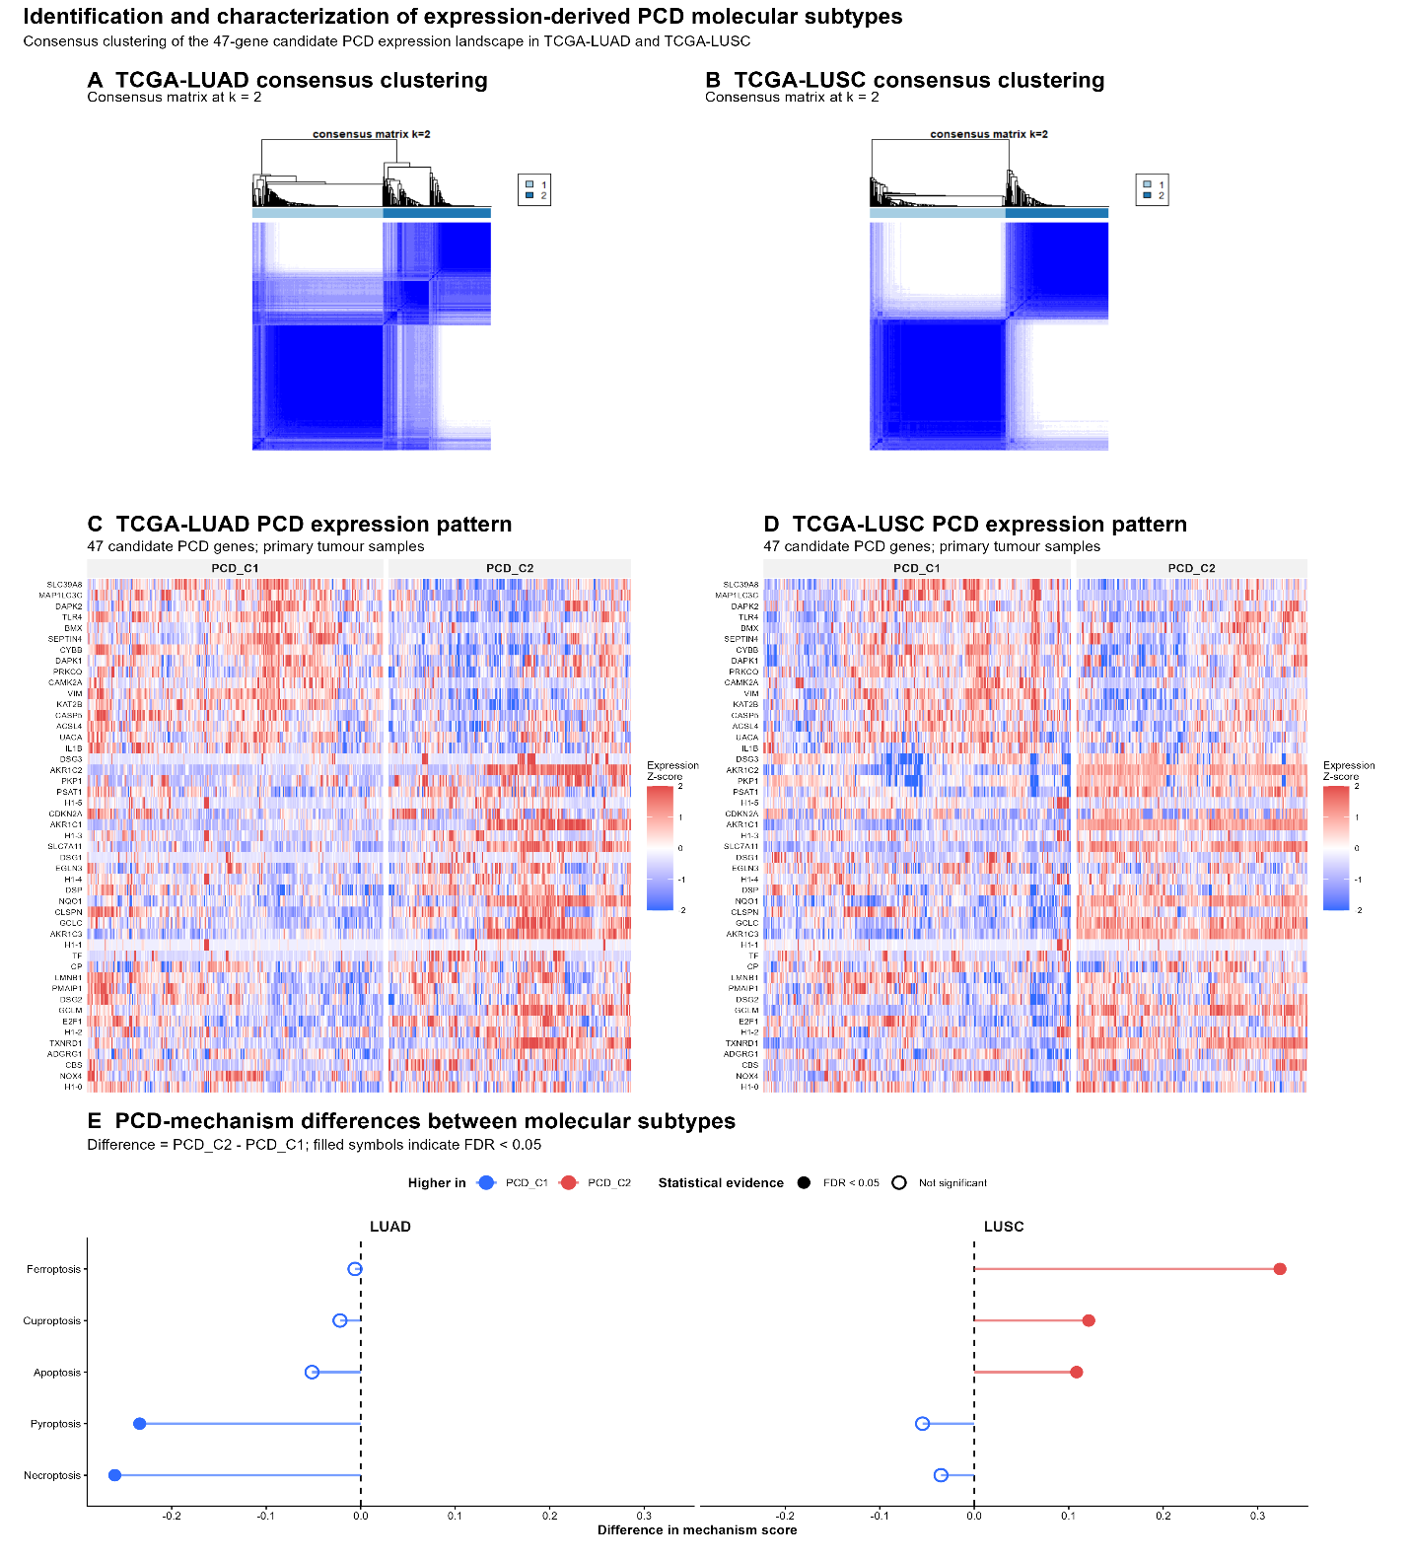
Figure 8 Identification of PCD molecular subtypes in TCGA-LUAD and TCGA-LUSC.
Caption: (A) LUAD two-cluster consensus matrix. (B) LUSC two-cluster consensus matrix. (C) Expression of the 47 concordant PCD genes across LUAD subtypes. (D) Expression of the same genes across LUSC subtypes. (E) Differences in the five PCD mechanism scores between subtypes. PCD_C1 and PCD_C2 were assigned independently in LUAD and LUSC.

4.5 PCD MECHANISM PROFILES OF THE MOLECULAR SUBTYPES
The five PCD mechanism scores showed histology-dependent differences between PCD_C1 and PCD_C2. In LUAD, PCD_C1 demonstrated relatively greater necroptosis and pyroptosis activity. In contrast, LUSC PCD_C2 showed higher ferroptosis, apoptosis and cuproptosis scores (Figure 8E; Supplementary Figure S16).
These differences indicate that although both LUAD and LUSC were optimally represented by two expression-derived PCD clusters, the specific PCD mechanisms underlying the cluster structure differed between the two histological groups. Accordingly, PCD_C1 and PCD_C2 were retained as neutral labels rather than interpreted as identical biological states across LUAD and LUSC.

4.6 EXTERNAL VALIDATION OF THE PCD SUBTYPES
The subtype structures derived independently in TCGA-LUSC and TCGA-LUAD were projected using fixed TCGA centroids into four external GEO cohorts for each histology. In total, 516 LUSC and 1,239 LUAD samples were evaluated. Depending on the dataset, 46 or all 47 candidate genes were available for projection. Table 1 reports the assigned subtype sizes, mean silhouette widths and agreement of the five PCD mechanism differences with the corresponding TCGA cohort. Figure 9 displays the projected subtype composition and silhouette width for all eight cohorts.

4.6.1 External Validation in Four LUSC Cohorts
In GSE73403, 46 of the 47 candidate genes were available. Of 69 samples, 32 were assigned to PCD_C1 and 37 to PCD_C2. The mean silhouette width was 0.104, indicating weak geometric separation. All five PCD mechanism differences agreed in direction with TCGA-LUSC, although ferroptosis alone met the false-discovery-rate criterion in both datasets. The projected groups did not differ significantly in overall survival (log-rank P ≈ 0.549); the stage-adjusted hazard ratio for PCD_C2 relative to PCD_C1 was approximately 0.835 (P = 0.648).
The additional LUSC cohorts were GSE4573 (n = 130), GSE157010 (n = 235) and GSE30219 (n = 82). Their mean silhouette widths were 0.116, 0.119 and 0.100, respectively. All five mechanism differences agreed in direction with TCGA-LUSC in GSE4573 and GSE157010, while three of five agreed in GSE30219. Ferroptosis showed directionally concordant differences meeting the false-discovery-rate criterion in all four external LUSC cohorts. Apoptosis also met that criterion in GSE157010 and GSE30219. Thus, ferroptosis provided the most consistent mechanism-level result, despite modest separation between projected subtypes. The GSE73403 survival result should not be interpreted as a survival analysis of all four LUSC cohorts.

4.6.2 External Validation in Four LUAD Cohorts
In GSE68465, 46 of the 47 candidate genes were available. Of 443 expression-profiled samples, 256 were projected as PCD_C1 and 187 as PCD_C2; 442 had matched survival information. The mean silhouette width was 0.091, indicating modest separation. Three of five mechanism differences agreed in direction with TCGA-LUAD. Necroptosis and pyroptosis differences both agreed in direction and met the false-discovery-rate criterion in the external cohort. The projected subtype survival difference was not strongly significant, so these results were interpreted primarily as evidence of partial biological reproducibility rather than independent prognostic validation.
The additional LUAD cohorts were GSE72094 (n = 442), GSE31210 (n = 226) and GSE50081 (n = 128). Their mean silhouette widths were 0.102, 0.081 and 0.083, respectively. In GSE72094, four of five mechanism differences agreed in direction with TCGA-LUAD, and necroptosis and pyroptosis again met the false-discovery-rate criterion. Directional agreement was weaker in GSE31210 (one of five mechanisms) and GSE50081 (three of five); neither cohort showed a mechanism meeting the strict replication criterion. Across the four LUAD cohorts, necroptosis and pyroptosis each met that criterion in two cohorts. The evidence therefore supports partial, cohort-dependent reproducibility of LUAD PCD subtype characteristics.

Histology | GEO cohort | Samples | Genes available | PCD_C1 | PCD_C2 | Mean silhouette | Mechanisms agreeing in direction | Mechanisms meeting strict FDR replication
LUSC | GSE73403 | 69 | 46/47 | 32 | 37 | 0.104 | 5/5 | Ferroptosis
LUSC | GSE4573 | 130 | 46/47 | 66 | 64 | 0.116 | 5/5 | Ferroptosis
LUSC | GSE157010 | 235 | 47/47 | 125 | 110 | 0.119 | 5/5 | Apoptosis; ferroptosis
LUSC | GSE30219 | 82 | 47/47 | 44 | 38 | 0.100 | 3/5 | Apoptosis; ferroptosis
LUAD | GSE68465 | 443 | 46/47 | 256 | 187 | 0.091 | 3/5 | Necroptosis; pyroptosis
LUAD | GSE72094 | 442 | 46/47 | 248 | 194 | 0.102 | 4/5 | Necroptosis; pyroptosis
LUAD | GSE31210 | 226 | 47/47 | 125 | 101 | 0.081 | 1/5 | None
LUAD | GSE50081 | 128 | 47/47 | 74 | 54 | 0.083 | 3/5 | None
Table 1 External projection of TCGA-derived PCD subtypes across eight independent GEO cohorts. The table reports cohort size, projected subtype assignments, mean silhouette width and agreement of PCD mechanism differences with the corresponding TCGA cohort. Strict FDR replication indicates agreement in direction and statistical significance after false-discovery-rate correction in both datasets.
Figure 9 External projection of PCD molecular subtypes across eight GEO cohorts
Caption: External projection of PCD molecular subtypes across eight GEO cohorts. (A) Mean silhouette width following projection of the TCGA-derived subtype structure into four LUAD and four LUSC datasets. (B) Numbers assigned to PCD_C1 and PCD_C2 in each external cohort. These panels summarize subtype projection and composition; they do not display cohort-specific survival estimates. GEO accessions are labelled on the figure.

4.7 IMMUNE AND STROMAL CHARACTERISTICS OF PCD_C1 AND PCD_C2
The tumour microenvironment differed substantially between the PCD molecular subtypes. Across the principal immune and stromal analyses, PCD_C1 consistently demonstrated greater immune and stromal abundance than PCD_C2. Using MCP-counter, seven robust immune or stromal populations showed greater abundance in PCD_C1. ESTIMATE-derived immune and stromal metrics showed the same overall pattern.
Additional analyses using CIBERSORT, xCell, TIMER-family methods, EPIC and quanTIseq further supported several subtype-associated immune differences. Signals reproduced across multiple methods included differences involving B-cell populations, plasma cells, CD4 T-cell populations, macrophages, M2 macrophages and neutrophils. Some populations, including selected CD8 T-cell, monocyte and dendritic-cell estimates, showed method-dependent directions and were therefore not interpreted as uniformly reproducible. Overall, these findings indicated that PCD_C1 was associated with a more immune- and stromal-enriched tumour microenvironment (Supplementary Figures S11 and S12).

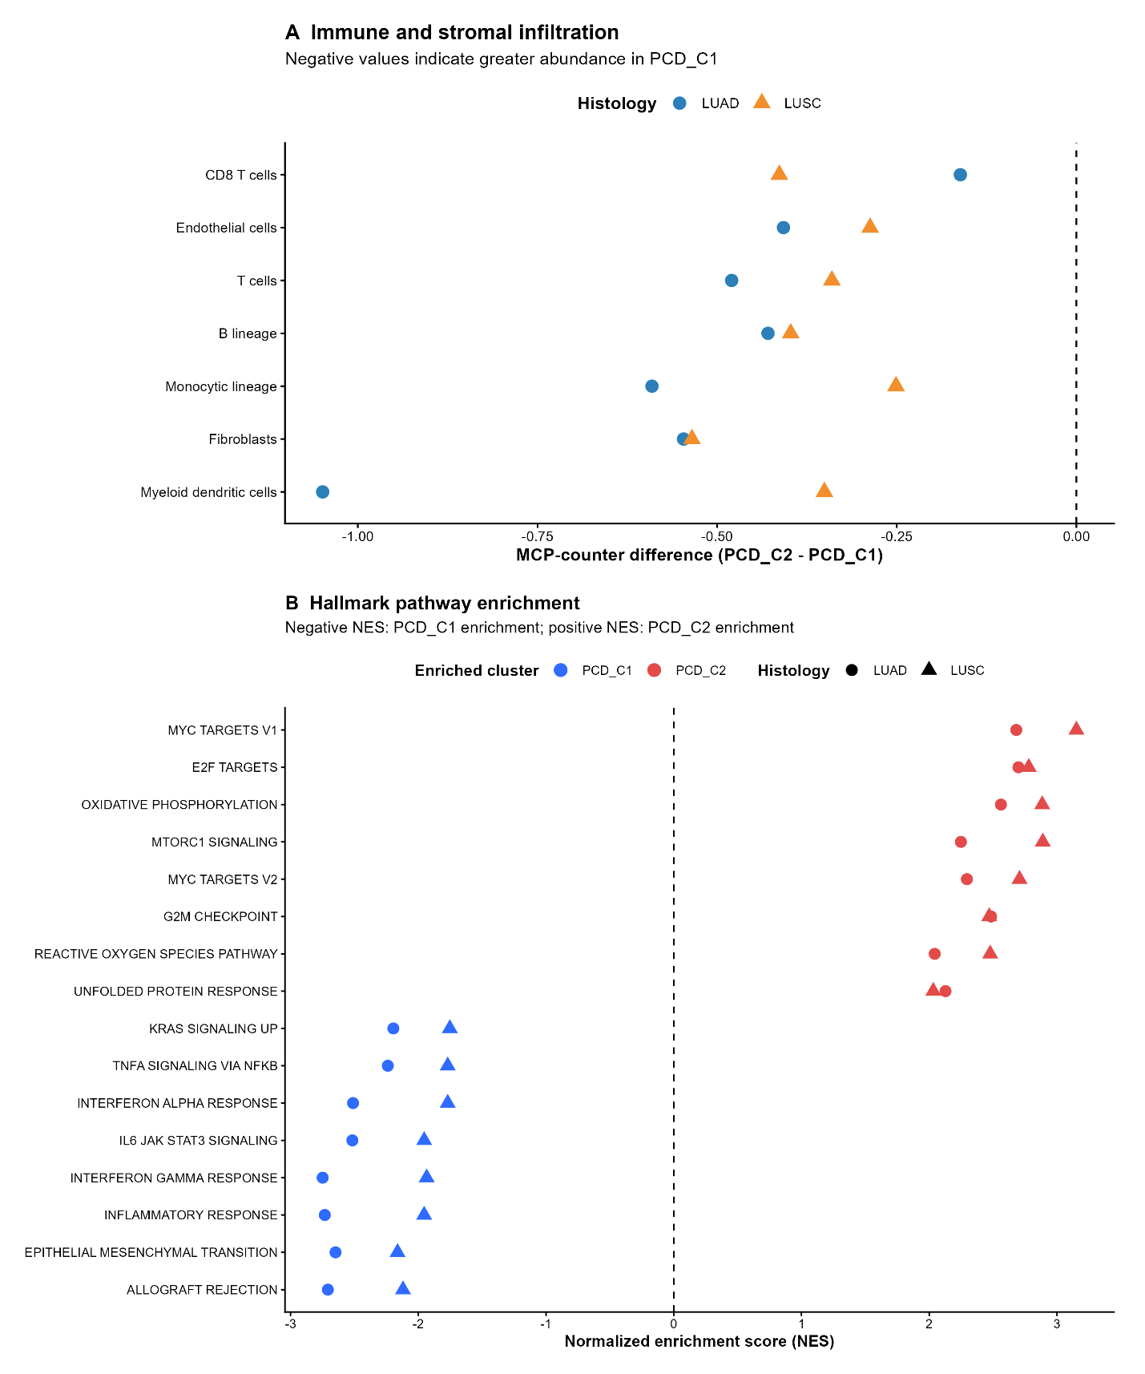
Figure 10 Immune and functional characterization of PCD molecular subtypes
Caption: Immune, stromal and functional differences between PCD subtypes in TCGA-LUAD and TCGA-LUSC. (A) Differences in selected MCP-counter cell-population scores, calculated as PCD_C2 minus PCD_C1; negative values indicate greater estimated abundance in PCD_C1. Circles represent LUAD and triangles represent LUSC. (B) Normalized enrichment scores for selected Hallmark pathways. Negative scores indicate enrichment toward PCD_C1, while positive scores indicate enrichment toward PCD_C2. Circles represent LUAD and triangles represent LUSC.

4.8 FUNCTIONAL PATHWAY DIFFERENCES BETWEEN PCD SUBTYPES
Hallmark gene-set enrichment analysis demonstrated broad functional differences between PCD_C1 and PCD_C2. Among pathways showing robust cross-histology patterns, 15 were enriched toward PCD_C1 and 20 toward PCD_C2. PCD_C1 was predominantly characterized by immune, inflammatory and stromal programmes.
In contrast, PCD_C2 showed stronger enrichment of proliferative and metabolic programmes, including MYC-related signaling, E2F targets, oxidative phosphorylation, mTORC1 signaling and cell-cycle-associated pathways (Figure 10B; Supplementary Figure S15). These results suggested that the PCD-derived molecular subtypes reflected broader tumour-biological states beyond cell-death pathway expression alone.

4.9 MULTI-OMICS CHARACTERIZATION OF THE PCD SUBTYPES

4.9.1 Nonsynonymous Mutation Burden
Nonsynonymous mutation burden differed significantly between PCD_C1 and PCD_C2 in LUAD. PCD_C2 showed a higher mutation burden than PCD_C1, with a P-value of approximately $1.3×{10}^{-6}$. In LUSC, however, the corresponding subtype difference was not statistically significant, with P approximately 0.20 (Figure 11A).

4.9.2 $KEAP1$ Mutation Frequency
A recurrent cross-histology genomic feature was enrichment of $KEAP1$ mutation in PCD_C2. This pattern was observed in both LUAD and LUSC, supporting a reproducible association between KEAP1 alteration and the PCD_C2 transcriptional state (Figure 11B). The result was interpreted as an association rather than evidence that KEAP1 mutation directly caused the PCD_C2 phenotype.

4.9.3 Copy-Number Alteration Burden
PCD_C2 demonstrated a greater absolute copy-number alteration burden in both LUAD and LUSC (Figure 11C). This reproducibility across histologies suggested that the expression-derived PCD_C2 phenotype was associated with greater genomic structural alteration.

4.9.4 DNA Methylation Differences
DNA methylation analysis identified 2,056 CpG probes that were significantly differentially methylated between PCD_C1 and PCD_C2 in both LUAD and LUSC. Of these, 1,570 showed concordant direction of methylation change across the two histological cohorts. The majority of concordant sites, 1,408 probes, were relatively hypomethylated in PCD_C2 (Figure 11D; Supplementary Figure S17). Together, the mutation, CNV and methylation findings demonstrated that the expression-derived PCD subtypes were accompanied by broader genomic and epigenomic differences.
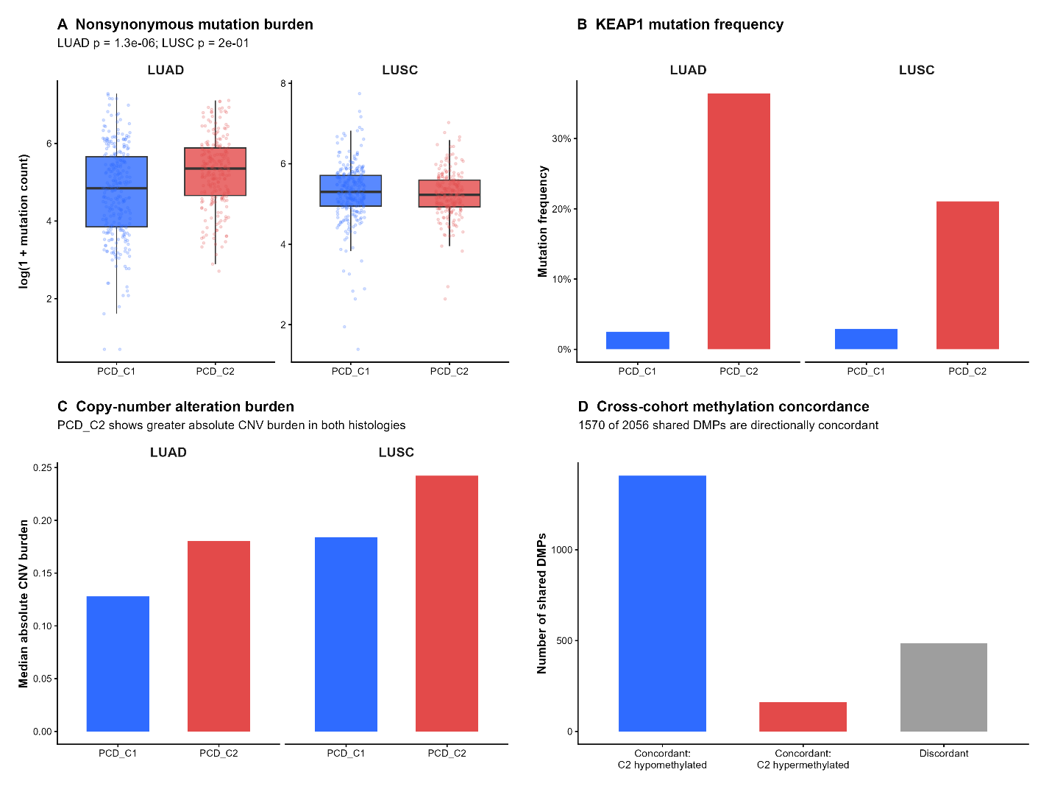
Figure 11 Multi-omics characteristics of PCD subtypes in TCGA-LUAD and TCGA-LUSC
Caption: (A) Patient-level nonsynonymous mutation counts, displayed on a log(1 + count) scale, by subtype in each histology. (B) Percentage of patients with a KEAP1 mutation in PCD_C1 and PCD_C2. (C) Median absolute, segment-length-weighted copy-number alteration burden by subtype and histology. (D) Numbers of CpG probes differentially methylated in both histologies, grouped by whether the direction of methylation change in PCD_C2 agreed across LUAD and LUSC. Of 2,056 shared probes, 1,570 were directionally concordant, including 1,408 that were relatively hypomethylated in PCD_C2.

4.10 DEVELOPMENT AND INTERNAL VALIDATION OF THE MPCDS
The prognostic utility of the 47-gene PCD expression programme was evaluated independently in LUAD and LUSC using repeated nested cross-validation. In LUAD, the mean cross-validated C-index was 0.604. The corresponding LUSC value was 0.505, indicating approximately chance-level prognostic discrimination. Because no reproducible prognostic signal was identified in LUSC, no LUSC MPCDS was advanced.
The final prognostic model was therefore restricted to LUAD and was constructed using ridge-penalized Cox regression. All 47 candidate genes retained non-zero coefficients in the final ridge model (Figure 12B; Supplementary Figure S18). Using the TCGA-LUAD development-cohort median for descriptive visualization, 252 patients were classified as low MPCDS and 252 as high MPCDS. The high-MPCDS group had significantly poorer overall survival than the low-MPCDS group, with a log-rank P-value of $1.82×{10}^{-7}$ and a high-versus-low hazard ratio of approximately 2.20.
When evaluated continuously in a stage-stratified Cox model, each one-standard-deviation increase in MPCDS was associated with an HR of $1.71 (95\% CI: 1.45-2.01)$. Adding MPCDS to clinical variables increased the mean internal C-index from approximately 0.664 to 0.675, representing a mean improvement of 0.011. The improvement was positive in 18 of 20 repeated validation runs.
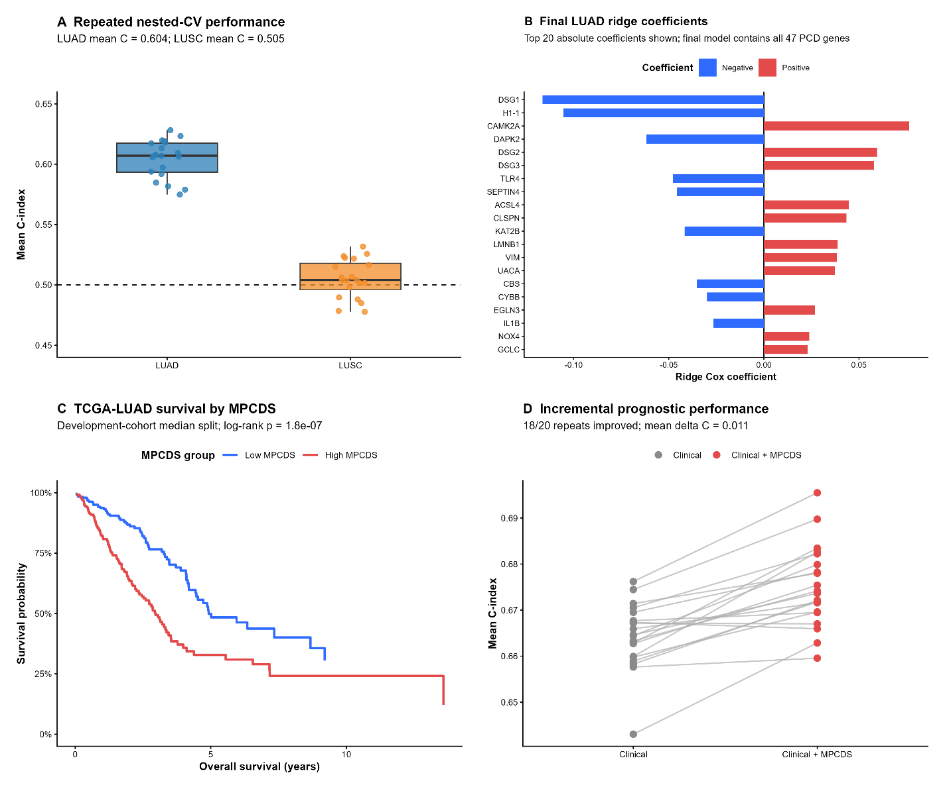
Figure 12 Development and internal validation of the LUAD programmed cell death score (MPCDS).
Caption: (A) Distribution of mean held-out C-indices across 20 repeated nested cross-validation runs in LUAD and LUSC; the dashed line marks chance-level discrimination (C-index = 0.5). (B) The 20 largest absolute ridge-Cox coefficients in the final LUAD model; all 47 candidate genes were retained. (C) Kaplan–Meier overall-survival curves for TCGA-LUAD patients divided at the development-cohort median MPCDS for descriptive display. (D) C-index of the clinical model and clinical model plus MPCDS across 20 repeated validation runs. Adding MPCDS improved the C-index in 18 of 20 runs, with a mean difference of 0.011.

4.11 LASSO-COX SENSITIVITY ANALYSIS
A proposal-aligned 70/30 train-test LASSO-Cox analysis was conducted as a sensitivity analysis. The model selected four genes:
- GCLC, EGLN3, DSG2 and CLSPN.
The training C-index was approximately 0.657. However, prognostic performance in the held-out testing cohort was weak, with a C-index of approximately 0.524. The continuous Cox association in the test cohort was not statistically significant, and the high-versus-low risk comparison showed essentially no separation. The time-dependent AUC values were also close to chance levels. These findings demonstrated limited generalization of the sparse single-split LASSO model and supported retention of the repeated nested-CV ridge MPCDS as the primary prognostic framework.
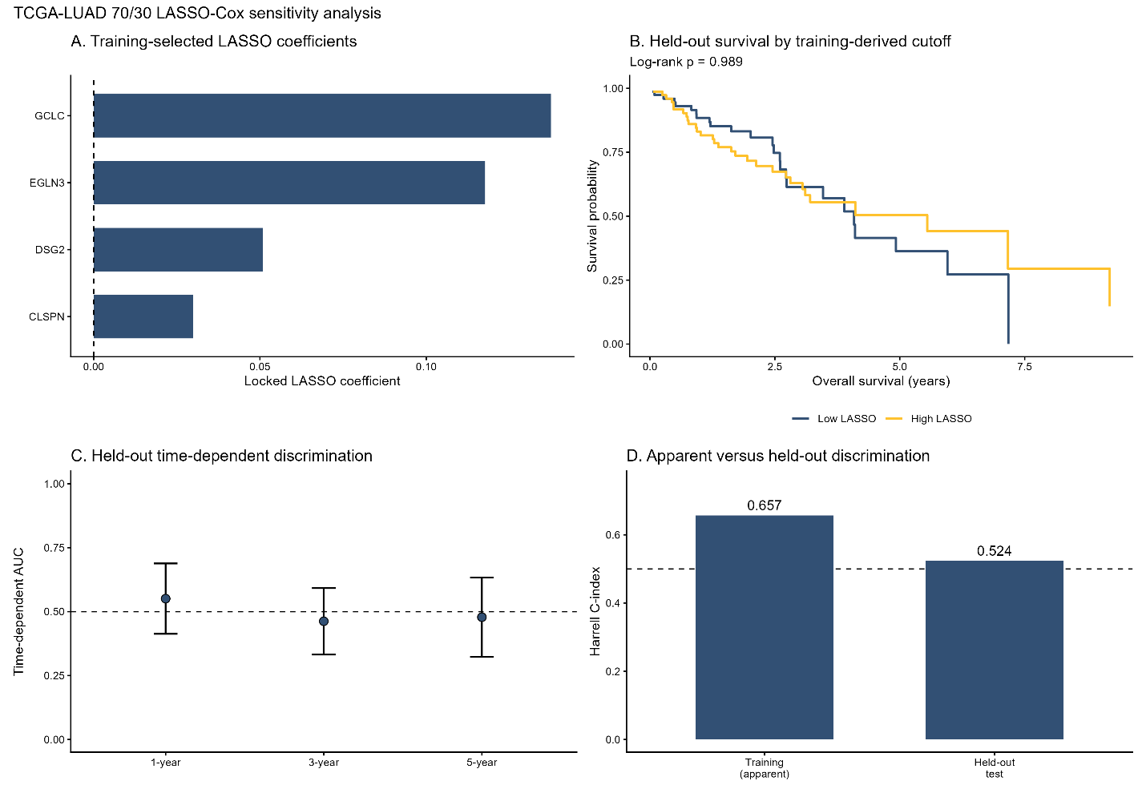
Figure 13 Sensitivity analysis using a 70/30 LUAD training and held-out split with LASSO-Cox regression
Caption: Seventy/thirty training and held-out test sensitivity analysis of a LUAD LASSO-Cox model. (A) Coefficients of the four genes selected in the training set: GCLC, EGLN3, DSG2 and CLSPN. (B) Overall survival in the held-out test set using the risk-group cutoff determined from training data; the groups showed little separation. (C) Held-out time-dependent AUC estimates at 1, 3 and 5 years, with confidence intervals. (D) Apparent training and held-out test C-indices of 0.657 and 0.524, respectively. The held-out results indicate limited generalization of this sparse sensitivity model.

4.12 EXTERNAL VALIDATION OF MPCDS IN FOUR GEO COHORTS
The fixed TCGA-LUAD ridge-model coefficients were applied to GSE68465, GSE72094, GSE31210 and GSE50081 without refitting the score using external survival outcomes. In total, 1,194 patients with overall-survival data and 436 deaths were evaluated. Forty-six of the 47 model genes were available in GSE68465 and GSE72094, while all 47 were available in GSE31210 and GSE50081. Higher continuous MPCDS was associated with greater mortality risk in the same direction in all four cohorts; the association was statistically significant in three.
In GSE68465, 442 patients with survival data were analysed. MPCDS achieved a C-index of 0.597 (95% CI: 0.558–0.636), and the hazard ratio per one-standard-deviation increase was 1.23 (95% CI: 1.08–1.40; P = 0.002). Using the cohort median for descriptive Kaplan–Meier plots, the high-MPCDS group had shorter median overall survival than the low-MPCDS group (47.0 versus 75.7 months; log-rank P = 0.007). Among 439 patients with the clinical variables required for adjustment, the adjusted hazard ratio per one-standard-deviation increase was 1.17 (95% CI: 1.02–1.35; P = 0.023). Adding MPCDS increased the clinical-model C-index from 0.700 to 0.715, a difference of 0.015. Proportional-hazards diagnostics indicated that the MPCDS association varied with follow-up time in this cohort.
In GSE72094, MPCDS was evaluated in 398 patients with survival information and achieved a C-index of 0.702 (95% CI: 0.653–0.750); the continuous hazard ratio per one-standard-deviation increase was 1.85 (95% CI: 1.56–2.21; P < 0.001). In GSE31210, the corresponding C-index was 0.579 (95% CI: 0.487–0.671) among 226 patients, and the continuous association did not reach statistical significance (hazard ratio 1.33, 95% CI: 0.97–1.84; P = 0.081). In GSE50081, the C-index was 0.594 (95% CI: 0.506–0.681) among 128 patients, with a hazard ratio of 1.38 (95% CI: 1.07–1.79; P = 0.014). Thus, the adverse-risk direction was consistent, but the strength and precision of discrimination varied across cohorts. The clinical-adjusted model comparison was performed in GSE68465 and is not presented as a result for the other three cohorts.
Figure 14 External prognostic evaluation of the LUAD MPCDS in four GEO cohorts.
Caption: (A–D) Kaplan–Meier overall-survival curves for GSE68465, GSE72094, GSE31210 and GSE50081, respectively. (E) Cohort-specific hazard ratios with 95% confidence intervals for a one-standard-deviation increase in continuous MPCDS. (F) Clinical-model C-index with and without MPCDS in GSE68465. (G) Time-varying adjusted MPCDS hazard ratios in GSE68465. Panels F and G apply only to GSE68465.

4.13 TIME-DEPENDENT ROC PERFORMANCE
Time-dependent ROC analysis assessed discrimination by the continuous LUAD MPCDS at 1, 3 and 5 years in TCGA-LUAD and four independent GEO cohorts. The AUC estimates varied across cohorts and follow-up times (Table 2; Figure 15; Supplementary Figures S7–S10). In TCGA-LUAD, AUC was approximately 0.705 at 1 year, 0.709 at 3 years and 0.649 at 5 years. Among the external cohorts, GSE72094 had the highest estimated AUCs at 1 and 3 years, whereas the 3-year estimates in GSE31210 and GSE50081 were close to 0.5. These differences indicate that the score’s time-specific discrimination was not uniform across datasets.
The GSE72094 5-year AUC of 0.721 requires particular caution: only five patients were known to survive beyond five years, and its 95% confidence interval was wide (0.409–1.000). The ROC results describe discrimination at specified time points; they do not establish clinical usefulness or patient treatment benefit.

Cohort | 1-year AUC (95% CI) | 3-year AUC (95% CI) | 5-year AUC (95% CI)
TCGA-LUAD | 0.705 (0.636–0.775) | 0.709 (0.645–0.773) | 0.649 (0.567–0.732)
GSE68465 | 0.645 (0.571–0.720) | 0.637 (0.582–0.694) | 0.586 (0.526–0.645)
GSE72094 | 0.731 (0.658–0.805) | 0.732 (0.651–0.814) | 0.721 (0.409–1.000)
GSE31210 | 0.725 (0.548–0.903) | 0.551 (0.427–0.674) | 0.589 (0.474–0.704)
GSE50081 | 0.579 (0.380–0.777) | 0.575 (0.450–0.699) | 0.619 (0.508–0.730)
Table 2 Time-dependent AUC estimates and 95% confidence intervals for the continuous LUAD MPCDS at 1, 3 and 5 years in TCGA-LUAD and four external GEO cohorts.
Figure 15 Time-dependent ROC performance of the LUAD MPCDS in TCGA-LUAD and four GEO cohorts.
Caption: (A) TCGA-LUAD; (B) GSE68465; (C) GSE72094; (D) GSE31210; and (E) GSE50081. Curves and legends show discrimination and AUC at 1, 3 and 5 years. (F) External-cohort AUC estimates and pointwise 95% confidence intervals at each time point. The GSE72094 5-year estimate has limited follow-up support and should be interpreted cautiously.

4.14 DECISION-CURVE ANALYSIS
Decision-curve analysis compared a clinical model with the same model plus continuous MPCDS in 475 TCGA-LUAD patients. Net benefit was assessed for predicted mortality at 1, 3 and 5 years across threshold probabilities of 0.05–0.70. Adding MPCDS produced higher estimated net benefit than the clinical model at many evaluated thresholds at 1 and 3 years; the difference was less consistent at 5 years, when censoring was more substantial. These are apparent development-cohort estimates. They do not establish that using MPCDS improves clinical decisions in an external population.
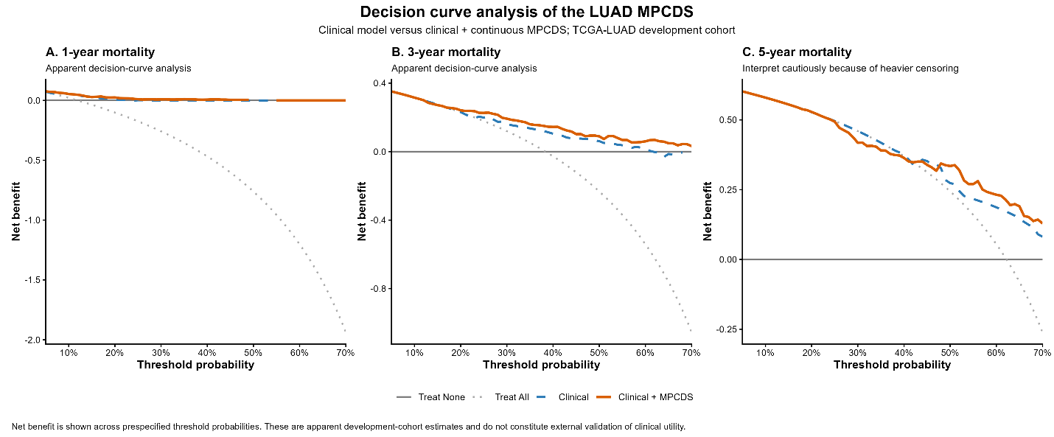
Figure 16 Decision-curve analysis of the LUAD MPCDS in the TCGA-LUAD development cohort.
Caption: Net benefit is shown across threshold probabilities for predicting mortality at (A) 1 year, (B) 3 years and (C) 5 years. The curves compare the clinical model, clinical model plus continuous MPCDS, treat-all and treat-none strategies. Results are apparent estimates; the 5-year panel should be interpreted cautiously because of greater censoring.

4.15 PREDICTED DRUG SENSITIVITY USING GDSC2/ONCOPREDICT
Predicted IC50 values for 198 GDSC2 compounds were generated for TCGA-LUAD using oncoPredict. Among the 198 compounds, 110 showed statistically significant associations with continuous MPCDS after Benjamini-Hochberg correction. Of these, 59 associations indicated greater predicted sensitivity with increasing MPCDS, while 51 indicated greater predicted resistance.
Subtype-associated predicted drug sensitivity was also observed. A total of 104 of the 198 compounds differed significantly between PCD_C1 and PCD_C2 after FDR correction. Among these, 38 showed lower predicted IC50 values in PCD_C2, indicating greater predicted sensitivity, whereas 66 showed higher IC50 values, indicating greater predicted resistance. These findings represented transcriptome-derived drug-sensitivity predictions and were therefore interpreted as hypothesis-generating rather than direct evidence of clinical therapeutic response. For the 72 drugs that could be matched and tested across GDSC2 and PRISM, association directions agreed for 37 and disagreed for 35; the cross-platform correlation was weak ($Spearman ρ = -0.09, P = 0.45$).

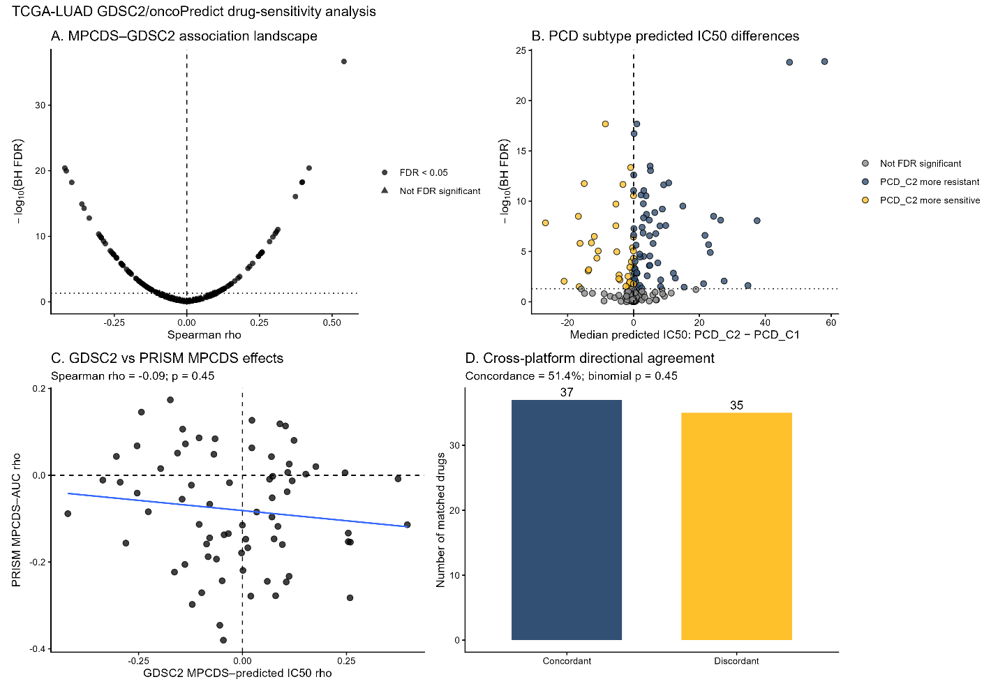
Figure 17 Predicted drug-sensitivity associations in TCGA-LUAD and comparison with PRISM cell-line data.
Caption: (A) Spearman correlations between continuous MPCDS and GDSC2/oncoPredict-predicted IC50 across 198 compounds. (B) Median predicted IC50 differences between PCD_C2 and PCD_C1; negative values indicate lower predicted IC50 in PCD_C2. (C) MPCDS–drug association estimates for agents matched between GDSC2 and PRISM. (D) Numbers of matched drugs with concordant and discordant association directions. Predicted IC50 and cell-line PRISM measurements do not represent observed treatment responses in patients.

4.16 PRISM PHARMACOGENOMIC ANALYSIS
The fixed LUAD MPCDS was additionally projected into DepMap LUAD cell lines and compared with PRISM Repurposing Secondary drug-response data. Fifty LUAD cell lines had complete expression and pharmacogenomic information. A total of 1,440 compounds were tested for association with MPCDS. Of these, 121 compounds showed nominal P-values below 0.05, 29 showed P-values below 0.01, and five showed P-values below 0.001 (Figure 18A; Supplementary Figure S19).
However, none remained statistically significant after Benjamini-Hochberg correction. The minimum FDR was approximately 0.189 (Figure 18D; Supplementary Figure S20). The strongest nominal negative correlations included warfarin, TG-101209, fluorometholone, ciclosporin and olverembatinib, but these signals were not considered validated therapeutic associations. Comparison of overlapping GDSC and PRISM drugs also demonstrated limited cross-platform agreement. The PRISM results were therefore interpreted as exploratory pharmacogenomic signals only.
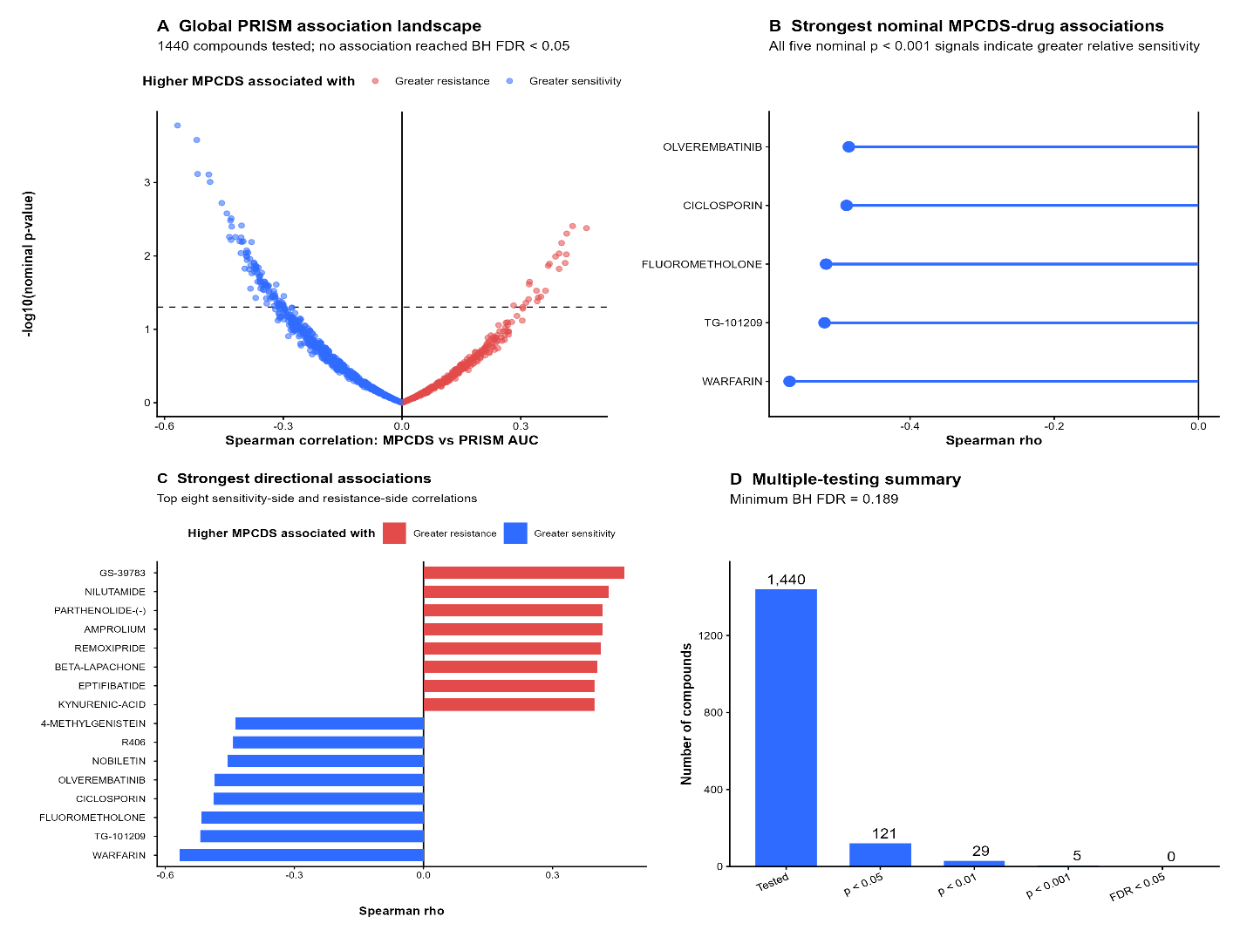
Figure 18 Associations between LUAD MPCDS and PRISM drug-response measurements in DepMap cell lines.
Caption: (A) Spearman correlations between continuous MPCDS and PRISM drug-response AUC across 1,440 tested compounds; negative correlations indicate greater relative sensitivity with higher MPCDS. (B) The five strongest nominal associations in the sensitivity direction. (C) Compounds with the largest negative and positive correlations, shown to illustrate both directions of association. (D) Numbers of compounds tested and meeting successive nominal P-value thresholds; none met the Benjamini–Hochberg FDR threshold of 0.05. These cell-line findings are exploratory and do not demonstrate treatment benefit in patients.

4.17 IMMUNOTHERAPY-RELATED BIOMARKERS

4.17.1 PD-L1/CD274 Expression
Continuous MPCDS showed a small but statistically significant positive correlation with CD274 expression. The Spearman correlation coefficient was approximately:
$$ρ=0.128$$
with P approximately 0.004.
CD274 expression also differed between the PCD molecular subtypes. Median expression was higher in PCD_C1 than in PCD_C2. These findings demonstrated an association between the PCD expression phenotype and PD-L1-related transcriptional characteristics.

4.17.2 Nonsynonymous Mutation Burden
MPCDS showed a positive correlation with nonsynonymous mutation burden. The Spearman correlation coefficient was approximately:
$$ρ=0.268$$
with a highly significant P-value. P = $1.6×{10}^{-9}$.
PCD_C2 also demonstrated greater nonsynonymous mutation burden than PCD_C1 in LUAD. Because the mutation count was not normalized to a callable megabase denominator, these findings were interpreted as nonsynonymous mutation burden rather than formal clinical TMB.

4.17.3 Microsatellite Instability
MANTIS information was available for 569 cases. Only three were classified as MSI-high, while 566 were microsatellite stable. No significant association was observed between continuous MPCDS and MANTIS score. Similarly, the subtype comparison of MANTIS scores was not statistically significant. The very small number of MSI-high cases limited meaningful categorical inference.

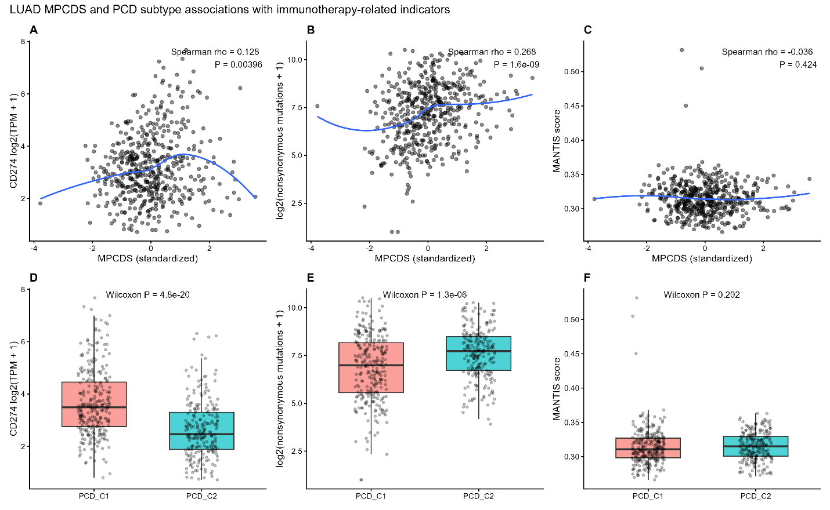
Figure 19 Associations of LUAD MPCDS and PCD subtype with immunotherapy-related molecular indicators.
Caption: (A) Continuous MPCDS and CD274 expression. (B) Continuous MPCDS and nonsynonymous mutation burden. (C) Continuous MPCDS and MANTIS microsatellite-instability score. (D) CD274 expression by PCD subtype. (E) Nonsynonymous mutation burden by PCD subtype. (F) MANTIS score by PCD subtype. Correlations and group comparisons describe molecular indicators; none of these panels measures patient response to immunotherapy.

4.18 TIDE IMMUNOTHERAPY SURROGATE ANALYSIS
TIDE analysis was completed for 517 TCGA-LUAD patients. The computational model classified 193 (37.3%) as predicted responders and 324 (62.7%) as predicted nonresponders. TIDE score did not differ significantly between PCD_C1 and PCD_C2 (Wilcoxon P = 0.556). The proportions classified as predicted responders were 40.5% and 33.5%, respectively, without a statistically significant subtype difference (Fisher’s exact P = 0.120).
The TIDE “no-benefits” flag was more frequent in PCD_C2 than PCD_C1 (14.6% versus 4.6%; Fisher’s exact $P = 9.39 × {10}^{-5}$). Among 504 patients with matched MPCDS and TIDE data, higher continuous MPCDS correlated with higher TIDE score ($Spearman ρ = 0.354; P = 2.49 × {10}^{-16}$). These are computational immunotherapy-response surrogates; actual patient responses to immune checkpoint treatment were not assessed.
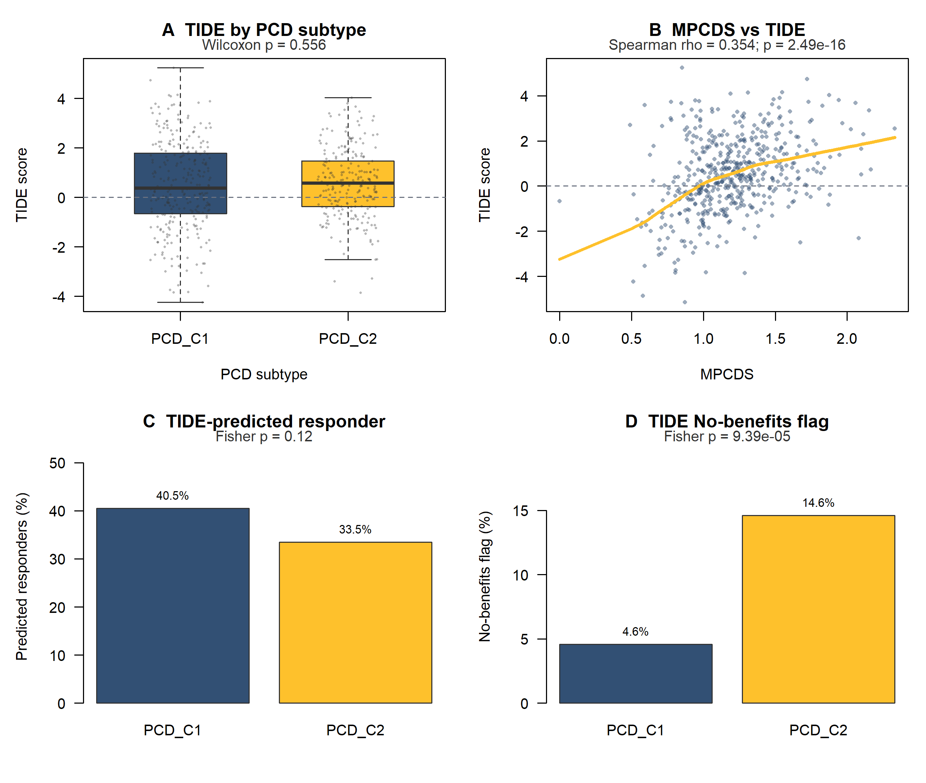
Figure 20 TIDE-derived immunotherapy-response surrogates in TCGA-LUAD.
Caption: (A) TIDE score by PCD subtype. (B) Association between continuous MPCDS and TIDE score. (C) Percentage classified by TIDE as predicted responders in each PCD subtype. (D) Percentage assigned the TIDE no-benefits flag in each subtype. TIDE classifications are computational predictions, not observed immunotherapy outcomes.

4.19 INTEGRATIVE VISUALIZATION OF PCD SUBTYPE, MPCDS AND STAGE
The relationship between PCD subtype, MPCDS group and AJCC stage was visualized in the 496 TCGA-LUAD patients with complete data for all three classifications. Of 270 PCD_C1 patients, 169 were in the low-MPCDS group; of 226 PCD_C2 patients, 148 were in the high-MPCDS group. The Sankey plot also shows patients from both subtypes and both MPCDS groups at each stage. These patterns indicate overlap between the classifications without implying that subtype determines MPCDS group or stage.
Principal-component analysis of the 47-gene expression profile included 517 TCGA-LUAD tumours. The first and second principal components explained 15.70% and 11.77% of expression variation, respectively. PCD_C1 and PCD_C2 showed partial separation in this two-dimensional view, with visible overlap between groups.
Figure 21 Relationship between PCD subtype, MPCDS group and AJCC stage in 496 TCGA-LUAD patients with complete data.
Caption: Ribbons trace patients from PCD_C1 or PCD_C2 through low or high MPCDS to pathological stage I–IV. Ribbon width represents patient count; colour identifies the originating PCD subtype. The diagram describes overlap between classifications and does not imply causation.
Figure 22 Principal-component analysis of the 47-gene PCD expression profile in 517 TCGA-LUAD tumours.
Caption: Each point is a tumour coloured by its PCD subtype. Principal components 1 and 2 explain 15.70% and 11.77% of expression variation, respectively. The groups show partial separation with overlap.

4.20 SUMMARY OF MAJOR FINDINGS
A catalogue of 296 programmed cell death (PCD) genes was assembled, of which 47 showed concordant tumour-versus-normal dysregulation in both LUAD and LUSC. Two expression-derived PCD subtypes were identified independently in each TCGA histology. The subtypes differed in estimated immune and stromal characteristics, pathway enrichment, mutation, copy-number alteration and DNA methylation. When projected into four LUAD and four LUSC GEO cohorts, the subtype groups showed modest separation and partial, mechanism-specific reproducibility. Ferroptosis differences were the most consistently replicated LUSC finding; LUAD necroptosis and pyroptosis differences replicated in two of four external cohorts.
Repeated nested cross-validation showed modest prognostic discrimination in LUAD (mean C-index = 0.604) and near-chance discrimination in LUSC (mean C-index = 0.505). A 47-gene ridge-penalized Cox MPCDS was therefore developed for LUAD. Across four independent LUAD GEO cohorts, higher continuous MPCDS had an adverse-risk association in every cohort, reaching statistical significance in three; discrimination and time-dependent AUC varied across cohorts. The clinical-adjusted external model comparison was performed in GSE68465. Drug-sensitivity predictions, PRISM cell-line analyses and immunotherapy-related indicators generated exploratory associations, but patient treatment response was not directly evaluated. The prognostic and therapeutic findings require further validation before clinical use.

CHAPTER 5: DISCUSSION

5.1 OVERVIEW OF THE PRINCIPAL FINDINGS
This study investigated programmed cell death-related molecular heterogeneity in LUAD and LUSC using transcriptomic, genomic, epigenomic, immune and clinical data. A curated 296-gene PCD catalogue was assembled, and 47 genes were identified as concordantly dysregulated between tumour and normal tissue in both LUAD and LUSC.
These 47 genes defined two expression-derived molecular subtypes, PCD_C1 and PCD_C2, in both histological groups. Although the specific PCD mechanism profiles differed between LUAD and LUSC, a reproducible broader biological contrast emerged. PCD_C1 showed greater immune and stromal enrichment, whereas PCD_C2 demonstrated stronger proliferative and metabolic activity. Projection into four independent GEO cohorts for each histology showed that the subtype patterns were only partly reproducible. Separation between projected groups was modest. Ferroptosis differences replicated most consistently in LUSC, while LUAD necroptosis and pyroptosis differences replicated in two of four cohorts.
Multi-omics characterization further showed that the PCD subtypes differed in somatic mutation patterns, copy-number alteration burden and DNA methylation. In particular, KEAP1 mutation was enriched in PCD_C2 across both LUAD and LUSC, while PCD_C2 showed greater copy-number disruption and widespread cross-histology methylation differences.
The prognostic relevance of the PCD programme was histology dependent. Repeated nested cross-validation showed modest discrimination in LUAD and near-chance discrimination in LUSC, so the final MPCDS was developed only for LUAD. In four independent LUAD GEO cohorts, higher MPCDS had an adverse-risk association in every cohort, reaching statistical significance in three. Discrimination varied across datasets, and the clinical-adjusted external comparison was available for GSE68465.
Finally, the study identified several associations between PCD phenotypes and predicted drug sensitivity or immunotherapy-related indicators. These findings provide biological and pharmacogenomic hypotheses but do not constitute direct evidence of patient treatment response.

5.2 CONCORDANT PCD DYSREGULATION IN LUAD AND LUSC
The identification of 47 PCD-related genes showing concordant tumour-associated dysregulation in both LUAD and LUSC suggests that several components of regulated cell-death biology are shared across major NSCLC histologies.
This is consistent with the broader understanding that resistance to regulated cell death is a common feature of malignant progression [6,10]. However, the present results also demonstrate that shared differential expression should not be interpreted as evidence of identical biological or prognostic function. Despite their concordant tumour-normal behaviour, the 47 genes showed markedly different survival associations between LUAD and LUSC. Nine genes remained prognostically significant after multiple-testing correction in LUAD, whereas none did so in LUSC.
This finding reinforces the established molecular differences between LUAD and LUSC demonstrated by TCGA studies [3,4]. It also supports the decision to maintain histology-specific analyses rather than treating NSCLC as a single molecular entity.
Previous studies of programmed cell death in lung cancer have often focused primarily or exclusively on LUAD. Wei et al. investigated 13 PCD mechanisms in LUAD and identified PCD-associated molecular subtypes together with a prognostic index [29]. Similarly, other recent studies have developed LUAD-specific PCD models using extensive machine-learning frameworks [62,63]. The present study differs by initially comparing LUAD and LUSC and selecting genes that were concordantly dysregulated across both histologies before evaluating their biological and prognostic behaviour separately.

5.3 BIOLOGICAL INTERPRETATION OF THE PCD MOLECULAR SUBTYPES
Two PCD molecular subtypes were identified independently in LUAD and LUSC. Although both histologies supported a two-cluster solution, their mechanism-level PCD profiles were not identical. This observation is important because clustering labels are arbitrary identifiers rather than fixed biological categories. Therefore, PCD_C1 in LUAD should not automatically be assumed to represent the same cell-death state as PCD_C1 in LUSC. Despite these mechanism-specific differences, a broader biological pattern was reproducible. PCD_C1 demonstrated greater immune and stromal abundance, whereas PCD_C2 exhibited stronger proliferative and metabolic activity.
The enrichment of immune and inflammatory programmes in PCD_C1 is consistent with increasing evidence that regulated cell-death pathways are closely linked to tumour immunity. Necroptosis and pyroptosis can produce inflammatory signaling and alter antigen availability, while other forms of regulated cell death can influence immune-cell recruitment and tumour-microenvironment composition [13]–[18]. Conversely, PCD_C2 showed enrichment of pathways involving MYC, E2F, oxidative phosphorylation, mTORC1 and cell-cycle activity. These features are compatible with a more proliferative and metabolically active tumour state.
A comparable relationship between PCD-related molecular phenotypes, immune activity and proliferative programmes has been reported in previous LUAD studies. Wei et al. identified two PCD-associated LUAD subtypes with differences in immune infiltration, prognosis and therapeutic characteristics [29]. Zhang et al. similarly reported that PCD-derived molecular scores were associated with tumour microenvironment characteristics and therapeutic response [62]. Therefore, the present results support the view that PCD-related transcriptional patterns are embedded within broader tumour-biological programmes rather than reflecting isolated cell-death pathways.

5.4 IMMUNE MICROENVIRONMENT DIFFERENCES
The consistent immune and stromal enrichment observed in PCD_C1 was supported by several computational approaches. MCP-counter and ESTIMATE demonstrated a broad increase in immune and stromal abundance, while additional analyses using CIBERSORT, xCell, TIMER-family methods, EPIC and quanTIseq reproduced several cell-population differences. This multimethod approach was useful because immune-deconvolution algorithms differ in their reference signatures, modelling assumptions and estimated cell populations. Agreement across methods therefore provides stronger evidence than reliance on a single algorithm.
However, not all immune-cell estimates were consistent. Selected CD8 T-cell, monocyte and dendritic-cell populations showed conflicting directions between methods. These differences highlight an important limitation of transcriptome-derived immune deconvolution and support cautious interpretation of individual cell populations.
The observed immune-rich phenotype of PCD_C1 is broadly consistent with previous PCD-related LUAD studies. Wei et al. reported that PCD-associated patient groups differed in immune-cell infiltration and therapeutic response [29]. Zhang et al. similarly found that lower-risk PCD groups exhibited more active immune environments and more favourable immunotherapy-related characteristics [62]. The present study extends these observations by demonstrating that immune/stromal enrichment associated with the PCD subtype structure was reproducible across both LUAD and LUSC, although the individual PCD mechanism patterns differed.

5.5 MULTI-OMICS SUPPORT FOR THE PCD SUBTYPES
The multi-omics analyses demonstrated that the expression-derived PCD subtypes were associated with additional genomic and epigenomic characteristics. One of the most notable findings was the enrichment of KEAP1 mutation in PCD_C2 in both LUAD and LUSC. The KEAP1-NRF2 pathway is a major regulator of oxidative stress, detoxification and metabolic adaptation. Dysregulation of this pathway is common in NSCLC and has been linked to therapy resistance, metabolic reprogramming and ferroptosis protection [64,65].
Therefore, enrichment of KEAP1 alteration in the more proliferative and metabolically active PCD_C2 subtype is biologically plausible. Nevertheless, the present analysis is associative and does not establish that KEAP1 mutation directly causes the PCD_C2 transcriptional phenotype. PCD_C2 also showed greater copy-number alteration burden in both LUAD and LUSC. This suggests that the subtype may be associated with greater genomic instability or structural genomic disruption.
DNA methylation provided an additional layer of evidence. Of the 2,056 methylation probes significantly associated with subtype in both histologies, 1,570 showed the same direction of change, and most concordant probes were hypomethylated in PCD_C2. The convergence of expression, mutation, CNV and methylation differences supports the interpretation that the PCD subtypes reflect broader molecular states rather than being artefacts of transcriptional clustering alone. At the same time, this analysis should be described as multi-layer characterization rather than a single mathematically integrated multi-omics model.

5.6 HISTOLOGY-SPECIFIC PROGNOSTIC PERFORMANCE
A major finding of this study was the difference in prognostic performance between LUAD and LUSC. Repeated nested cross-validation produced a mean C-index of 0.604 in LUAD but only 0.505 in LUSC. The LUSC value indicates approximately chance-level discrimination. Rather than developing a prognostic model despite this result, the analysis was restricted to LUAD.
This negative finding is scientifically important. It demonstrates that a transcriptional programme can be biologically relevant in more than one tumour type without necessarily providing equivalent prognostic information.
Several previous studies have developed PCD-based prognostic signatures specifically for LUAD. Wei et al. reported a five-gene programmed cell death index associated with prognosis and therapeutic response [29]. Zhang et al. developed a four-gene cell-death score using cross-validation across multiple machine-learning algorithms and reported prognostic and immunotherapy associations [62]. Other investigators have similarly used combinations of multiple machine-learning algorithms and external datasets to derive LUAD PCD signatures [63].
The current study adopted a more conservative modelling approach by emphasizing repeated nested cross-validation and retaining the negative LUSC result. This reduces the risk of assuming that a model trained on one histological context can be generalized automatically to another.

5.7 INTERPRETATION OF THE LUAD MPCDS
The final LUAD MPCDS was developed using ridge-penalized Cox regression and retained all 47 candidate genes. The repeated nested-CV mean C-index of 0.604 indicates modest prognostic discrimination rather than a highly accurate predictive model. Nevertheless, higher MPCDS was consistently associated with poorer overall survival. In TCGA-LUAD, the stage-stratified hazard ratio was approximately 1.71 per standard-deviation increase. The score also provided a small improvement beyond clinical variables. The mean internal C-index increased by approximately 0.011 after MPCDS was added to the clinical model.
This incremental gain is statistically meaningful but clinically modest. The MPCDS should therefore be viewed as complementary molecular information rather than a replacement for conventional prognostic factors. The separate LASSO sensitivity analysis also provided an important methodological observation. A four-gene model appeared stronger in the training cohort but failed to generalize effectively to the held-out test cohort. This illustrates the risk of overinterpreting apparent training performance in high-dimensional molecular studies. The decision to retain the ridge model rather than the apparently simpler LASSO signature therefore reflects prioritization of reproducibility over sparsity.

5.8 EXTERNAL VALIDATION OF THE LUAD MPCDS ACROSS FOUR GEO COHORTS
The fixed LUAD MPCDS showed an adverse-risk association in all four independent GEO cohorts, although its strength and discrimination varied. Continuous MPCDS was significantly associated with overall survival in GSE68465, GSE72094 and GSE50081. GSE31210 showed the same direction of association, but its confidence interval included no effect; only 35 deaths were recorded among its 226 patients with survival data. The C-index ranged from 0.579 in GSE31210 to 0.702 in GSE72094. These findings support external reproducibility of the score’s risk direction, while showing that its prognostic performance is not uniform across populations.
GSE68465 provided a more detailed assessment because the required clinical variables were available. Forty-six of the 47 model genes were represented, accounting for approximately 97% of the total absolute coefficient weight. The score achieved a C-index of 0.597 among 442 patients with survival data. In the 439 patients included in the clinical-adjusted comparison, higher MPCDS remained associated with poorer survival, and adding MPCDS increased the clinical-model C-index from 0.700 to 0.715. This increase of 0.015 suggests a small incremental contribution rather than a large improvement over clinical information. The clinical-adjusted result was specific to GSE68465 and should not be generalized to the other three cohorts.
The MPCDS proportional-hazards assumption was not satisfied in GSE68465, and the estimated association weakened with longer follow-up. Time-dependent ROC results also varied by cohort and horizon; notably, the GSE72094 five-year estimate had substantial uncertainty because only five patients were known to survive beyond that time point. Differences in cohort composition, available genes, measurement platforms and follow-up may contribute to variation across cohorts, although this study cannot establish which factor explains it. Taken together, the external analyses support a LUAD prognostic signal but do not justify describing MPCDS as a uniformly accurate or time-invariant clinical biomarker.

5.9 THERAPEUTIC SENSITIVITY AND PHARMACOGENOMIC FINDINGS
The GDSC/oncoPredict analysis identified numerous statistically significant associations between MPCDS or PCD subtype and predicted IC50 values. These findings suggest that transcriptional differences associated with the PCD programme may correspond to differences in predicted drug sensitivity.
However, both MPCDS and the drug-response predictions were derived from transcriptomic information. Therefore, these associations should not be considered independent biological validation. The PRISM analysis provided a more stringent complementary pharmacogenomic assessment in LUAD cell lines.
Although 121 of 1,440 compounds showed nominal associations with MPCDS, none remained significant after multiple-testing correction. The lack of FDR-significant PRISM associations is important because it limits claims of robust pharmacogenomic replication. Consequently, the therapeutic findings should be considered hypothesis generating. Previous PCD-related LUAD studies have also reported associations between PCD scores and predicted drug sensitivity [29,62]. However, computational sensitivity estimates cannot substitute for response data from treated patients. Future validation in clinical cohorts receiving specific therapies would therefore be necessary before MPCDS could be considered a treatment-selection biomarker.

5.10 IMMUNOTHERAPY-RELATED FINDINGS
MPCDS and PCD subtype were associated with several immunotherapy-related indicators. A small positive association was observed between MPCDS and CD274 expression, while nonsynonymous mutation burden also increased with MPCDS. However, these biomarkers should be interpreted individually and cautiously.
PD-L1 expression is clinically relevant but is an imperfect predictor of immune-checkpoint inhibitor response. Similarly, the mutation variable used in this study represented nonsynonymous mutation burden rather than formally calculated mutations per megabase and should therefore not be described as clinical TMB. MSI analysis provided little evidence of association. Only three MSI-high cases were identified, severely limiting statistical power for categorical comparison.
TIDE additionally suggested that PCD_C2 contained a higher proportion of patients categorized within the computational “no-benefits” group. However, TIDE is an expression-derived surrogate rather than direct clinical response information.
Previous studies have reported relationships between PCD-derived scores, immune infiltration, TIDE and immunotherapy response in LUAD [62,63]. Some studies have also incorporated actual immunotherapy cohorts, providing stronger therapeutic evidence than transcriptome-based surrogate analysis alone [62]. The present study therefore supports an association between the PCD programme and immune-related tumour characteristics but does not establish that MPCDS predicts clinical immunotherapy benefit.

5.11 STRENGTHS OF THE STUDY
Several aspects of the study strengthen the reliability of the findings. First, LUAD and LUSC were analysed separately rather than being treated as a homogeneous NSCLC cohort. Second, candidate genes were required to show concordant tumour-associated dysregulation across both histologies before being carried forward. Third, the PCD subtypes were characterized across transcriptomic, genomic, epigenomic, immune and functional layers. Fourth, multiple immune-deconvolution methods were used to identify robust rather than algorithm-specific immune signals. Fifth, prognostic modelling emphasized repeated nested cross-validation and independent external validation. Sixth, negative findings were retained. No prognostic LUSC MPCDS was advanced, the sparse LASSO model was not promoted after weak held-out performance, and the PRISM drug screen was reported as negative after FDR correction. These features reduce the likelihood of overstating the predictive or therapeutic significance of the findings.

5.12 LIMITATIONS
This study was retrospective and relied on publicly available datasets; prospective clinical validation was not performed. Although the PCD subtypes were projected into eight GEO cohorts, separation between the projected groups was modest and mechanism-level replication was incomplete. The four external LUAD cohorts supported a consistent adverse-risk direction for MPCDS, but discrimination varied and the association was not statistically significant in GSE31210. Gene coverage also differed across cohorts: 46 of 47 MPCDS genes were available in GSE68465 and GSE72094, compared with all 47 in GSE31210 and GSE50081. The 47-gene score may be less practical for clinical implementation than a smaller panel.
Clinical-adjusted external evaluation was performed in GSE68465, where the required variables were available; the same incremental-value analysis was not established across all four external cohorts. The proportional-hazards assumption was not satisfied for MPCDS in GSE68465, and some longer-term ROC estimates had limited follow-up support. Decision-curve analysis produced apparent estimates in TCGA-LUAD rather than externally validated evidence of clinical utility. Immune-cell estimates came from computational methods that did not always agree. GDSC2/oncoPredict, PRISM and TIDE analyses did not measure treatment responses in patients.
Finally, nonsynonymous mutation burden was used instead of formal mutation-per-megabase TMB, and MSI-high cases were extremely rare. These limitations should be considered when interpreting the translational relevance of the findings.

5.13 FUTURE DIRECTIONS
PCD-related expression patterns captured biological differences in both LUAD and LUSC. The independently derived subtypes differed in immune and stromal estimates, pathway enrichment, genomic alterations and DNA methylation. Projection into eight GEO cohorts showed modest separation and partial, mechanism-specific reproducibility. These findings support further study of the subtype patterns without implying that they replicate uniformly across cohorts or have established prognostic value in both histologies.
Prognostic performance differed substantially by histology: repeated nested cross-validation showed a modest signal in LUAD and near-chance discrimination in LUSC. The LUAD MPCDS had an adverse-risk association in all four external GEO cohorts, statistically significant in three, but discrimination varied. Drug-sensitivity and immunotherapy-related findings remain exploratory because patient treatment responses were not evaluated. MPCDS therefore requires further validation before clinical use.
Such studies would determine whether the associations observed here have genuine predictive value rather than reflecting general tumour biology.

5.14 CHAPTER SUMMARY
This study demonstrates that PCD-associated transcriptional patterns capture meaningful molecular heterogeneity in lung cancer. Two PCD subtypes were identified in both LUAD and LUSC and were associated with differences in immune composition, functional pathways, genomic alterations and DNA methylation. However, prognostic relevance differed substantially between histologies. A modest but reproducible MPCDS was supported in LUAD, whereas LUSC showed approximately chance-level prognostic discrimination.
External LUAD validation supported the prognostic association but confirmed that predictive performance remained modest. Therapeutic and immunotherapy-related analyses identified several associations, but these remain exploratory and require validation using patient treatment-response data. Overall, the findings support further investigation of PCD-related molecular patterns as complementary biomarkers of lung-cancer biology and prognosis rather than as immediately deployable clinical tools.

CHAPTER 6: CONCLUSION AND RECOMMENDATIONS

6.1 CONCLUSION
This study investigated programmed cell death-related molecular patterns in lung adenocarcinoma and lung squamous cell carcinoma using transcriptomic, genomic, epigenomic, immune and clinical data. A curated catalogue of 296 programmed cell death-related genes representing apoptosis, necroptosis, pyroptosis, ferroptosis and cuproptosis was established. Differential-expression analysis identified 47 genes that were significantly and concordantly dysregulated in both LUAD and LUSC.
Using these 47 genes, two expression-derived molecular subtypes, PCD_C1 and PCD_C2, were identified independently in LUAD and LUSC. Their PCD mechanism profiles differed between histologies. Projection into four independent GEO cohorts for each histology showed modest separation between assigned groups and partial, mechanism-specific reproducibility, particularly for ferroptosis in LUSC and necroptosis and pyroptosis in two LUAD cohorts.
Multi-omics characterization demonstrated that the two PCD subtypes differed beyond gene expression. PCD_C2 showed enrichment of KEAP1 mutation across both histologies, greater copy-number alteration burden, and extensive cross-histology DNA methylation differences. These findings support the interpretation that the identified PCD subtypes represent broader molecular states rather than expression-only clusters.
The prognostic relevance of the PCD programme was strongly dependent on histological context. In LUAD, repeated nested cross-validation produced a mean C-index of 0.604, demonstrating modest but reproducible prognostic discrimination. In contrast, LUSC showed a mean C-index of approximately 0.505, indicating near-chance performance. Consequently, no prognostic MPCDS was advanced for LUSC.
The final LUAD MPCDS was constructed using ridge-penalized Cox regression with all 47 candidate genes. Higher scores were associated with poorer overall survival. Adding MPCDS produced a small improvement over the clinical model in the TCGA-LUAD analysis; an external clinical-adjusted comparison was performed in GSE68465, where the required variables were available.
External evaluation across GSE68465, GSE72094, GSE31210 and GSE50081 showed an adverse-risk association for continuous MPCDS in all four cohorts, statistically significant in three. Prognostic discrimination varied across cohorts. In GSE68465, the association remained significant after clinical adjustment, but the estimated effect changed with follow-up time. These findings support a modest LUAD prognostic role for MPCDS without establishing a clinically ready model.
Therapeutic analyses also identified associations between the PCD programme and predicted drug sensitivity. GDSC/oncoPredict demonstrated multiple significant transcriptome-derived IC50 associations, while PRISM analysis identified several nominal pharmacogenomic signals. However, no PRISM drug association remained significant after false-discovery-rate correction, indicating that these drug-response findings remain exploratory.
Immunotherapy-related analyses showed associations between MPCDS or PCD subtype and PD-L1 expression, nonsynonymous mutation burden and TIDE-derived characteristics. No convincing relationship was identified with MANTIS-based microsatellite instability. These results suggest that PCD-associated molecular states may interact with the immune environment, but they do not demonstrate clinical immunotherapy response.
Overall, this study shows that programmed cell death-related transcriptional patterns capture meaningful biological heterogeneity in lung cancer. The findings support a LUAD-specific prognostic role for the MPCDS and demonstrate associations with immune, genomic, epigenomic and therapeutic characteristics. However, the model should presently be regarded as a research tool requiring further validation rather than as a clinically deployable biomarker.

6.2 RECOMMENDATIONS
Based on the findings of this study, the following recommendations are proposed:
The LUAD MPCDS should be validated in additional independent patient cohorts, particularly cohorts generated using contemporary RNA-sequencing platforms.
Prospective studies should be conducted to determine whether MPCDS provides clinically meaningful prognostic information beyond established pathological and molecular predictors.
Future work should investigate whether the 47-gene ridge model can be simplified into a smaller, clinically practical gene panel without substantial loss of predictive performance.
Functional laboratory studies should examine the biological relationship between KEAP1 alteration and the PCD_C2 phenotype, particularly its relationship with oxidative stress, ferroptosis and metabolic adaptation.
Single-cell and spatial transcriptomic approaches should be considered to determine whether PCD-associated expression patterns originate predominantly from malignant cells, immune cells, stromal cells or combinations of these compartments.
The therapeutic associations identified using GDSC, oncoPredict and PRISM should be tested experimentally in lung-cancer cell lines, organoids or patient-derived models before therapeutic conclusions are drawn.
Future studies should evaluate MPCDS in clinical cohorts with documented treatment exposure and response, including chemotherapy, targeted therapy and immune-checkpoint inhibition.
Immunotherapy validation should preferably use cohorts with observed response, progression-free survival and overall survival following immune-checkpoint inhibitor treatment rather than relying solely on computational surrogates such as TIDE.
Formal tumour mutation burden expressed as mutations per megabase should be evaluated in future studies to determine whether the observed nonsynonymous mutation-burden association persists using a clinically standardized TMB definition.
Future LUSC studies should test whether the near-chance prognostic performance observed here persists in independent cohorts with adequate survival data, and whether alternative PCD-based models perform better.

6.3 FINAL STATEMENT
This study found that programmed cell death-related expression patterns were associated with biological differences in LUAD and LUSC. The subtype patterns showed partial external reproducibility across eight GEO cohorts. A LUAD-specific MPCDS showed modest internal prognostic discrimination and a consistent adverse-risk direction across four external cohorts, although its performance varied between datasets.
The findings provide a foundation for further investigation of PCD-informed patient stratification in lung cancer. However, clinical translation will require prospective validation, biological confirmation and direct assessment in treatment-response cohorts before the MPCDS or associated therapeutic signals can be considered for clinical decision-making.

REFERENCES
[1] Sung H, Filho AM, Laversanne M, Ferlay J, Siegel RL, Soerjomataram I, et al. Global cancer statistics 2024: GLOBOCAN estimates of incidence and mortality worldwide for 34 cancers in 186 countries. CA Cancer J Clin 2026;76. https://doi.org/10.3322/CAAC.70090.
[2] Hendriks LEL, Remon J, Faivre-Finn C, Garassino MC, Heymach J V., Kerr KM, et al. Non-small-cell lung cancer. Nat Rev Dis Primers 2024;10. https://doi.org/10.1038/S41572-024-00551-9.
[3] Collisson EA, Campbell JD, Brooks AN, Berger AH, Lee W, Chmielecki J, et al. Comprehensive molecular profiling of lung adenocarcinoma. Nature 2014 511:7511 2014;511:543–50. https://doi.org/10.1038/nature13385.
[4] Hammerman PS, Voet D, Lawrence MS, Voet D, Jing R, Cibulskis K, et al. Comprehensive genomic characterization of squamous cell lung cancers. Nature 2012 489:7417 2012;489:519–25. https://doi.org/10.1038/nature11404.
[5] Koban MU, Hartmann M, Amexis G, Franco P, Huggins L, Shah I, et al. Targeted Therapies, Novel Antibodies, and Immunotherapies in Advanced Non-Small Cell Lung Cancer: Clinical Evidence and Drug Approval Patterns. Clin Cancer Res 2024;30:4822–33. https://doi.org/10.1158/1078-0432.CCR-24-0741.
[6] Hanahan D. Hallmarks of Cancer: New Dimensions. Cancer Discov 2022;12:31–46. https://doi.org/10.1158/2159-8290.CD-21-1059.
[7] Galluzzi L, Vitale I, Aaronson SA, Abrams JM, Adam D, Agostinis P, et al. Molecular mechanisms of cell death: recommendations of the Nomenclature Committee on Cell Death 2018. Cell Death & Differentiation 2018 25:3 2018;25:486–541. https://doi.org/10.1038/s41418-017-0012-4.
[8] Stockwell BR, Friedmann Angeli JP, Bayir H, Bush AI, Conrad M, Dixon SJ, et al. Ferroptosis: A Regulated Cell Death Nexus Linking Metabolism, Redox Biology, and Disease. Cell 2017;171:273–85. https://doi.org/10.1016/j.cell.2017.09.021.
[9] Tsvetkov P, Coy S, Petrova B, Dreishpoon M, Verma A, Abdusamad M, et al. Copper induces cell death by targeting lipoylated TCA cycle proteins. Science 2022;375:1254–61. https://doi.org/10.1126/SCIENCE.ABF0529.
[10] Koren E, Fuchs Y. Modes of Regulated Cell Death in Cancer. Cancer Discov 2021;11:245–65. https://doi.org/10.1158/2159-8290.CD-20-0789.
[11] Hendriks LE, Kerr KM, Menis J, Mok TS, Nestle U, Passaro A, et al. Non-oncogene-addicted metastatic non-small-cell lung cancer: ESMO Clinical Practice Guideline for diagnosis, treatment and follow-up☆. Annals of Oncology 2023;34:358–76. https://doi.org/10.1016/j.annonc.2022.12.013.
[12] Villaruz LC, Socinski MA, Weiss J. Guidance for clinicians and patients with non-small cell lung cancer in the time of precision medicine. Front Oncol 2023;13. https://doi.org/10.3389/FONC.2023.1124167.
[13] Meier P, Legrand AJ, Adam D, Silke J. Immunogenic cell death in cancer: targeting necroptosis to induce antitumour immunity. Nat Rev Cancer 2024;24:299–315. https://doi.org/10.1038/S41568-024-00674-X.
[14] Kroemer G, Galluzzi L, Kepp O, Zitvogel L. Immunogenic cell death in cancer therapy. Annu Rev Immunol 2013;31:51–72. https://doi.org/10.1146/ANNUREV-IMMUNOL-032712-100008/CITE/REFWORKS.
[15] Li P, Nijhawan D, Budihardjo I, Srinivasula SM, Ahmad M, Alnemri ES, et al. Cytochrome c and dATP-dependent formation of Apaf-1/caspase-9 complex initiates an apoptotic protease cascade. Cell 1997;91:479–89. https://doi.org/10.1016/S0092-8674(00)80434-1.
[16] Juo P, Kuo CJ, Yuan J, Blenis J. Essential requirement for caspase-8/FLICE in the initiation of the Fas-induced apoptotic cascade. Current Biology 1998;8:1001–8. https://doi.org/10.1016/S0960-9822(07)00420-4.
[17] Sun L, Wang H, Wang Z, He S, Chen S, Liao D, et al. Mixed lineage kinase domain-like protein mediates necrosis signaling downstream of RIP3 kinase. Cell 2012;148:213–27. https://doi.org/10.1016/j.cell.2011.11.031.
[18] Guo Z, Liu Y, Chen D, Sun Y, Li D, Meng Y, et al. Targeting regulated cell death: Apoptosis, necroptosis, pyroptosis, ferroptosis, and cuproptosis in anticancer immunity. J Transl Int Med 2025;13:10. https://doi.org/10.1515/JTIM-2025-0004.
[19] Shi J, Zhao Y, Wang K, Shi X, Wang Y, Huang H, et al. Cleavage of GSDMD by inflammatory caspases determines pyroptotic cell death. Nature 2015 526:7575 2015;526:660–5. https://doi.org/10.1038/nature15514.
[20] Dixon SJ, Lemberg KM, Lamprecht MR, Skouta R, Zaitsev EM, Gleason CE, et al. Ferroptosis: An iron-dependent form of nonapoptotic cell death. Cell 2012;149:1060–72. https://doi.org/10.1016/j.cell.2012.03.042.
[21] Yang WS, Sriramaratnam R, Welsch ME, Shimada K, Skouta R, Viswanathan VS, et al. Regulation of ferroptotic cancer cell death by GPX4. Cell 2014;156:317–31. https://doi.org/10.1016/j.cell.2013.12.010.
[22] Nicholson AG, Scagliotti G, Tsao MS, Yatabe Y, Travis WD. 2021 WHO Classification of Lung Cancer: A Globally Applicable and Molecular Biomarker-Relevant Classification. Journal of Thoracic Oncology 2022;17:e80–3. https://doi.org/10.1016/j.jtho.2022.07.006.
[23] Hendriks LE, Kerr KM, Menis J, Mok TS, Nestle U, Passaro A, et al. Oncogene-addicted metastatic non-small-cell lung cancer: ESMO Clinical Practice Guideline for diagnosis, treatment and follow-up☆. Annals of Oncology 2023;34:339–57. https://doi.org/10.1016/j.annonc.2022.12.009.
[24] Liu Y, Chen Q, Xu J, Chi H. Programmed cell death in lung cancer: mechanisms, immune responses, and therapeutics. Apoptosis 2026;31. https://doi.org/10.1007/S10495-026-02298-Y.
[25] Liang KH, Luo YH, Wang ML, Chiou SH, Chen YM, Hsu HS. A multiomic investigation of lung adenocarcinoma molecular subtypes. J Chin Med Assoc 2024;87:33–9. https://doi.org/10.1097/JCMA.0000000000001029.
[26] Brativnyk A, Ankill J, Helland Å, Fleischer T. Multi-omics analysis reveals epigenetically regulated processes and patient classification in lung adenocarcinoma. Int J Cancer 2024;155:282–97. https://doi.org/10.1002/IJC.34915.
[27] Wei J, Wang X, Guo H, Zhang L, Shi Y, Wang X. Subclassification of lung adenocarcinoma through comprehensive multi-omics data to benefit survival outcomes. Comput Biol Chem 2024;112. https://doi.org/10.1016/j.compbiolchem.2024.108150.
[28] Zhang Y, Wang Y, Qian H. Multi-omics characterization and machine learning of lung adenocarcinoma molecular subtypes to guide precise chemotherapy and immunotherapy. Front Immunol 2024;15. https://doi.org/10.3389/FIMMU.2024.1497300.
[29] Wei Q, Jiang X, Miao X, Zhang Y, Chen F, Zhang P. Molecular subtypes of lung adenocarcinoma patients for prognosis and therapeutic response prediction with machine learning on 13 programmed cell death patterns. J Cancer Res Clin Oncol 2023;149:11351–68. https://doi.org/10.1007/S00432-023-05000-W.
[30] Colaprico A, Silva TC, Olsen C, Garofano L, Cava C, Garolini D, et al. TCGAbiolinks: an R/Bioconductor package for integrative analysis of TCGA data. Nucleic Acids Res 2016;44:e71–e71. https://doi.org/10.1093/NAR/GKV1507.
[31] Grossman RL, Heath AP, Ferretti V, Varmus HE, Lowy DR, Kibbe WA, et al. Toward a Shared Vision for Cancer Genomic Data. New England Journal of Medicine 2016;375:1109–12. https://doi.org/10.1056/NEJMP1607591.
[32] File Format: MAF - GDC Docs n.d. https://docs.gdc.cancer.gov/Data/File_Formats/MAF_Format/?utm_source=chatgpt.com (accessed September 28, 2026).
[33] Aliquot Ensemble Somatic Variant Merging and Masking - GDC Docs n.d. https://docs.gdc.cancer.gov/Encyclopedia/pages/Aliquot_Ensemble_Somatic_Variant_Merging_and_Masking/?utm_source=chatgpt.com (accessed September 28, 2026).
[34] Taylor AM, Shih J, Ha G, Gao GF, Zhang X, Berger AC, et al. Genomic and Functional Approaches to Understanding Cancer Aneuploidy. Cancer Cell 2018;33:676-689.e3. https://doi.org/10.1016/J.CCELL.2018.03.007.
[35] Bibikova M, Barnes B, Tsan C, Ho V, Klotzle B, Le JM, et al. High density DNA methylation array with single CpG site resolution. Genomics 2011;98:288–95. https://doi.org/10.1016/J.YGENO.2011.07.007.
[36] Zhou W, Laird PW, Shen H. Comprehensive characterization, annotation and innovative use of Infinium DNA methylation BeadChip probes. Nucleic Acids Res 2017;45:e22. https://doi.org/10.1093/NAR/GKW967.
[37] Zhou W, Triche TJ, Laird PW, Shen H. SeSAMe: Reducing artifactual detection of DNA methylation by Infinium BeadChips in genomic deletions. Nucleic Acids Res 2018;46. https://doi.org/10.1093/NAR/GKY691.
[38] Shedden K, Taylor JMG, Enkemann SA, Tsao MS, Yeatman TJ, Gerald WL, et al. Gene expression–based survival prediction in lung adenocarcinoma: a multi-site, blinded validation study. Nature Medicine 2008 14:8 2008;14:822–7. https://doi.org/10.1038/nm.1790.
[39] Liberzon A, Subramanian A, Pinchback R, Thorvaldsdóttir H, Tamayo P, Mesirov JP. Molecular signatures database (MSigDB) 3.0. Bioinformatics 2011;27:1739–40. https://doi.org/10.1093/BIOINFORMATICS/BTR260.
[40] Subramanian A, Tamayo P, Mootha VK, Mukherjee S, Ebert BL, Gillette MA, et al. Gene set enrichment analysis: A knowledge-based approach for interpreting genome-wide expression profiles. Proc Natl Acad Sci U S A 2005;102:15545–50. https://doi.org/10.1073/PNAS.0506580102;WEBSITE:WEBSITE:PNAS-SITE;ISSUE:ISSUE:DOI.
[41] Love MI, Huber W, Anders S. Moderated estimation of fold change and dispersion for RNA-seq data with DESeq2. Genome Biology 2014 15:12 2014;15:550-. https://doi.org/10.1186/S13059-014-0550-8.
[42] Monti S, Tamayo P, Mesirov J, Golub T. Consensus clustering: A resampling-based method for class discovery and visualization of gene expression microarray data. Mach Learn 2003;52:91–118. https://doi.org/10.1023/A:1023949509487/METRICS.
[43] Wilkerson MD, Hayes DN. ConsensusClusterPlus: a class discovery tool with confidence assessments and item tracking. Bioinformatics 2010;26:1572–3. https://doi.org/10.1093/BIOINFORMATICS/BTQ170.
[44] Liberzon A, Birger C, Thorvaldsdóttir H, Ghandi M, Mesirov JP, Tamayo P. The Molecular Signatures Database Hallmark Gene Set Collection. Cell Syst 2015;1:417–25. https://doi.org/10.1016/j.cels.2015.12.004.
[45] Becht E, Giraldo NA, Lacroix L, Buttard B, Elarouci N, Petitprez F, et al. Estimating the population abundance of tissue-infiltrating immune and stromal cell populations using gene expression. Genome Biology 2016 17:1 2016;17:218-. https://doi.org/10.1186/S13059-016-1070-5.
[46] Yoshihara K, Shahmoradgoli M, Martínez E, Vegesna R, Kim H, Torres-Garcia W, et al. Inferring tumour purity and stromal and immune cell admixture from expression data. Nature Communications 2013 4:1 2013;4:2612-. https://doi.org/10.1038/ncomms3612.
[47] Newman AM, Liu CL, Green MR, Gentles AJ, Feng W, Xu Y, et al. Robust enumeration of cell subsets from tissue expression profiles. Nature Methods 2015 12:5 2015;12:453–7. https://doi.org/10.1038/nmeth.3337.
[48] Aran D, Hu Z, Butte AJ. xCell: digitally portraying the tissue cellular heterogeneity landscape. Genome Biology 2017 18:1 2017;18:220-. https://doi.org/10.1186/S13059-017-1349-1.
[49] Li B, Severson E, Pignon JC, Zhao H, Li T, Novak J, et al. Comprehensive analyses of tumor immunity: implications for cancer immunotherapy. Genome Biology 2016 17:1 2016;17:174-. https://doi.org/10.1186/S13059-016-1028-7.
[50] Racle J, de Jonge K, Baumgaertner P, Speiser DE, Gfeller D. Simultaneous enumeration of cancer and immune cell types from bulk tumor gene expression data. Elife 2017;6. https://doi.org/10.7554/ELIFE.26476.
[51] Finotello F, Mayer C, Plattner C, Laschober G, Rieder Di, Hackl H, et al. Molecular and pharmacological modulators of the tumor immune contexture revealed by deconvolution of RNA-seq data. Genome Medicine 2019 11:1 2019;11:34-. https://doi.org/10.1186/S13073-019-0638-6.
[52] Ritchie ME, Phipson B, Wu D, Hu Y, Law CW, Shi W, et al. limma powers differential expression analyses for RNA-sequencing and microarray studies. Nucleic Acids Res 2015;43:e47–e47. https://doi.org/10.1093/NAR/GKV007.
[53] Simon N, Friedman J, Hastie T, Tibshirani R. Regularization Paths for Cox’s Proportional Hazards Model via Coordinate Descent. J Stat Softw 2011;39:1–13. https://doi.org/10.18637/JSS.V039.I05.
[54] Blanche P, Dartigues JF, Jacqmin-Gadda H. Estimating and comparing time-dependent areas under receiver operating characteristic curves for censored event times with competing risks. Stat Med 2013;32:5381–97. https://doi.org/10.1002/SIM.5958;PAGEGROUP:STRING:PUBLICATION.
[55] Vickers AJ, Elkin EB. Decision curve analysis: A novel method for evaluating prediction models. Medical Decision Making 2006;26:565–74. https://doi.org/10.1177/0272989X06295361;REQUESTEDJOURNAL:JOURNAL:MDMA;ISSUE:ISSUE:DOI.
[56] Iorio F, Knijnenburg TA, Vis DJ, Bignell GR, Menden MP, Schubert M, et al. A Landscape of Pharmacogenomic Interactions in Cancer. Cell 2016;166:740–54. https://doi.org/10.1016/J.CELL.2016.06.017.
[57] Maeser D, Gruener RF, Huang RS. oncoPredict: an R package for predicting in vivo or cancer patient drug response and biomarkers from cell line screening data. Brief Bioinform 2021;22. https://doi.org/10.1093/BIB/BBAB260.
[58] Corsello SM, Nagari RT, Spangler RD, Rossen J, Kocak M, Bryan JG, et al. Discovering the anticancer potential of non-oncology drugs by systematic viability profiling. Nature Cancer 2020 1:2 2020;1:235–48. https://doi.org/10.1038/s43018-019-0018-6.
[59] Kautto EA, Bonneville R, Miya J, Yu L, Krook MA, Reeser JW, et al. Performance evaluation for rapid detection of pan-cancer microsatellite instability with MANTIS. Oncotarget 2016;8:7452–63. https://doi.org/10.18632/ONCOTARGET.13918.
[60] Bonneville R, Krook MA, Kautto EA, Miya J, Wing MR, Chen H-Z, et al. Landscape of Microsatellite Instability Across 39 Cancer Types. JCO Precis Oncol 2017:1–15. https://doi.org/10.1200/PO.17.00073.
[61] Jiang P, Gu S, Pan D, Fu J, Sahu A, Hu X, et al. Signatures of T cell dysfunction and exclusion predict cancer immunotherapy response. Nat Med 2018;24:1550–8. https://doi.org/10.1038/S41591-018-0136-1.
[62] Zhang Y, Wang Y, Chen J, Xia Y, Huang Y. A programmed cell death-related model based on machine learning for predicting prognosis and immunotherapy responses in patients with lung adenocarcinoma. Front Immunol 2023;14. https://doi.org/10.3389/FIMMU.2023.1183230.
[63] Wang S, Wang R, Hu D, Zhang C, Cao P, Huang J. Machine learning reveals diverse cell death patterns in lung adenocarcinoma prognosis and therapy. NPJ Precis Oncol 2024;8. https://doi.org/10.1038/S41698-024-00538-5.
[64] Scalera S, Mazzotta M, Cortile C, Krasniqi E, De Maria R, Cappuzzo F, et al. KEAP1-Mutant NSCLC: The Catastrophic Failure of a Cell-Protecting Hub. Journal of Thoracic Oncology 2022;17:751–7. https://doi.org/10.1016/j.jtho.2022.03.011.
[65] Camiña N, Penning TM. Genetic and epigenetic regulation of the NRF2-KEAP1 pathway in human lung cancer. Br J Cancer 2022;126:1244–52. https://doi.org/10.1038/S41416-021-01642-0.

APPENDICES/SUPPLEMENTARY TABLES AND FIGURES

APPENDIX A SUPPLEMENTARY FIGURES
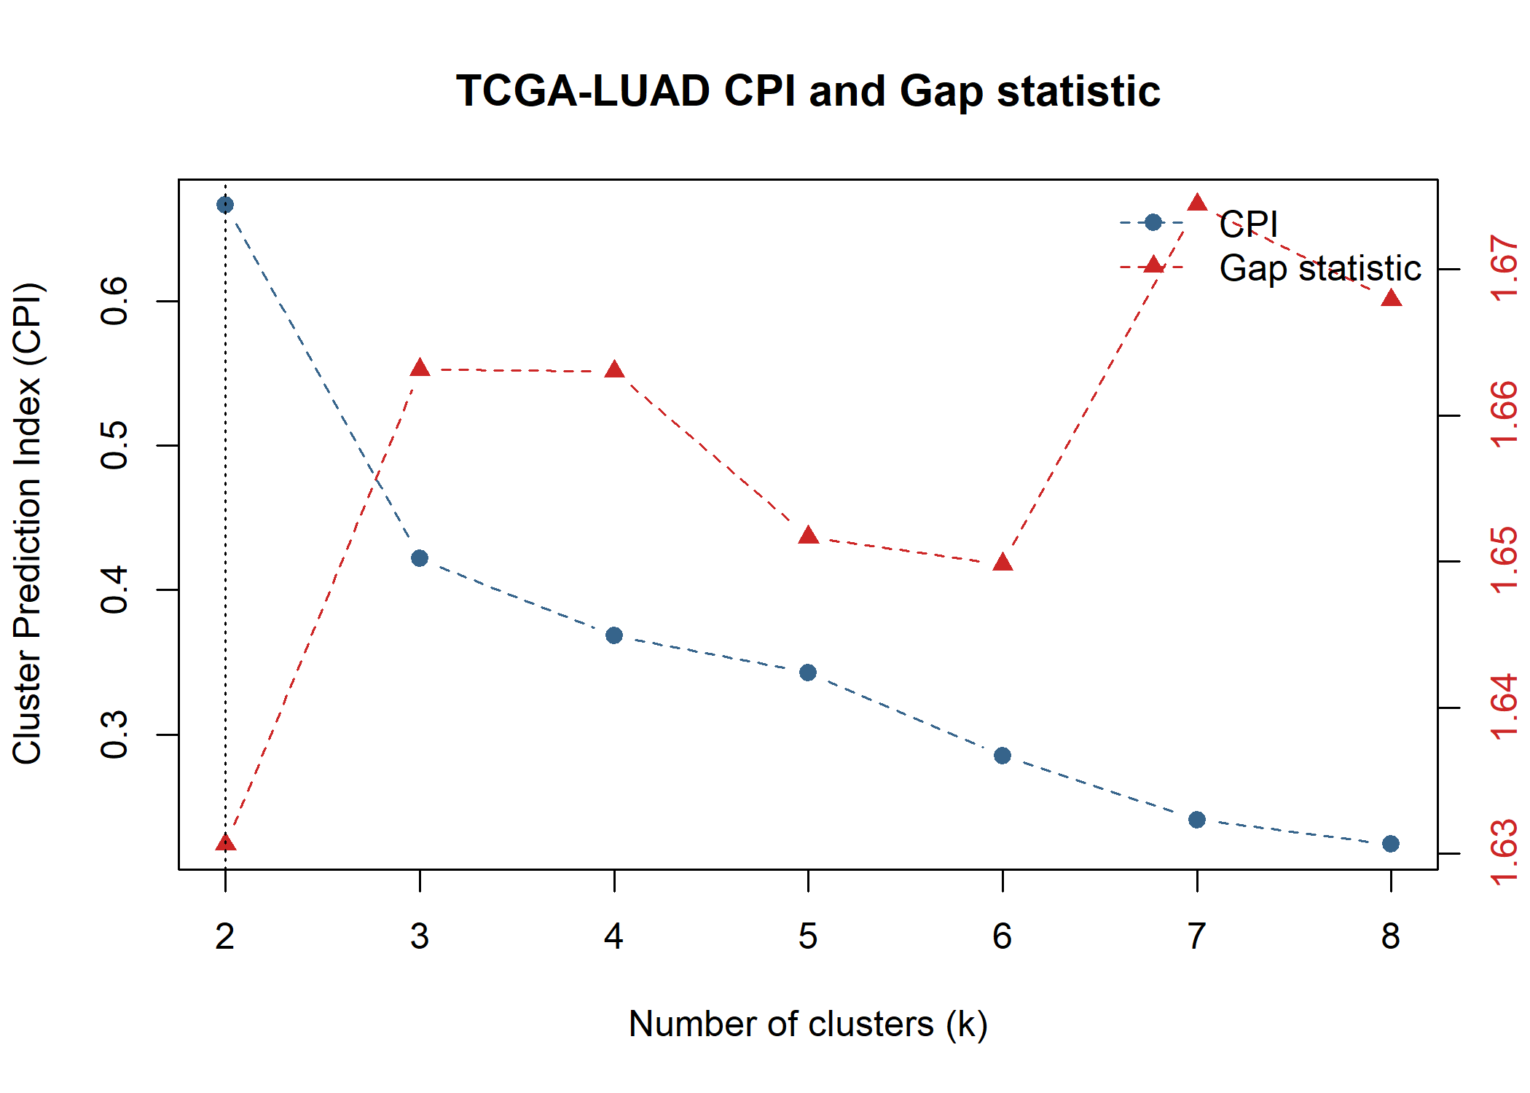
Figure 23 Supplementary Figure S1. Cluster-number diagnostics for TCGA-LUAD
Caption: The cluster prediction index (CPI; blue circles, left axis) and gap statistic (red triangles, right axis) are shown for candidate cluster numbers k = 2–8. The dotted vertical line marks the selected two-cluster solution. CPI was highest at k = 2, whereas the gap statistic followed a different pattern; these criteria were considered alongside the other clustering diagnostics.
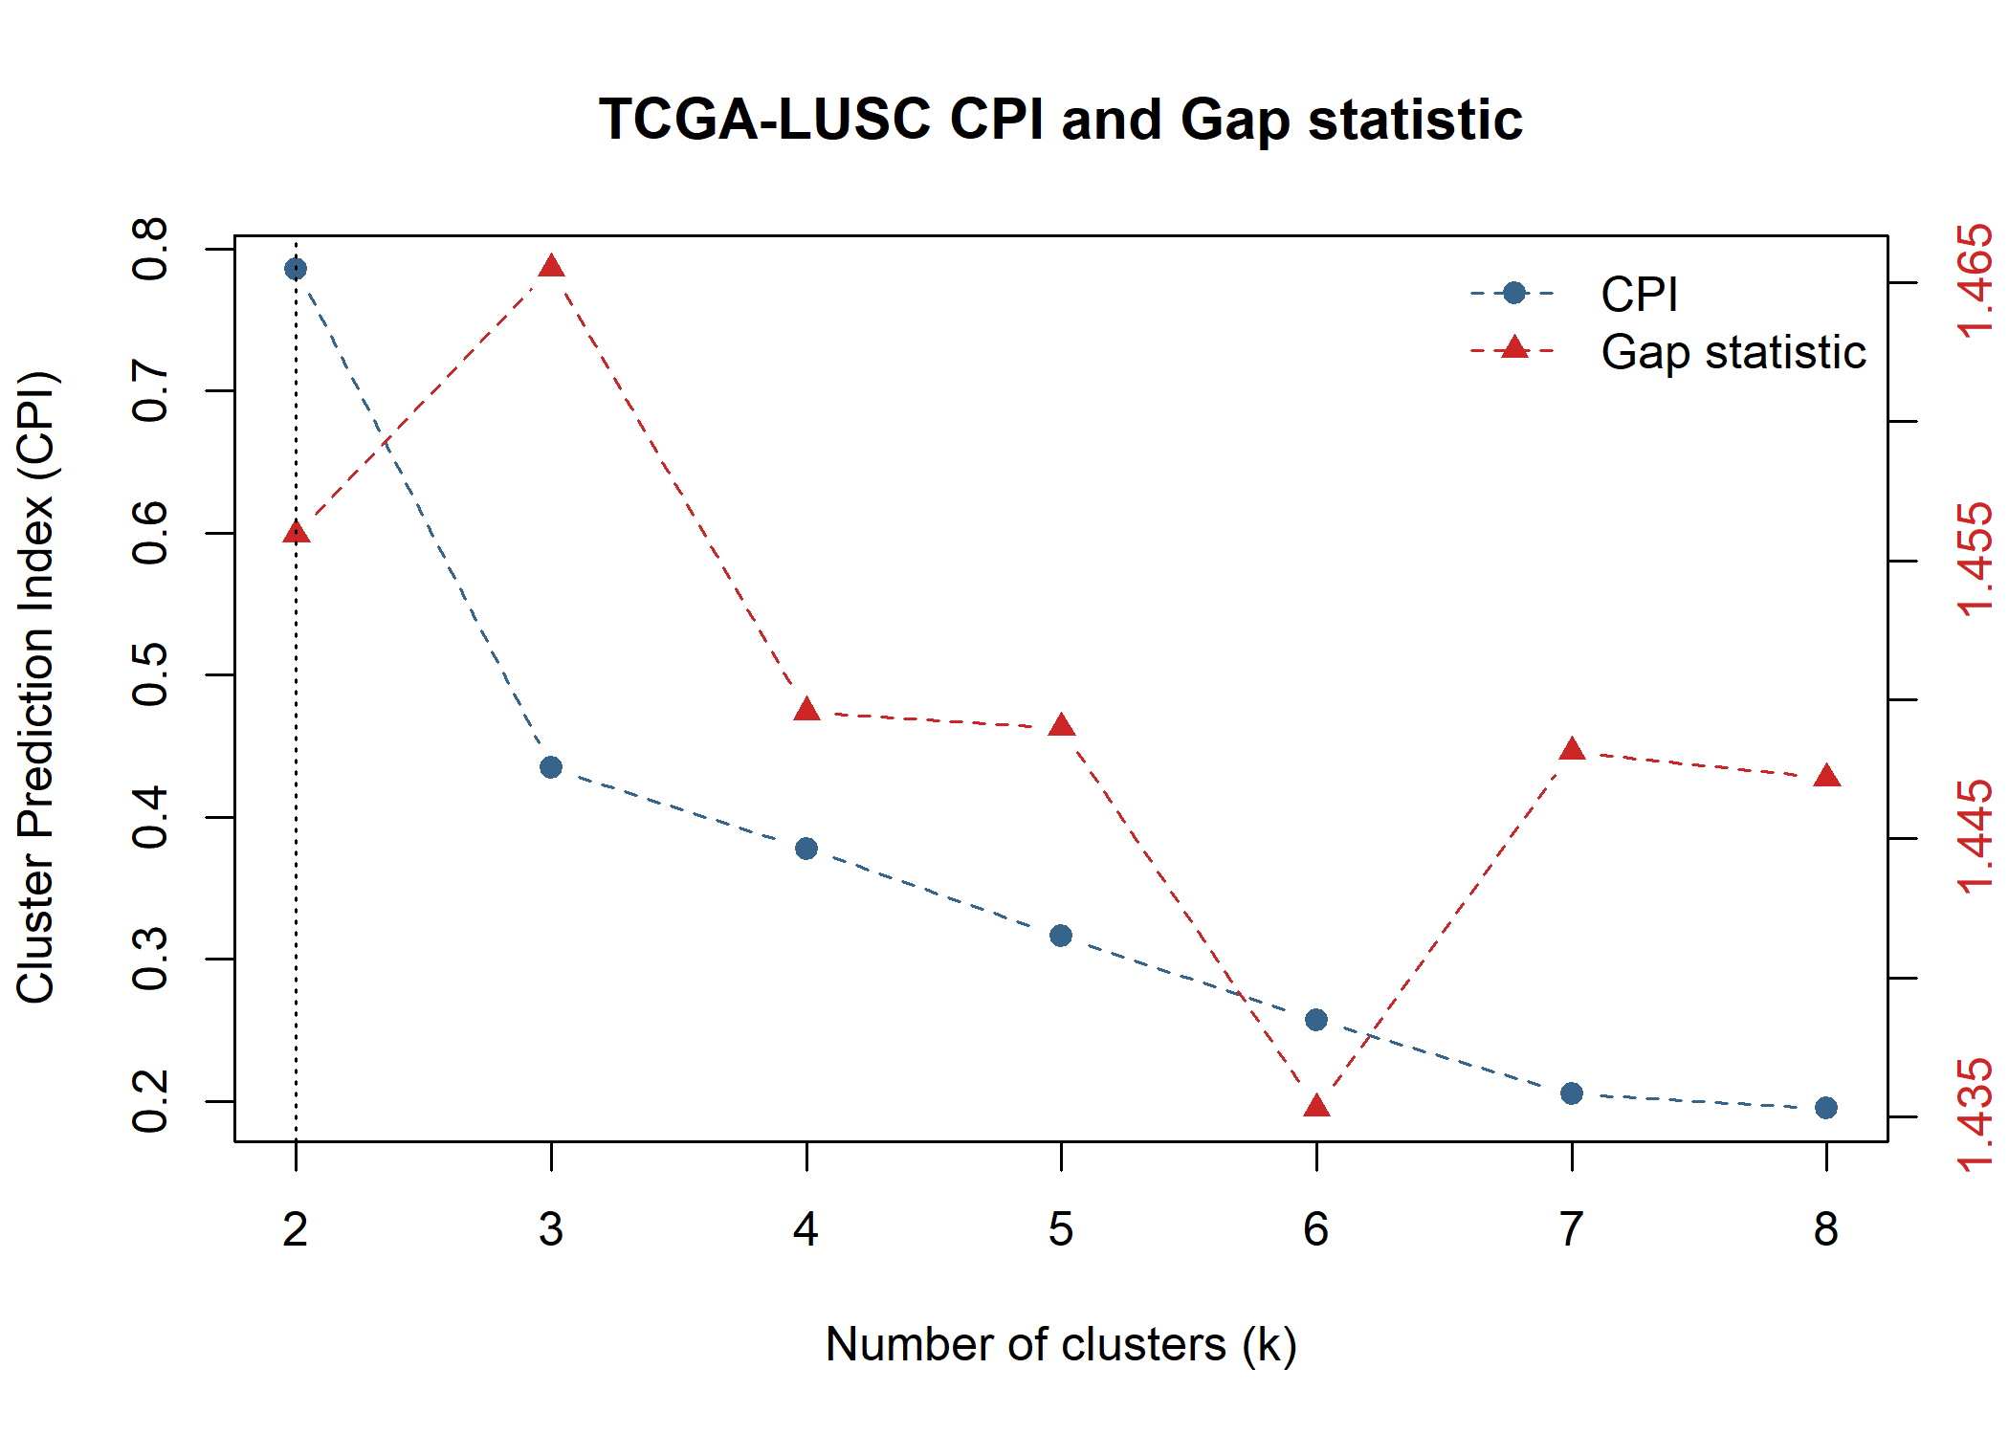
Figure 24 Supplementary Figure S2. Cluster-number diagnostics for TCGA-LUSC.
Caption: The cluster prediction index (CPI; blue circles, left axis) and gap statistic (red triangles, right axis) are shown for candidate cluster numbers k = 2–8. The dotted vertical line marks the selected two-cluster solution. CPI was highest at k = 2, while the gap statistic was highest at k = 3. Cluster number was selected by considering these results together with the other diagnostics.
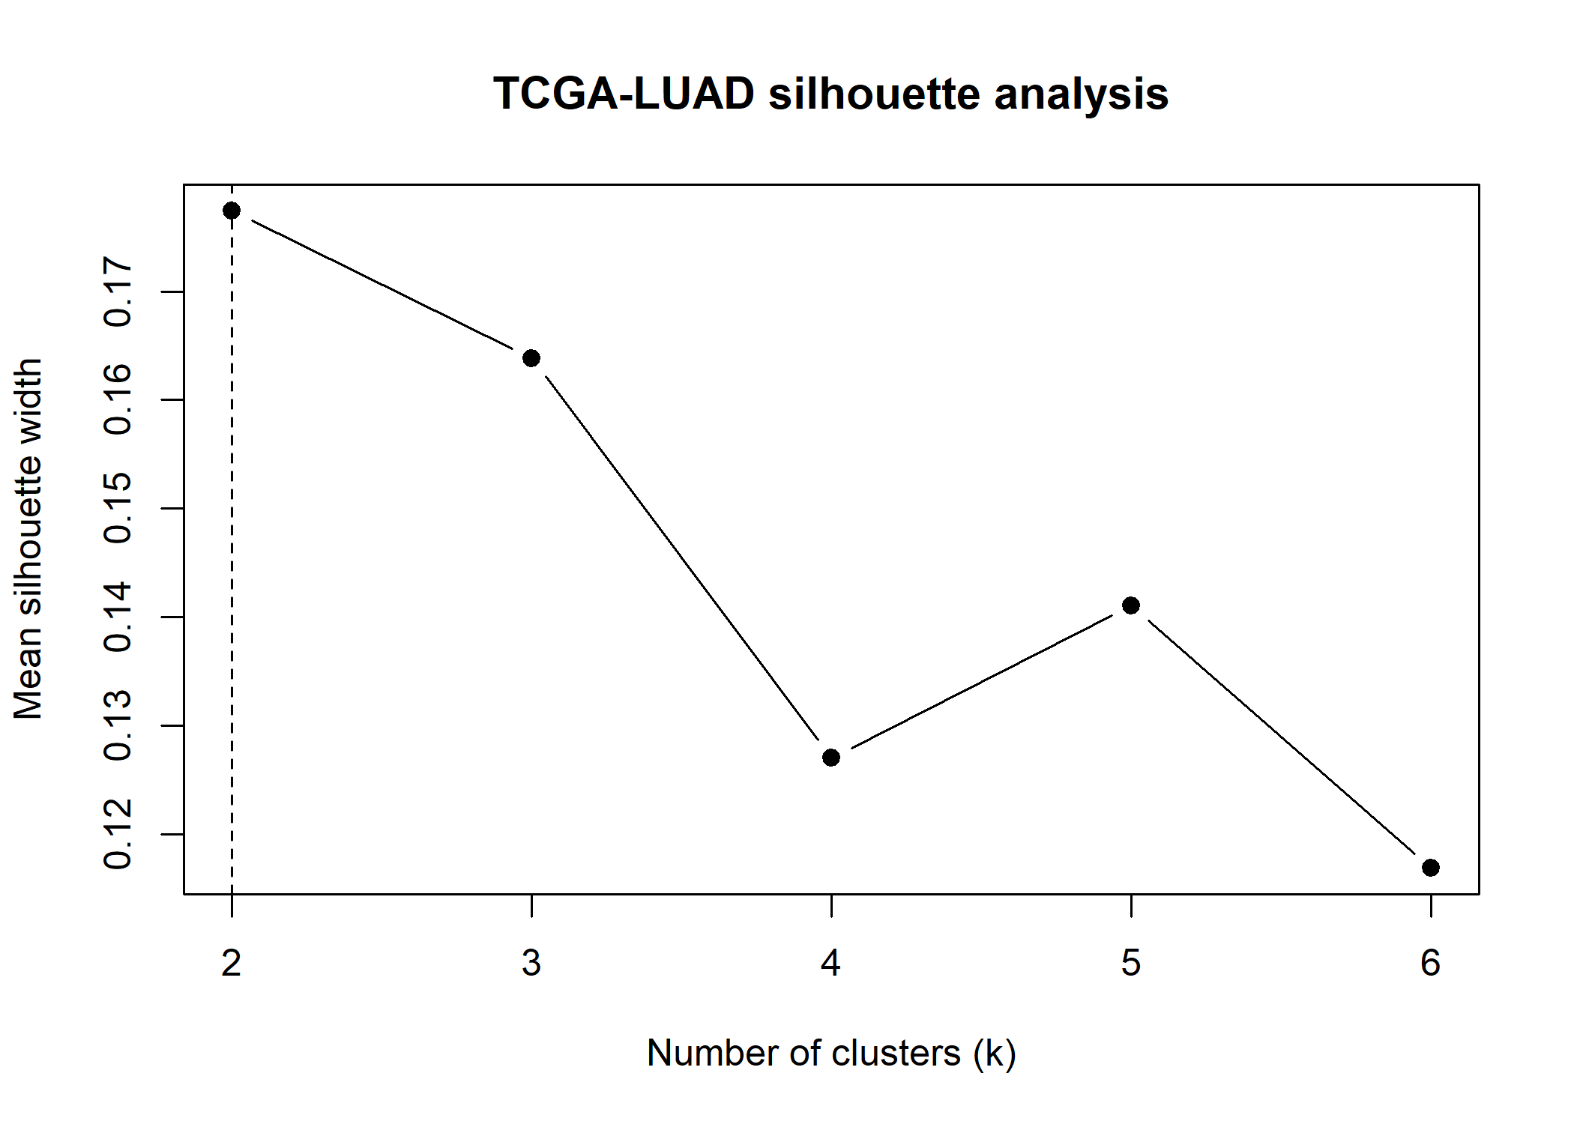
Figure 25 Supplementary Figure S3. Mean silhouette width across candidate cluster numbers in TCGA-LUAD.
Caption: Mean silhouette width is shown for k = 2–6 clusters. The dashed line marks the selected two-cluster solution, which had the highest mean silhouette width among those evaluated (approximately 0.177). The modest value indicates limited separation between the two groups.
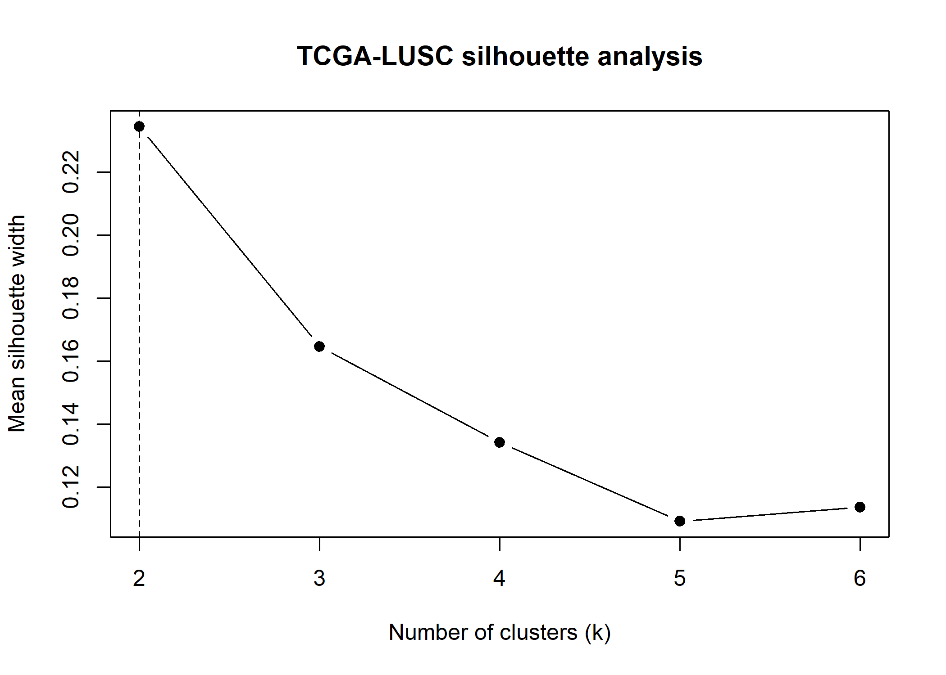
Figure 26 Supplementary Figure S4. Mean silhouette width across candidate cluster numbers in TCGA-LUSC.
Caption: Mean silhouette width is shown for k = 2–6 clusters. The dashed line marks the selected two-cluster solution, which had the highest mean silhouette width among those evaluated (approximately 0.235). This value indicates modest separation between the two groups.

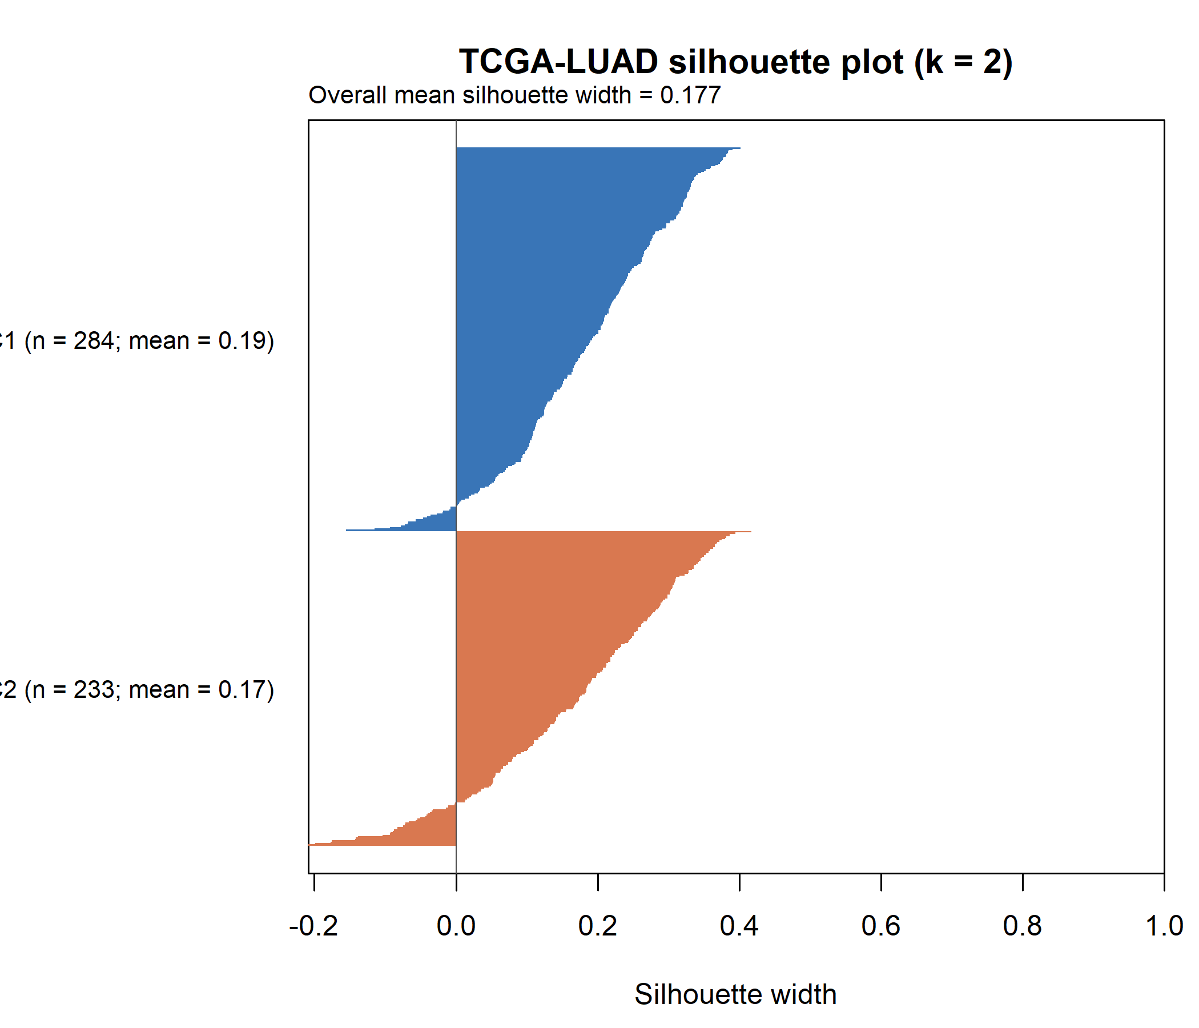  Figure 27 Supplementary Figure S5. Sample-level silhouette plot for the two TCGA-LUAD PCD subtypes.  Caption: Each horizontal bar represents one of 517 tumour samples. Blue bars indicate PCD_C1 (n = 284), and orange bars indicate PCD_C2 (n = 233). Positive widths indicate that a sample is closer to its assigned cluster than to the other cluster; negative widths indicate the reverse. The overall mean silhouette width was 0.177, indicating modest separation. | 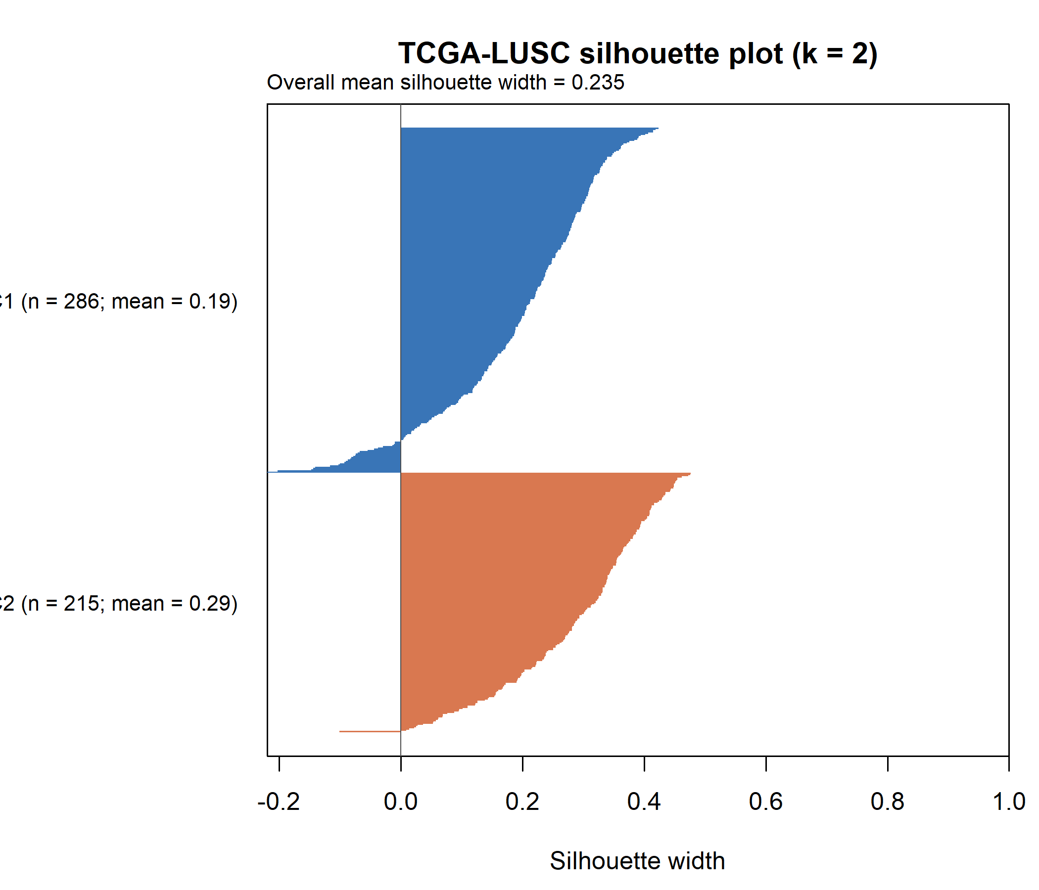  Figure 28 Supplementary Figure S6. Sample-level silhouette plot for the two TCGA-LUSC PCD subtypes.  Caption: Each horizontal bar represents one of 501 tumour samples. Blue bars indicate PCD_C1 (n = 286), and orange bars indicate PCD_C2 (n = 215). Positive widths indicate that a sample is closer to its assigned cluster than to the other cluster; negative widths indicate the reverse. The overall mean silhouette width was 0.235, indicating modest separation.
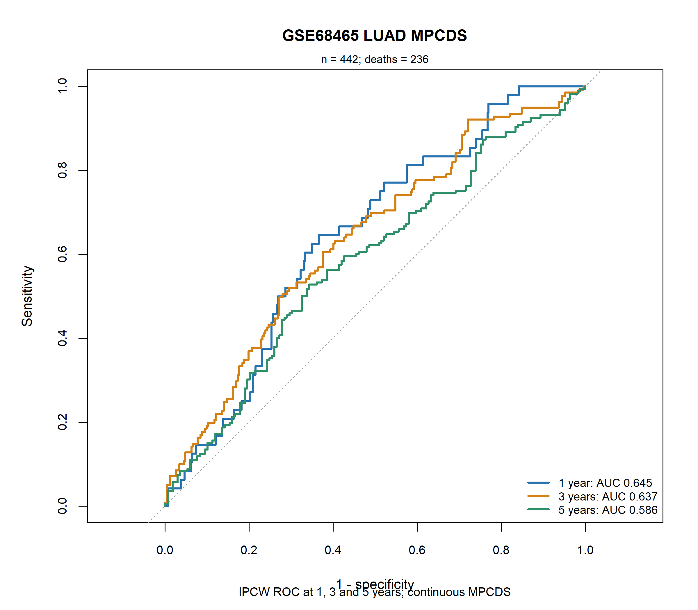  Figure 29 Supplementary Figure S7. Time-dependent ROC curves for the continuous LUAD MPCDS in GSE68465.  Caption: Inverse-probability-of-censoring-weighted ROC curves show discrimination for overall survival at 1, 3 and 5 years. The analysis included 442 patients and 236 observed deaths; the respective AUCs were 0.645, 0.637 and 0.586. |  | 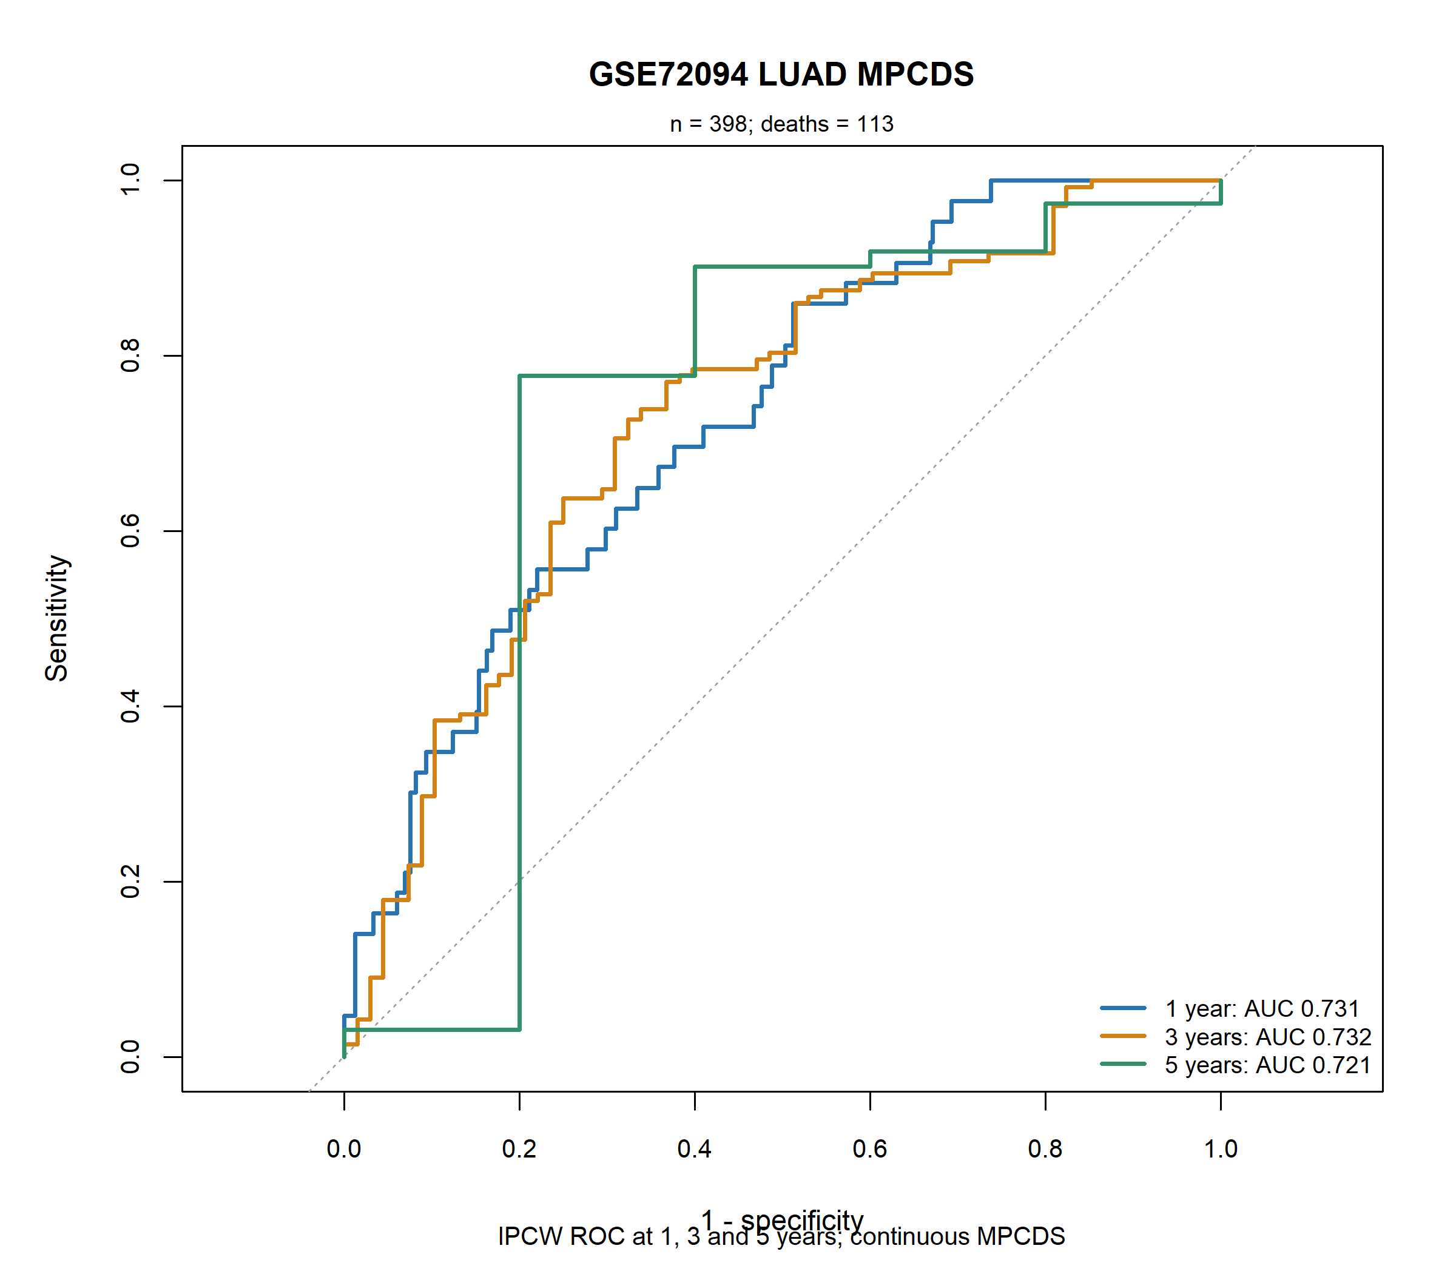  Figure 30 Supplementary Figure S8. Time-dependent ROC curves for the continuous LUAD MPCDS in GSE72094.  Caption: Inverse-probability-of-censoring-weighted ROC curves show discrimination for overall survival at 1, 3 and 5 years. The analysis included 398 patients and 113 observed deaths; the respective AUCs were 0.731, 0.732 and 0.721. The 5-year estimate should be interpreted cautiously because few patients were known to survive beyond that time point.

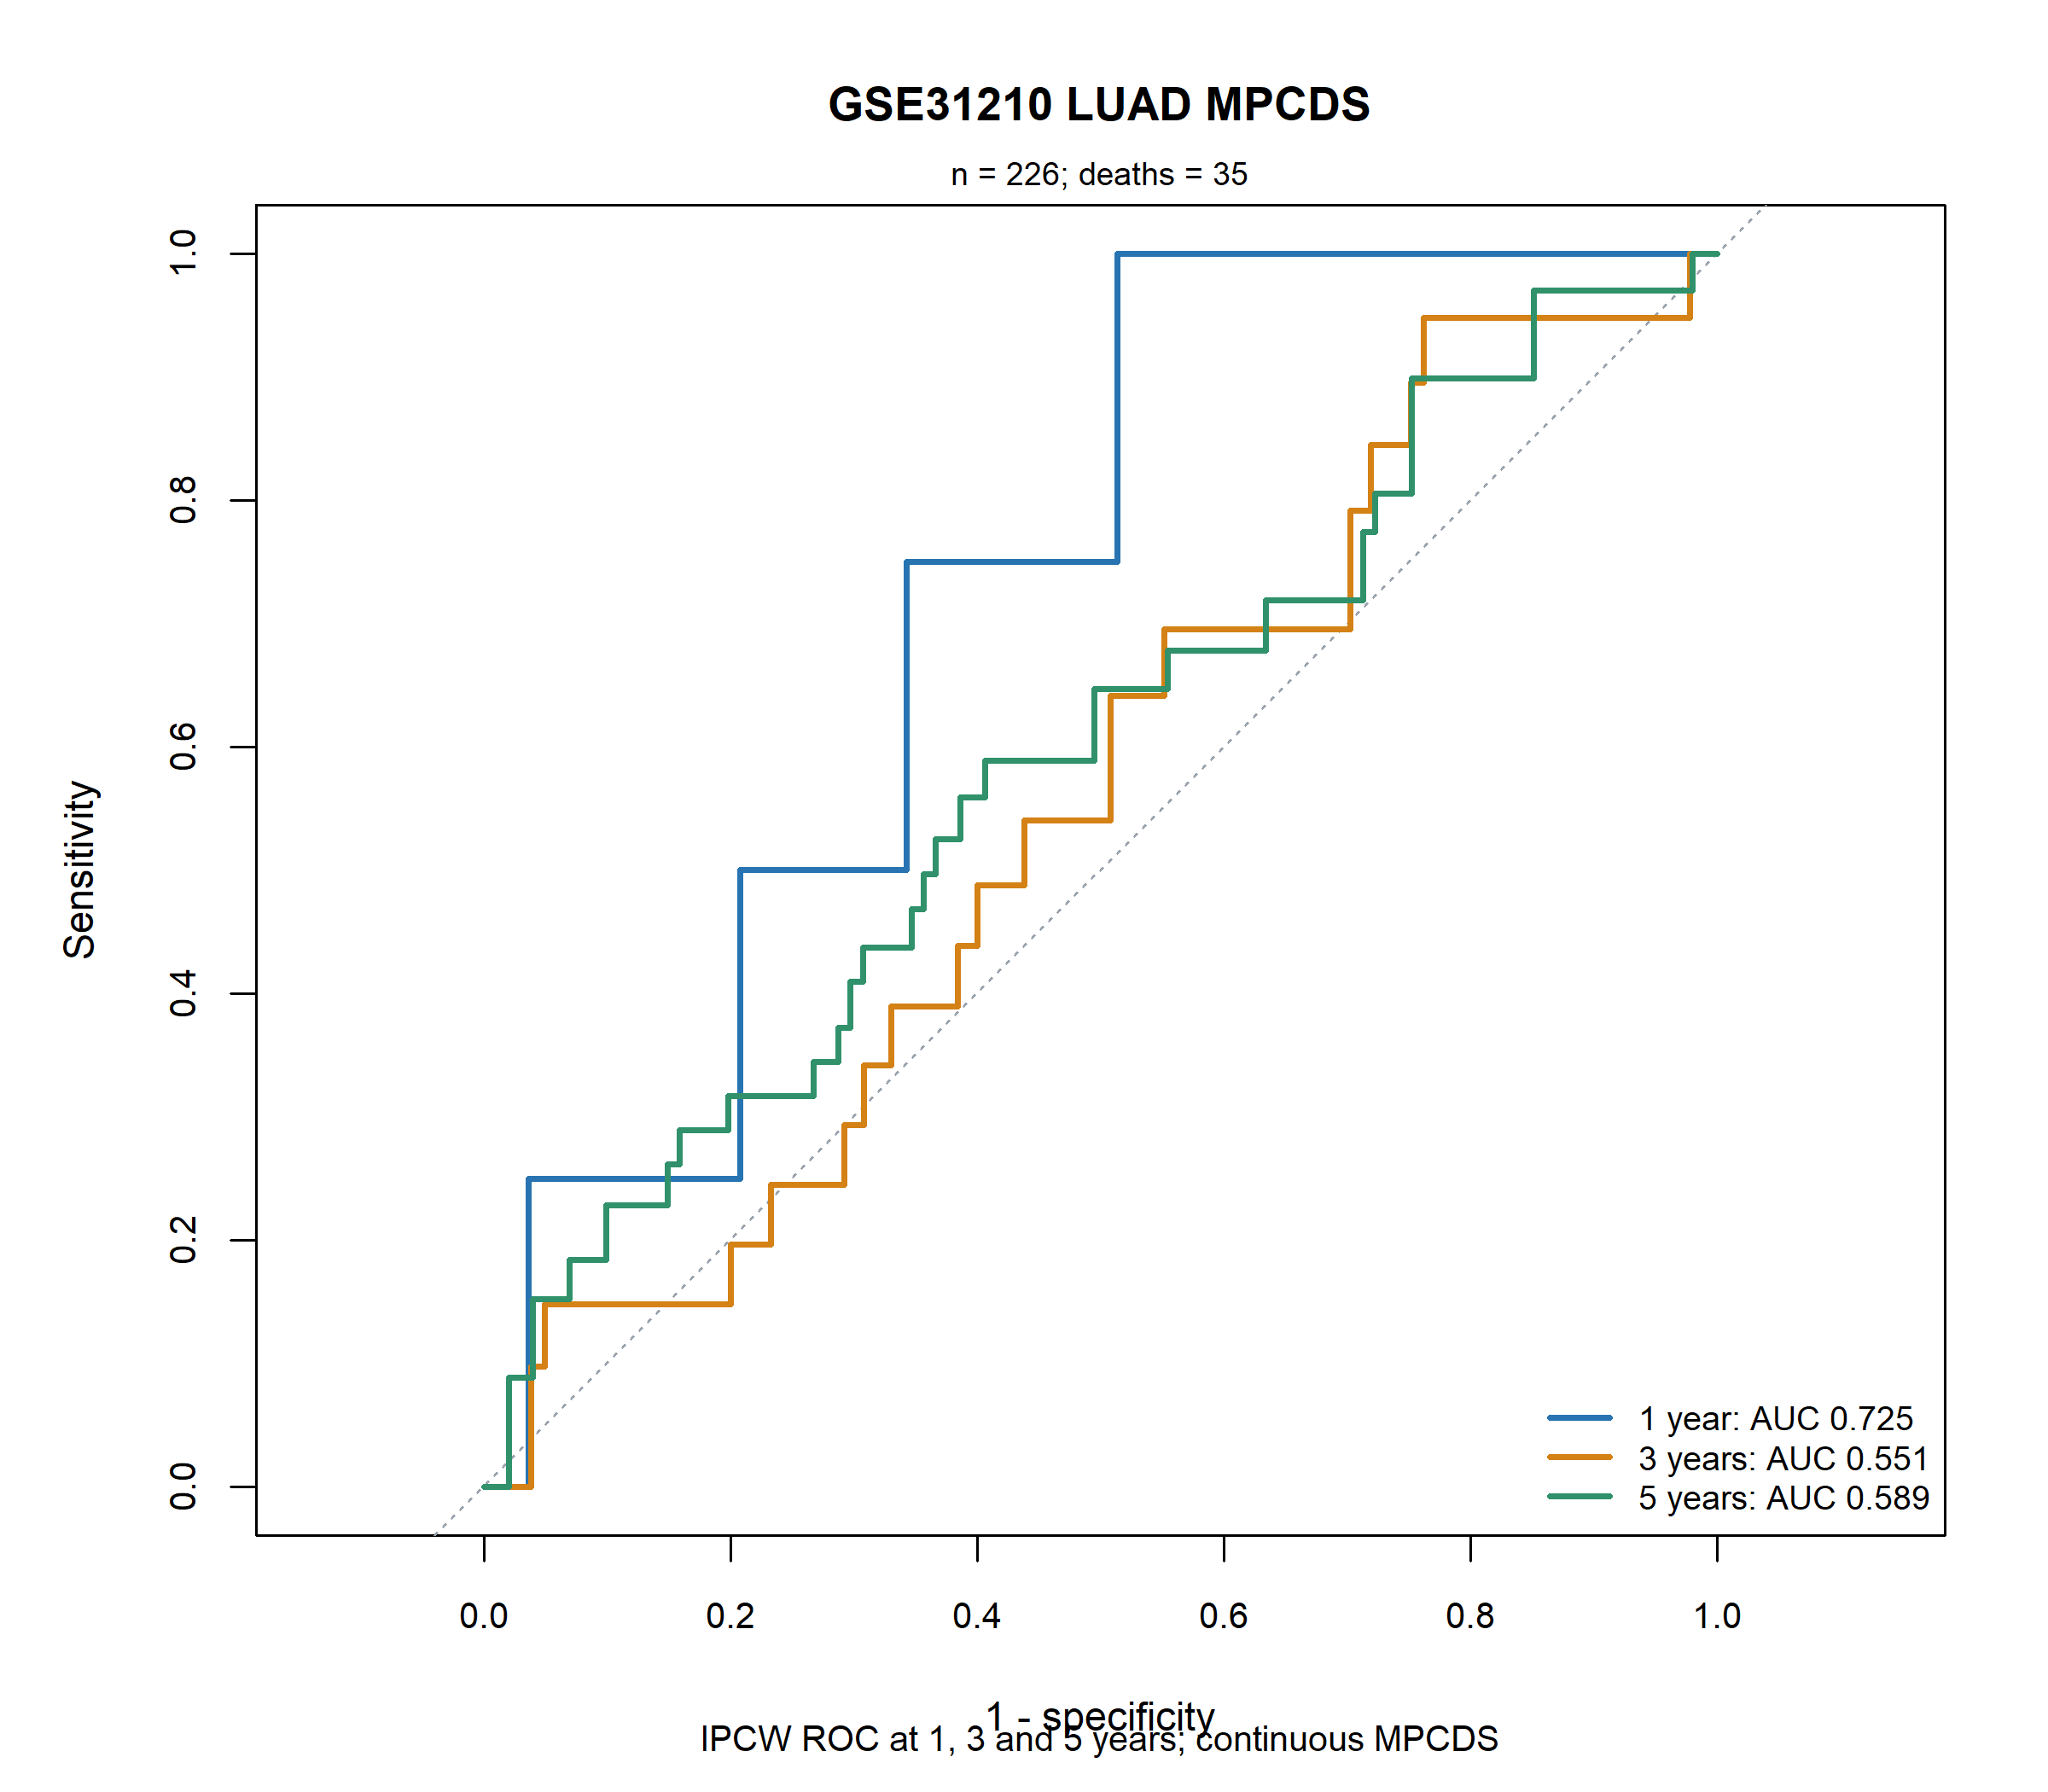  Figure 31 Supplementary Figure S9. Time-dependent ROC curves for the continuous LUAD MPCDS in GSE31210.  Caption: Inverse-probability-of-censoring-weighted ROC curves show discrimination for overall survival at 1, 3 and 5 years. The analysis included 226 patients and 35 observed deaths; the respective AUCs were 0.725, 0.551 and 0.589. | 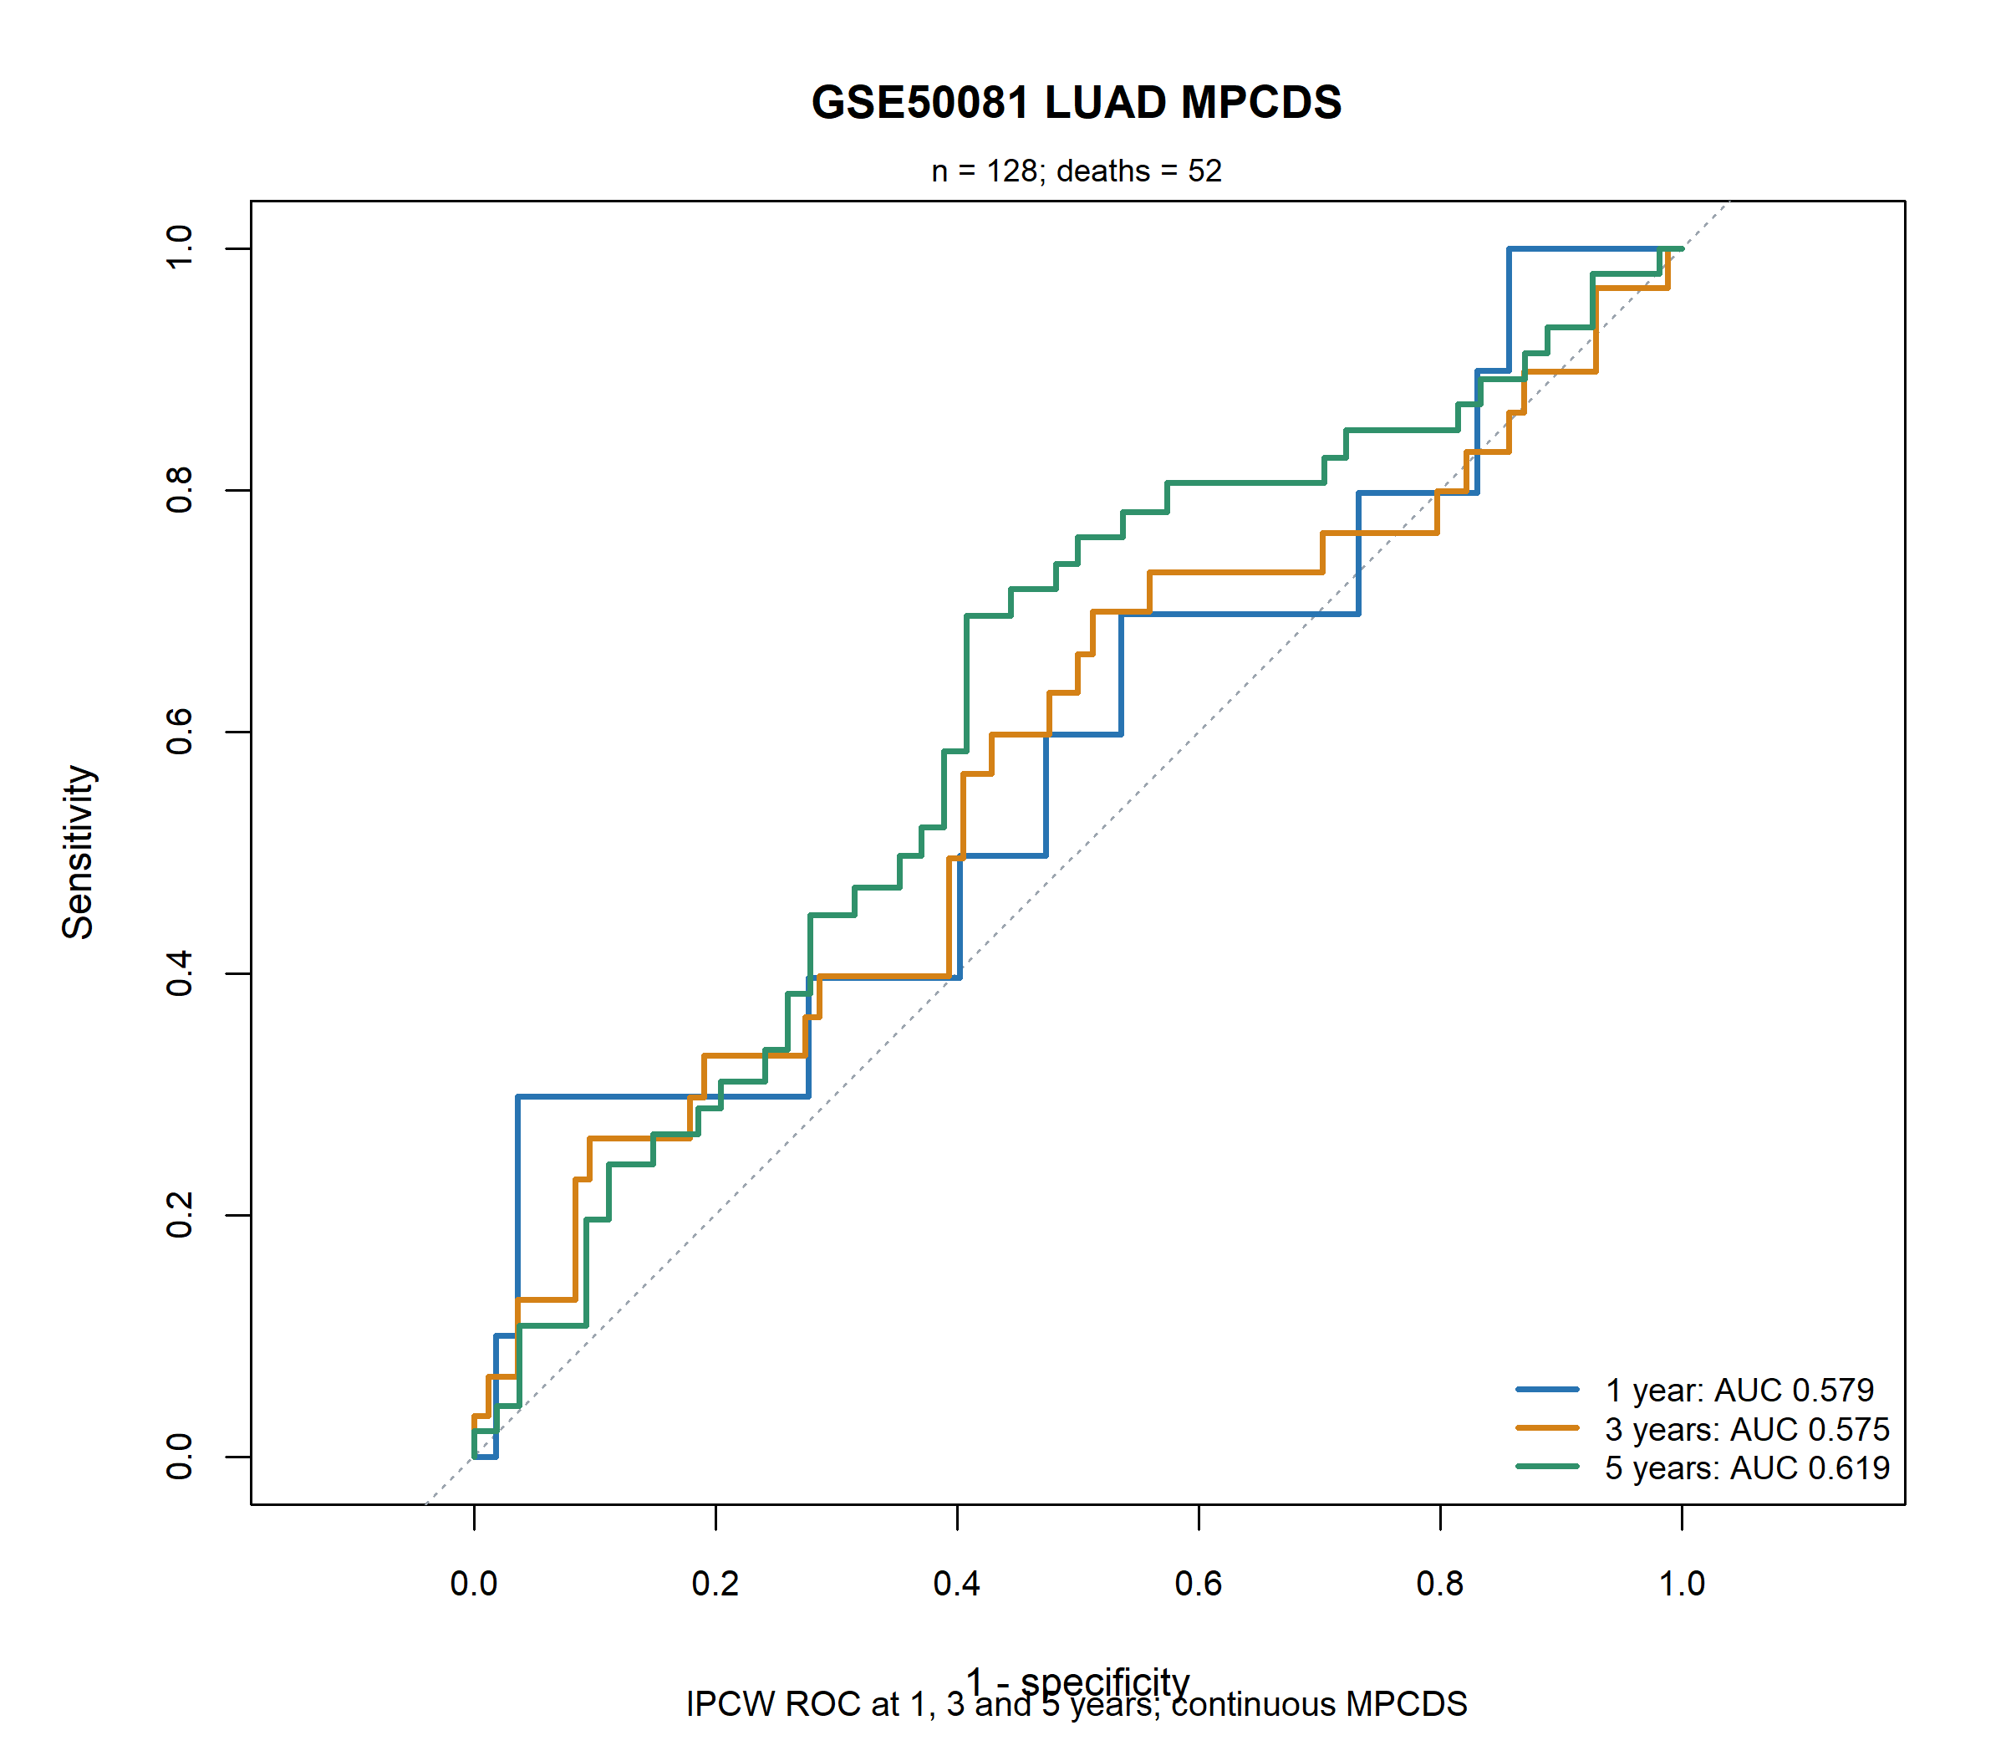  Figure 32 Supplementary Figure S10. Time-dependent ROC curves for the continuous LUAD MPCDS in GSE50081.  Caption: Inverse-probability-of-censoring-weighted ROC curves show discrimination for overall survival at 1, 3 and 5 years. The analysis included 128 patients and 52 observed deaths; the respective AUCs were 0.579, 0.575 and 0.619.

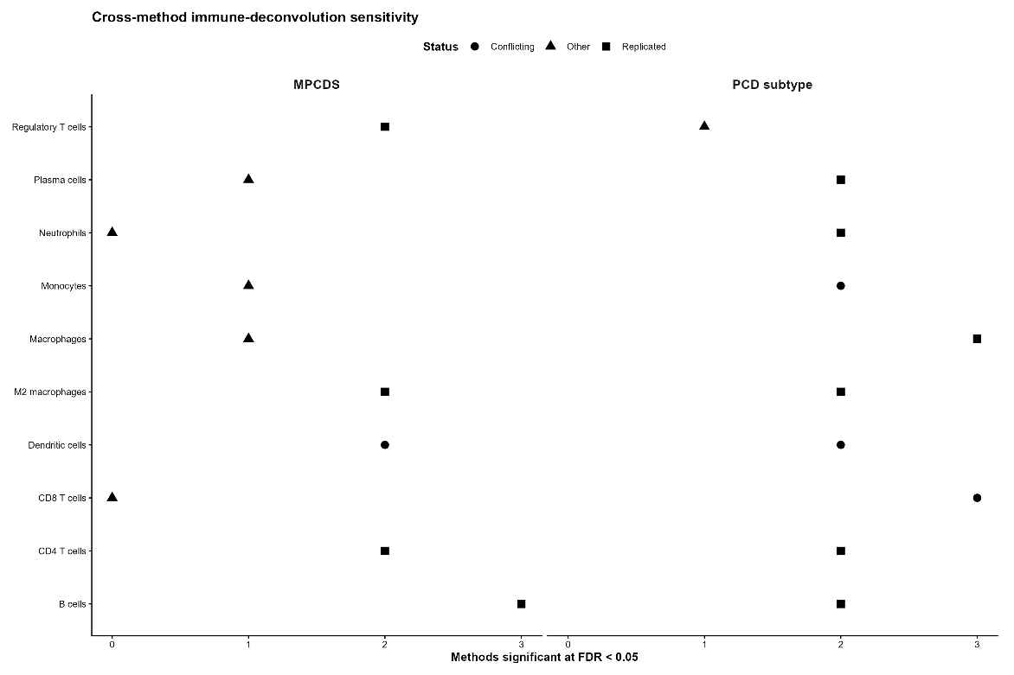
Figure 33 Supplementary Figure S11. Cross-method sensitivity of immune-cell associations in TCGA-LUAD
Caption: The left panel summarizes associations with continuous MPCDS and the right panel summarizes associations with PCD subtype. Horizontal position indicates the number of immune-estimation methods reporting an association at false-discovery-rate-adjusted P < 0.05. Plot symbols distinguish replicated, conflicting and other patterns across methods.

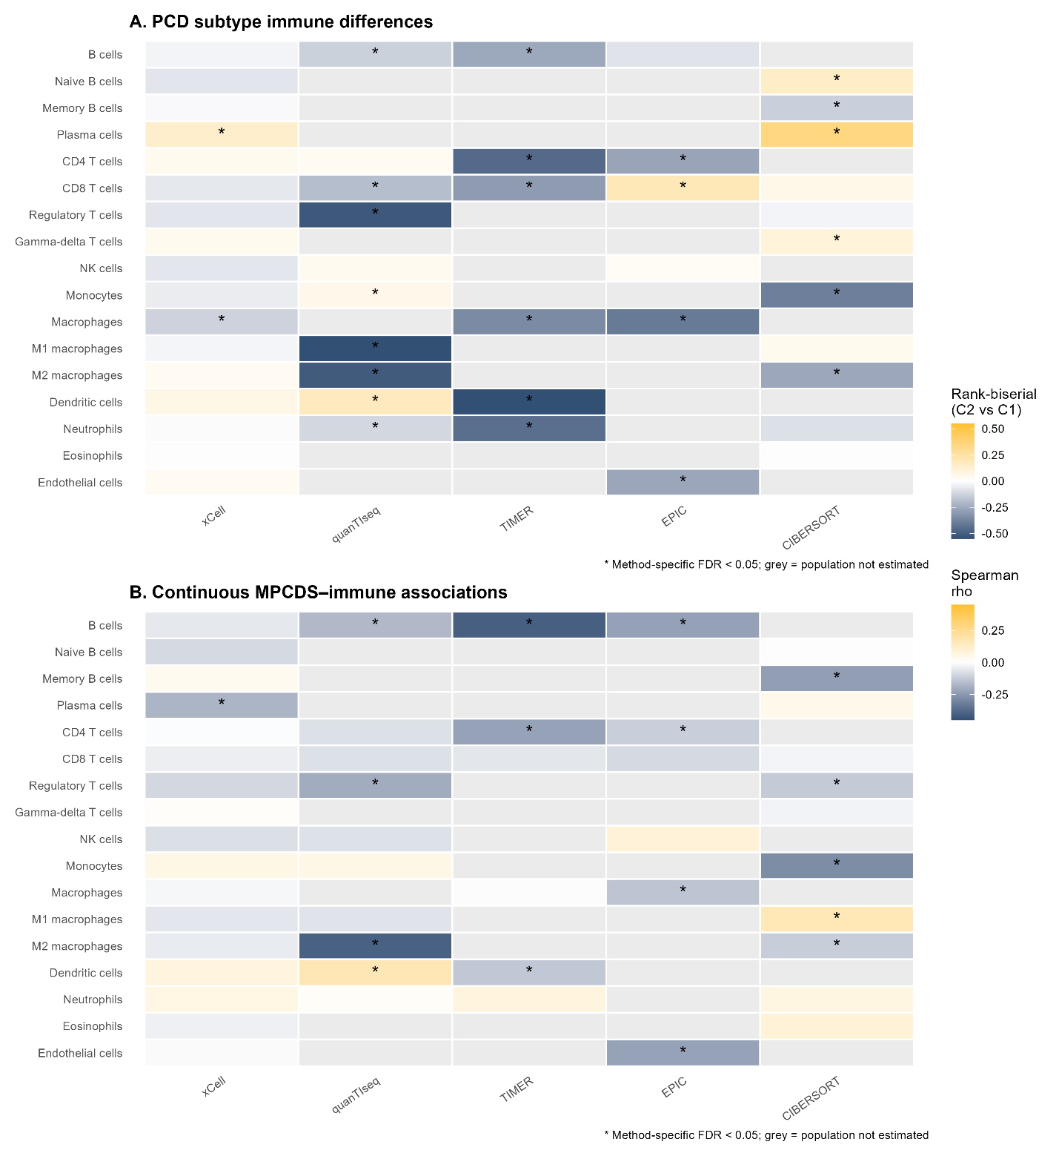
Figure 34 Supplementary Figure S12. Immune-cell associations across five computational estimation methods in TCGA-LUAD.
Caption: (A) PCD_C2 versus PCD_C1 differences are displayed as rank-biserial correlations. (B) Associations with continuous MPCDS are displayed as Spearman correlation coefficients. Columns represent xCell, quanTIseq, TIMER, EPIC and CIBERSORT. Asterisks indicate method-specific associations with false-discovery-rate-adjusted P < 0.05; grey cells indicate populations not estimated by that method.

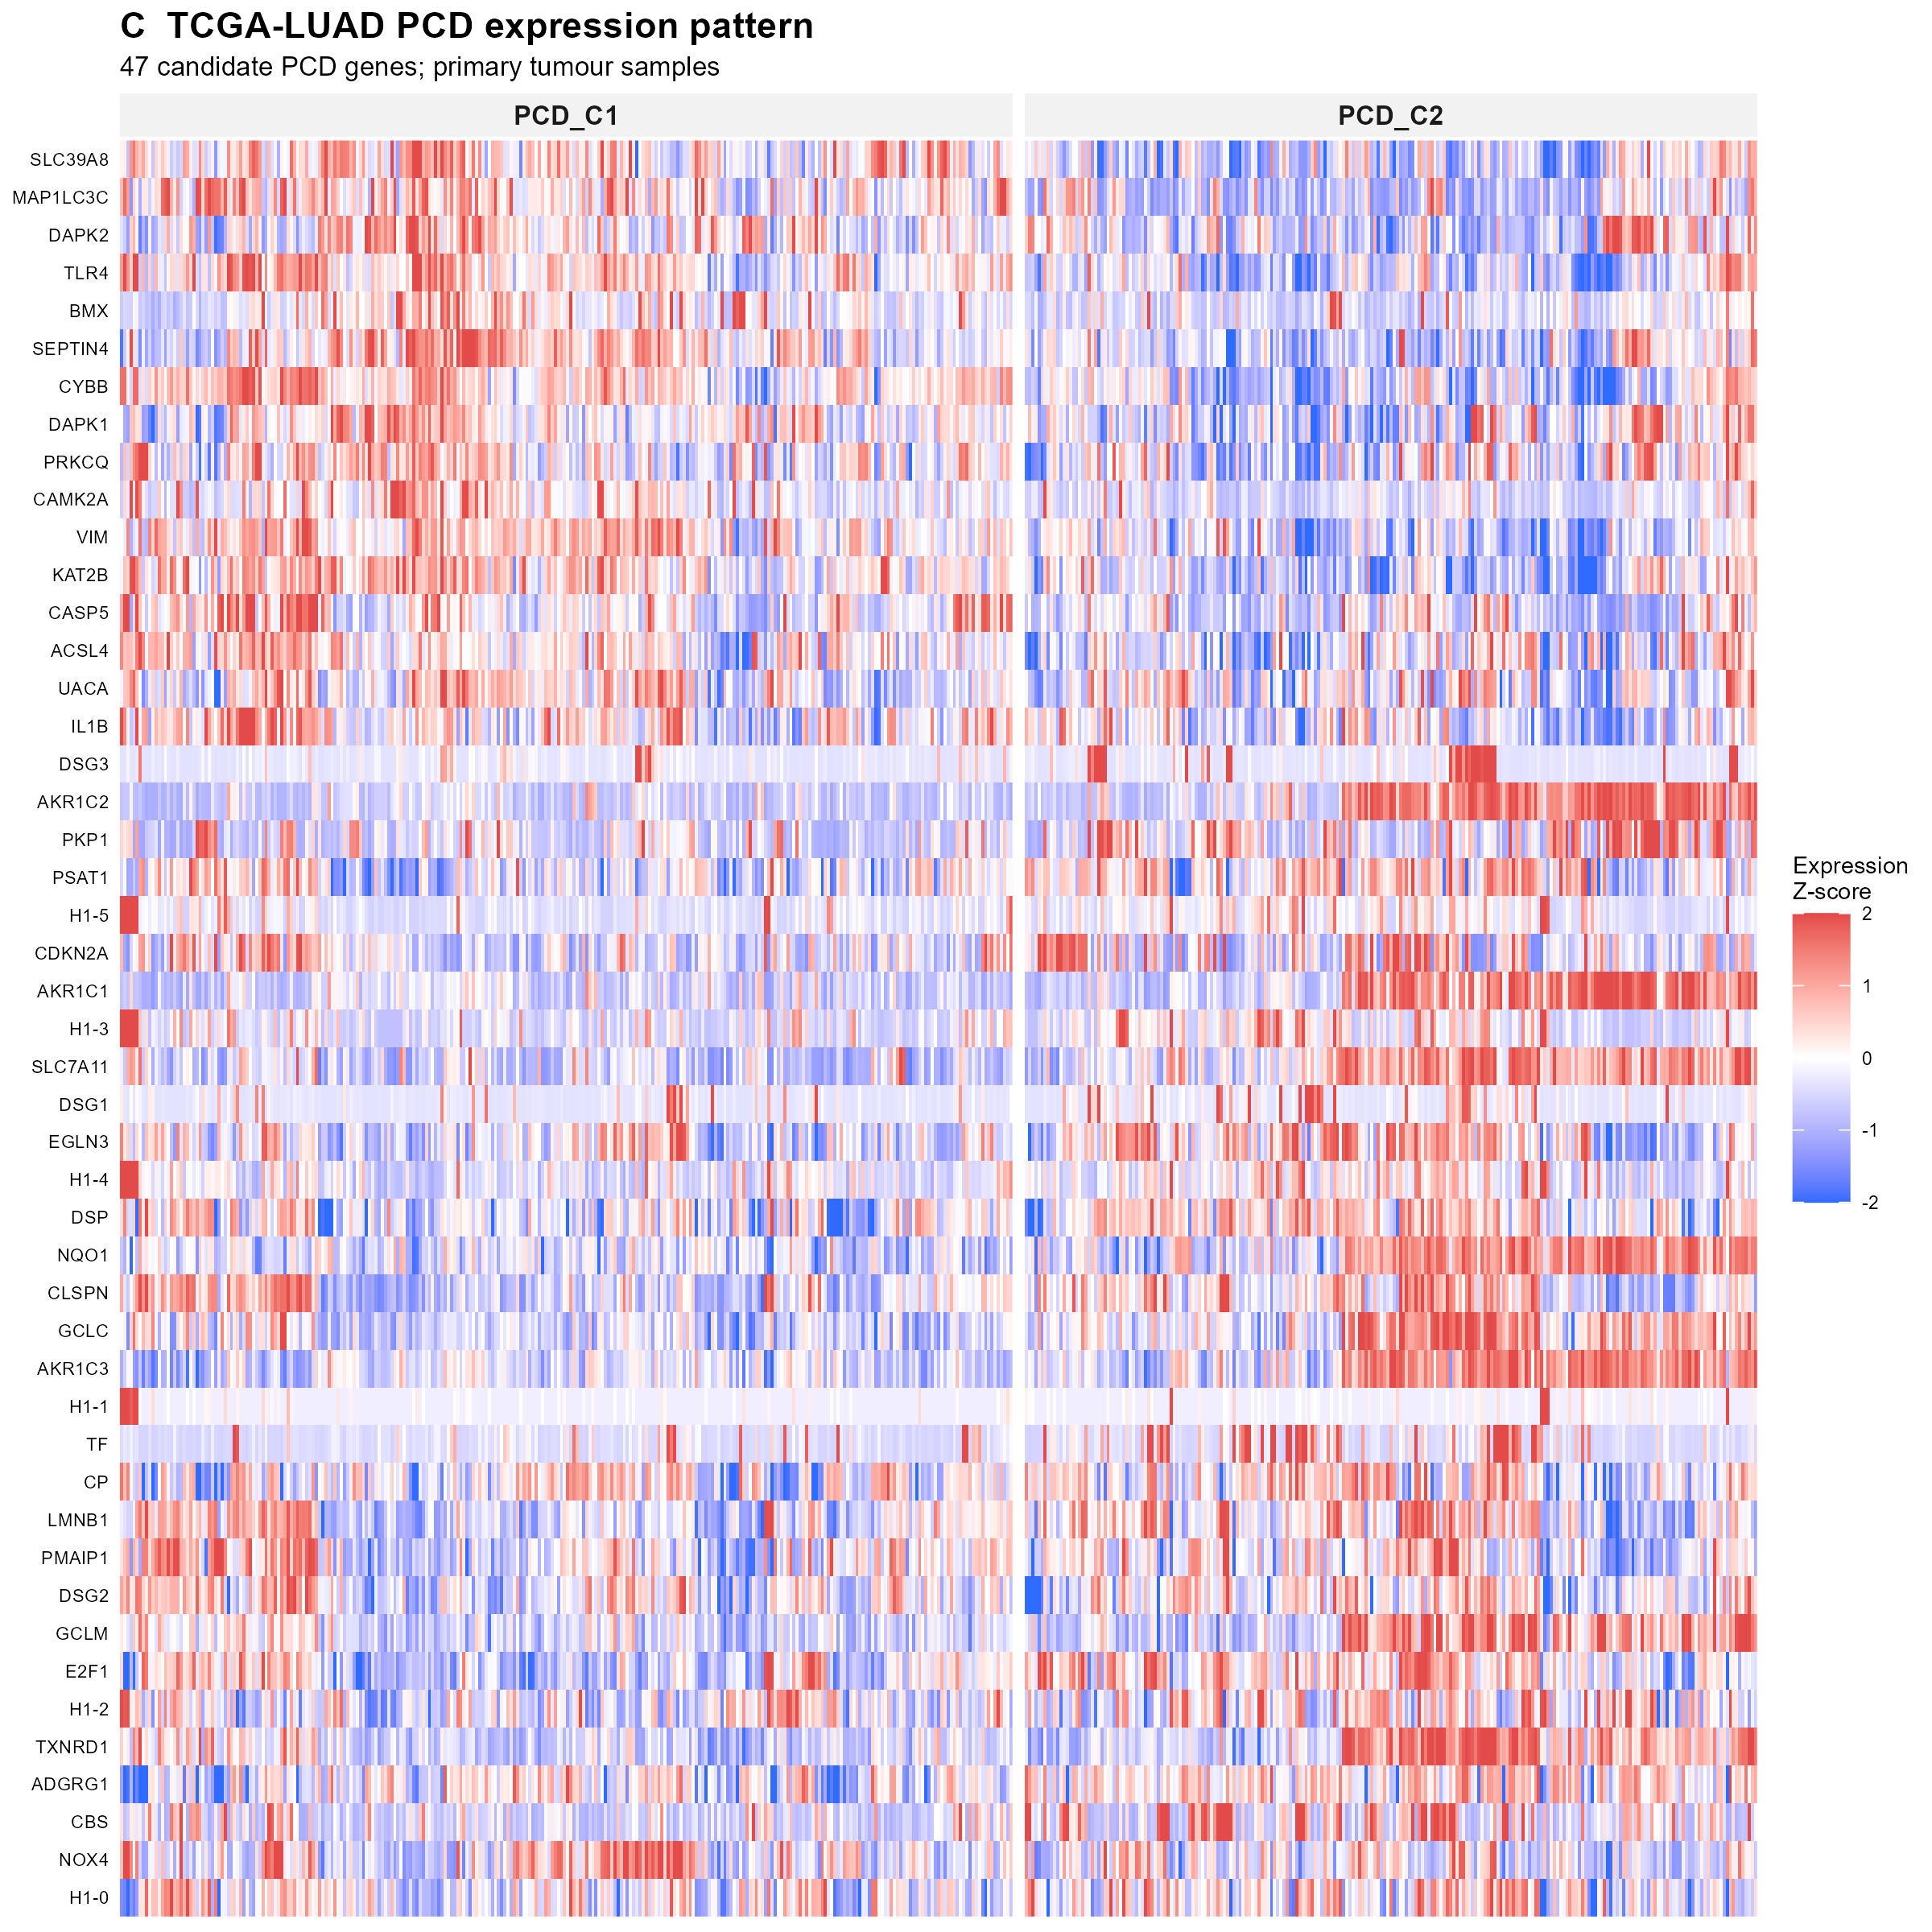
Figure 35 Supplementary Figure S13. Expression of the 47 concordant PCD genes across TCGA-LUAD molecular subtypes.
Caption: Columns represent primary tumour samples grouped by PCD_C1 and PCD_C2; rows represent the 47 subtype-defining genes. Colours show gene-wise standardized expression, with blue indicating lower and red indicating higher relative expression. The full-size panel allows individual gene labels and within-subtype variation to be inspected.

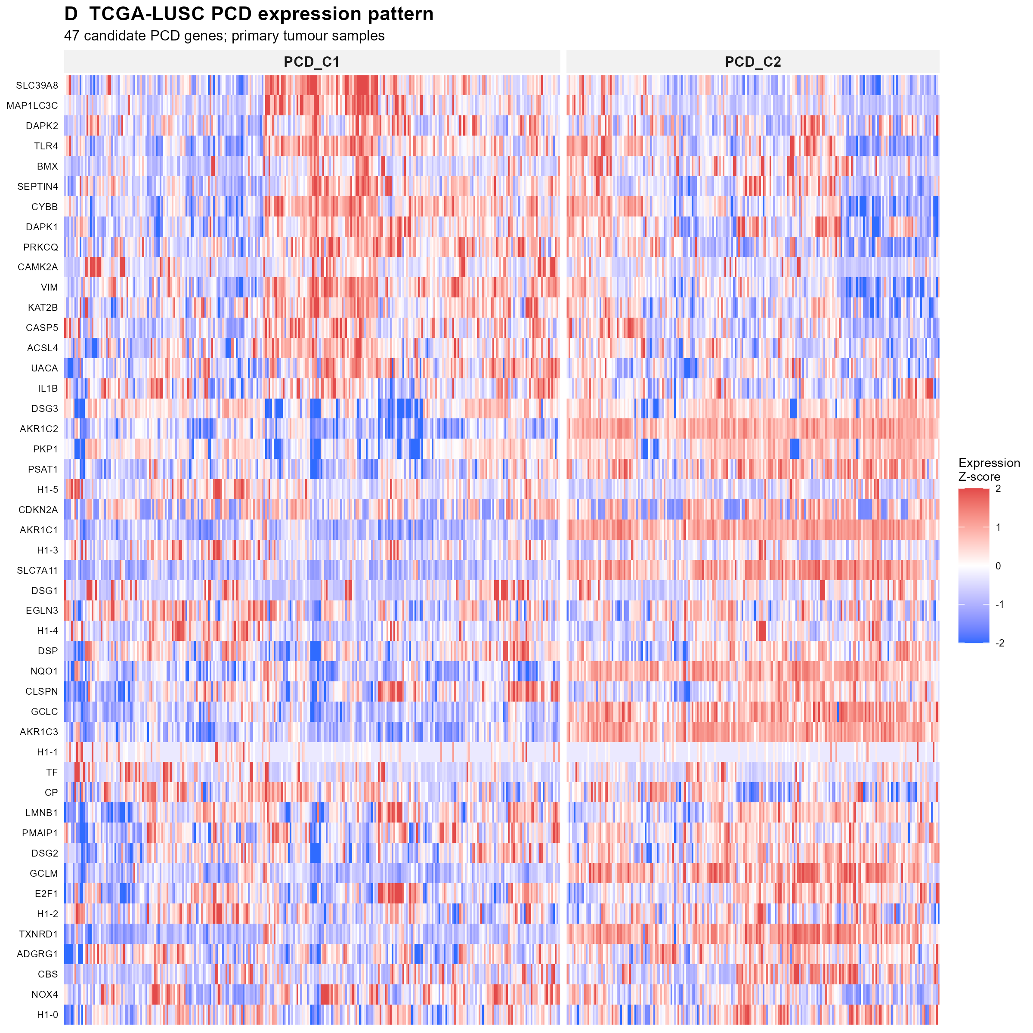
Figure 36 Supplementary Figure S14. Expression of the 47 concordant PCD genes across TCGA-LUSC molecular subtypes.
Caption: Columns represent primary tumour samples grouped by PCD_C1 and PCD_C2; rows represent the 47 subtype-defining genes. Colours show gene-wise standardized expression, with blue indicating lower and red indicating higher relative expression. LUAD and LUSC subtypes were identified independently.

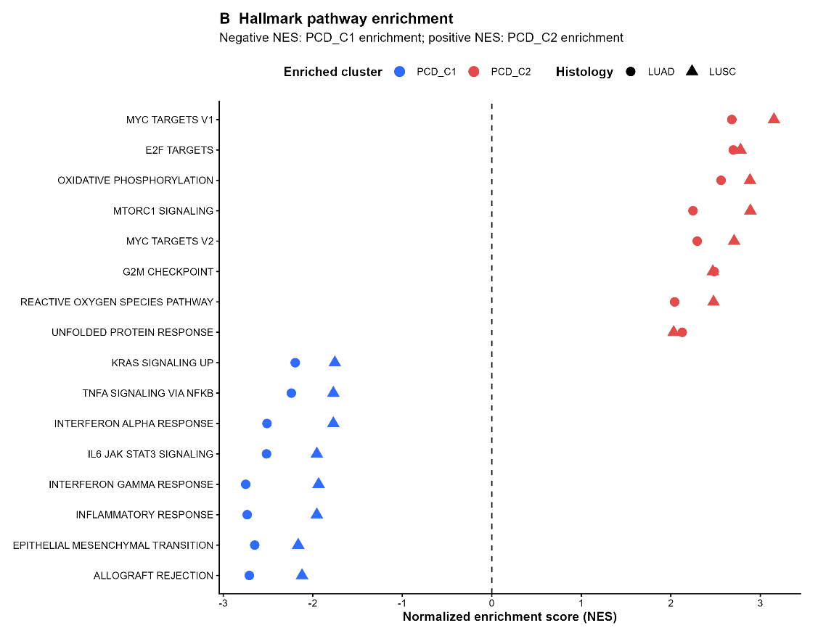
Figure 37 Supplementary Figure S15. Selected Hallmark pathway differences between PCD molecular subtypes.
Caption: Normalized enrichment scores are shown separately for LUAD (circles) and LUSC (triangles). Negative scores indicate enrichment toward PCD_C1, whereas positive scores indicate enrichment toward PCD_C2. The displayed pathways illustrate immune and inflammatory programmes associated with PCD_C1 and proliferative or metabolic programmes associated with PCD_C2.
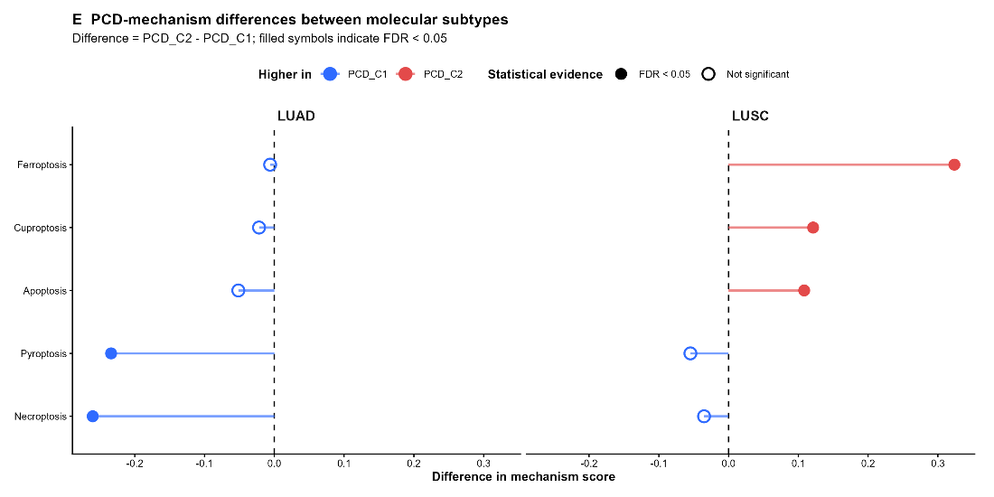
Figure 38 Supplementary Figure S16. Differences in programmed cell death mechanism scores between molecular subtypes in TCGA-LUAD and TCGA-LUSC.
Caption: Points show the difference calculated as PCD_C2 minus PCD_C1 for apoptosis, necroptosis, pyroptosis, ferroptosis and cuproptosis. Negative values indicate higher scores in PCD_C1; positive values indicate higher scores in PCD_C2. Filled symbols indicate false-discovery-rate-adjusted P < 0.05. Subtypes were defined independently in the two histologies.
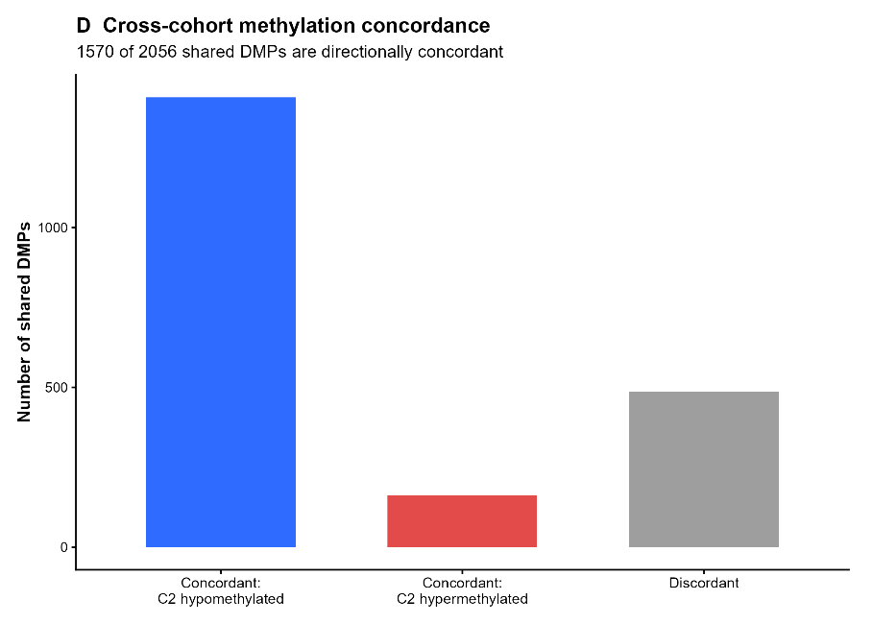
Figure 39 Supplementary Figure S17. Directional concordance of subtype-associated DNA methylation across TCGA-LUAD and TCGA-LUSC.
Caption: Of 2,056 CpG probes differentially methylated between PCD subtypes in both histologies, 1,570 showed the same direction of change. Bars distinguish concordant sites relatively hypomethylated in PCD_C2, concordant sites relatively hypermethylated in PCD_C2 and sites with discordant directions between histologies.
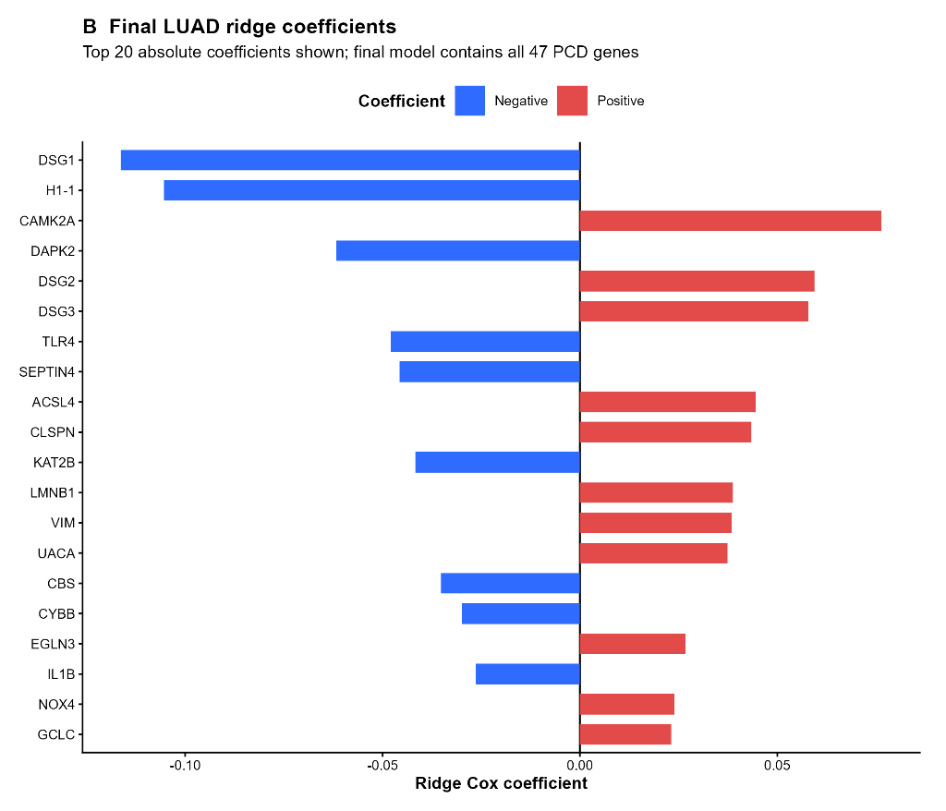
Figure 40 Supplementary Figure S18. Largest coefficients in the final TCGA-LUAD ridge-Cox MPCDS model.
Caption: The plot displays the 20 genes with the largest absolute fitted coefficients and indicates coefficient direction. The final prognostic score retained all 47 candidate PCD genes; showing 20 genes here is for visualization only.
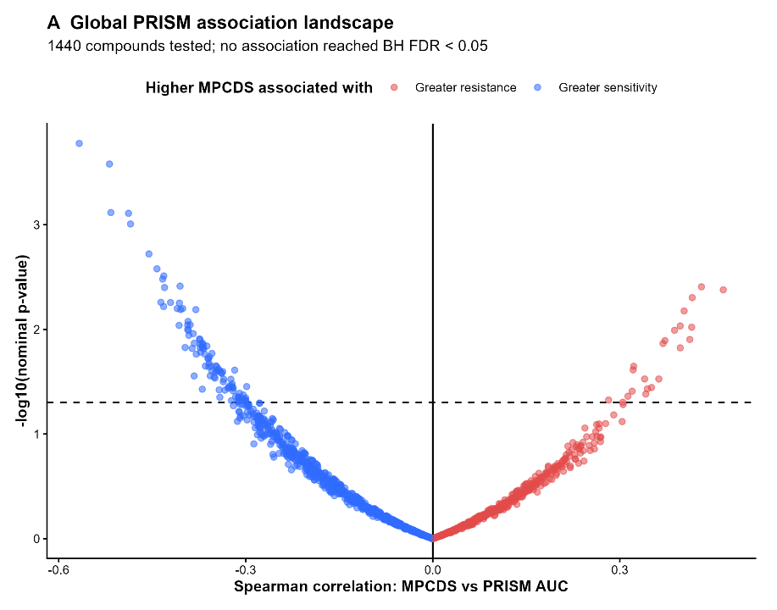
Figure 41 Supplementary Figure S19. Global association landscape for MPCDS and PRISM drug-response measurements in LUAD cell lines. Each point represents one of 1,440 tested compounds.
Caption: The horizontal axis shows the Spearman correlation between continuous MPCDS and PRISM response AUC; the vertical axis shows the negative logarithm of the nominal P-value. Negative correlations indicate greater relative sensitivity with increasing MPCDS. No compound met the Benjamini–Hochberg false-discovery-rate threshold of 0.05.
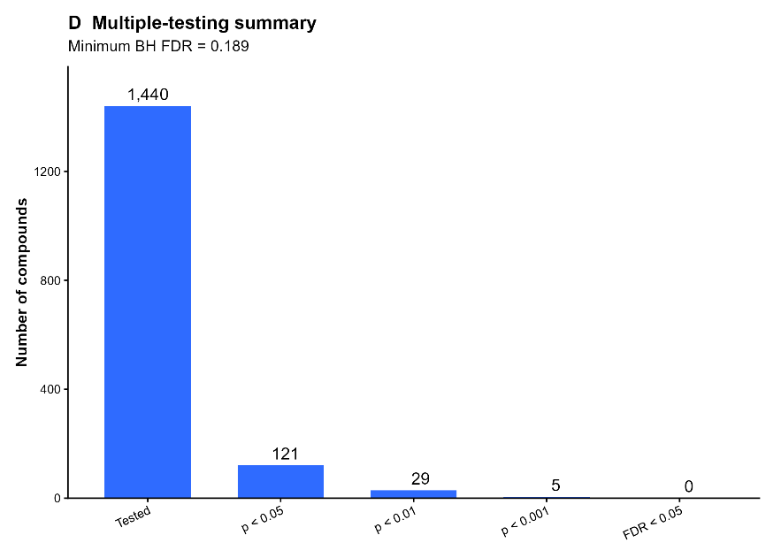
Figure 42 Supplementary Figure S20. Multiple-testing summary of MPCDS–PRISM drug-response associations.
Caption: Of 1,440 tested compounds, 121 had nominal P < 0.05, 29 had P < 0.01 and five had P < 0.001. None met the Benjamini–Hochberg false-discovery-rate threshold of 0.05; the minimum adjusted P-value was 0.189. These cell-line associations are exploratory and do not establish patient treatment response.

APPENDIX B SUPPLEMENTARY TABLES
The following tables are provided as separate electronic supplementary files. File paths are relative to the project folder supplied with the thesis.
Supplementary Table S1. Curated programmed cell death gene catalogue. The file lists 296 unique PCD-related genes, their assigned PCD mechanisms and source gene sets.
File: 02_processed_data/PCD_genes/PCD_master_unique_genes.csv

Supplementary Table S2. Concordantly dysregulated PCD candidate genes. The file lists the 47 genes significantly altered in both LUAD and LUSC with the same direction of tumour-versus-normal change.
File: 04_results/differential_expression/TCGA_concordant_PCD_candidates_LUAD_LUSC.csv

Supplementary Table S3. Integrated PCD subtype multi-omics summary. The file summarizes subtype composition and findings from immune, pathway, mutation, copy-number alteration and DNA methylation analyses in LUAD and LUSC.
File: 06_tables/final/Table_PCD_cluster_multiomics_summary.csv

Supplementary Table S4. Subtype-associated immune and stromal populations. The file reports seven selected cell populations assessed using MCP-counter, with subtype means and statistical comparisons for LUAD and LUSC.
File: 06_tables/final/Table_robust_immune_populations.csv

Supplementary Table S5. Selected Hallmark pathway associations. The file reports 16 selected Hallmark pathways, with normalized enrichment scores and adjusted P-values for LUAD and LUSC.
File: 06_tables/final/Table_top_robust_Hallmark_pathways.csv

Supplementary Table S6. Cross-histology DNA methylation concordance. The file summarizes the 2,056 significant differentially methylated probes shared between LUAD and LUSC, including 1,570 with concordant subtype-associated directions.
File: 06_tables/final/Table_methylation_concordance.csv

Supplementary Table S7. MPCDS internal and external validation summary. The file summarizes internal validation and prognostic results in four independent LUAD GEO cohorts: GSE68465, GSE72094, GSE31210 and GSE50081. The clinical-adjusted analysis listed in the file was conducted in GSE68465.
File: 06_tables/final/Table_03_MPCDS_validation_summary.csv

Supplementary Table S8. MPCDS prognostic associations in TCGA-LUAD and GSE68465. The file reports hazard ratios, confidence intervals and P-values for the TCGA-LUAD stage-stratified analysis and the unadjusted and clinical-adjusted analyses in GSE68465.
File: 06_tables/final/Table_MPCDS_prognostic_associations.csv

Supplementary Table S9. Exploratory PRISM pharmacogenomic signals. The file lists five nominal associations between MPCDS and PRISM drug-response AUC, with correlation and linear-model results. None of these associations remained significant after false-discovery-rate correction.
File: 06_tables/final/Table_PRISM_exploratory_nominal_signals.csv

Supplementary Table S10. Thesis objective completion audit. The file maps the study objectives to their completed analytical outputs.
File: 06_tables/final/Table_thesis_objective_completion_audit.csv

Supplementary Table S11. Proposal-to-implementation methodological mapping. The file records how proposed analytical components were implemented or addressed in the completed study.
File: 06_tables/final/Table_proposal_implementation_classification.csv

Supplementary Table S12. PCD genes passing expression filtering in LUAD and LUSC. The file lists all 294 curated PCD genes that passed expression filtering in both cohorts, with their PCD assignments, tumour-versus-normal differential-expression results and cross-histology classifications.
File: 04_results/differential_expression/TCGA_LUAD_vs_LUSC_PCD_DE_comparison.csv

Supplementary Table S13. PCD subtype validation across TCGA and independent GEO cohorts. The file reports subtype counts, mean silhouette values and key PCD mechanism findings for TCGA-LUAD, TCGA-LUSC and eight external GEO cohorts.
File: 06_tables/final/Table_02_subtype_validation_summary.csv

Supplementary Table S14. Time-dependent ROC and decision-curve results. The file summarizes the available time-dependent ROC results for TCGA-LUAD and four external LUAD GEO cohorts, together with the TCGA-LUAD decision-curve analysis.
File: 06_tables/final/Table_04_timeROC_and_DCA_summary.csv

